CQUniversity Australia
COIT20265 - Networks and Information Security
Assessment 3 - Project Progress Final Report

An NLP-Based Prototype for Anomaly Detection in
Cloud-Generated and Benchmark Cybersecurity Logs

Team Member | Student ID | Role | Primary Contributions
Tahmid | 12277037 | Project Manager | Project planning, stakeholder liaison, report writing, coordination
Mahin | 12282912 | Cloud Engineer | AWS infrastructure, website, LSTM model, Streamlit dashboard
Nafisa Sultana | 12289859 | Software Engineer | System integration, API design, component architecture
Yeakub | 12289551 | Data Analyst / NLP Developer | Dataset collection, Random Forest, data preprocessing, visualisations

Abstract
This report documents the complete lifecycle of LogGuard AI, an NLP-based cybersecurity anomaly detection prototype developed for the COIT20265 Networks and Information Security Project. The project was completed by a four-member team at CQUniversity Australia in response to the Client’s requirement for a cloud-based system capable of analysing benchmark and cloud-generated security logs, detecting anomalous behaviour, and presenting results through alerts and dashboard visualisation.
The prototype combines four machine learning and deep learning approaches: Random Forest, Isolation Forest, LogBERT, and Bidirectional LSTM. These models were trained and evaluated using a multi-source cybersecurity log dataset containing records from benchmark log repositories and a live AWS EC2 environment. The implemented cloud architecture uses a nine-stage AWS pipeline that includes an S3-hosted website, API Gateway, Lambda, CloudWatch, EC2-based processing, SNS email alerting, S3 alert storage, and a Streamlit dashboard.
The evaluation results showed strong supervised model performance, with the Bidirectional LSTM achieving an F1-score of 0.9987 and recall of 1.0000 on the test set. The Random Forest baseline achieved an F1-score of 0.9971 and ROC-AUC of 1.0000. However, these results are interpreted carefully because keyword-supported labelling may have contributed to data leakage and inflated performance. LogBERT was selected as the main future-facing model because it learns normal log sequence behaviour and produces structured anomaly scores suitable for alerting and dashboard integration.
The prototype successfully demonstrates the key components of an NLP-based cybersecurity anomaly detection workflow, including log collection, preprocessing, model comparison, anomaly scoring, alert generation, and visual reporting. However, the system remains a prototype for academic demonstration and practical learning. The automated connection between live CloudWatch logs and the EC2 LogBERT processor is identified as future work. Overall, the report presents the project background, stakeholder needs, design decisions, technical artefacts, ethical considerations, project management activities, performance evaluation, limitations, and future development plan in alignment with the COIT20265 Assessment 3 requirements.

Table of Contents
Abstract i
1. Project Overview and Problem Definition 1
1.1 Background 1
1.2 Problem Statement 1
1.3 Project Objectives 2
1.4 Project Scope 2
1.5 Requirements and Design Decisions 2
1.5.1 Initial Requirements 2
1.6.2 How Requirements Evolved 3
2. Literature Review - NLP in Cybersecurity 4
2.1 Evolution of Log-Based Anomaly Detection 4
2.2 BERT and Transformer Models for Log Analysis 5
2.3 LSTM for Sequential Log Analysis 6
2.4 Traditional Machine Learning Baselines 6
2.5 Cloud-Based Log Management and AWS Integration 7
2.6 Comparative Analysis of Prior Studies 7
3. System Architecture 9
3.1 Layered System Architecture 9
3.2 Nine-Stage Pipeline 11
3.3 Technology Stack 13
4. Dataset 14
4.1 Dataset Overview 14
4.2 Multi-Source Prototype Dataset 14
4.3 Cloud Log Collection 15
4.4 Final Dataset Selection for LogBERT and Model Comparison 16
4.5 Preprocessing Pipeline 16
4.6 Labelling Methodology and Validity Limitation 16
4.7 Dataset Suitability for the Prototype 17
5. Data Preprocessing 17
5.1 Preprocessing Pipeline Overview 17
5.2 Labelling Strategy and Data Leakage Acknowledgement 19
6. Algorithms and Models 20
6.1 Random Forest 21
6.2 Isolation Forest 22
6.3 LogBERT 23
6.4 Bidirectional LSTM 23
6.5 Algorithm Comparison 26
Supervised and Unsupervised Models - Binary Classification Metrics 27
LogBERT: Main Self-Supervised Model 27
7. AWS Cloud Integration Pipeline 28
7.1 Pipeline Overview 28
7.2 Stage 1 - Static Website Hosted on Amazon S3 30
7.3 Stage 2 - Website Event Logging 31
7.4 Stage 3 - API Gateway and Lambda Log Receiver 32
7.5 Stage 4 - Website Logs Stored in CloudWatch 33
7.6 Stage 5 - EC2 LogBERT Processing Environment 35
7.7 Stage 6 - LogBERT Anomaly Results as Structured JSON 36
7.8 Stage 7 - SNS Email Alerting with OpenAI Recommendations 37
7.9 Stage 8 - CloudWatch to S3 Storage 40
7.10 Stage 9 - Streamlit Dashboard 41
8. Website Development 42
8.1 Overview 42
8.2 Website Sections 42
8.3 Login Security Event Logging 43
9. Streamlit Dashboard 43
9.1 Dashboard Overview 44
9.2 Architecture and Features 44
9.3 Integration with Anomaly Algorithm 44
9.4 CSV Upload and Algorithm Testing Mode 45
9. 5 Dashboard Role in the Prototype 45
10. Evaluation and Performance Analysis 45
10.1 Evaluation Methodology 45
10.2 Supervised Model Comparison: Random Forest and Bidirectional LSTM 46
10.3 Non-Supervised Model Comparison: Isolation Forest and LogBERT 47
10.4 LogBERT Training and Test Loss Interpretation 48
10. 5 Why Non-Supervised Models Are More Suitable for the Final Direction 49
10. 6 Why LogBERT Was Selected as the Main Model 49
10. 7 Efficiency and Scalability Evaluation 50
10. 8 Key Findings 51
11. Ethical and Professional Considerations 52
11.1 Data Privacy and Consent 52
11.2 Security Responsibilities 52
11.3 AI Usage Transparency 53
11.4 Intellectual Property Considerations 53
11.5 Societal and Organisational Impact 53
12. Project Management Integration 54
12.1 Team Structure and Coordination 54
12.2 Work Breakdown Structure Summary 54
12.3 Risk Register 55
12.4 Change Management 55
12.5 Quality Assurance 56
12.6 Individual Contributions 56
13. Delivered Technical Artefacts 56
14. Limitations and Future Work 58
14.1 Current Limitations 58
Limitation 1 - Data Leakage from Keyword-Based Labelling 58
Limitation 2 - LogBERT Binary Classification Evaluation Incomplete 58
Limitation 3 - Live CloudWatch-to-EC2 Pipeline Pending 59
Limitation 4 - Small and Single-Environment Dataset 59
Limitation 5 - No GitHub Version Control 59
14.2 Future Work 59
Priority 1 - Complete Live CloudWatch-to-EC2 Connection 59
Priority 2 - LogBERT Binary Classification Output 59
Priority 3 - NIST Framework-Based Alert Recommendations 59
Priority 4 - GitHub Repository and CI/CD 59
15. Conclusion 60
16. References 61
17. Appendices 62
17.1 Random Forest 62
17.2 Isolation Forest 65
17.3 Bidirectional LSTM 68
17.4 Logbert Model 72
17.5 Github Repo 76
17.6 Jira 77

1. Project Overview and Problem Definition

1.1 Background
Cloud computing is an indispensable part of the day-to-day life of modern organisations. Regularly, huge amounts of log data are generated by cloud servers, web applications, authentication services, and networked systems. The logs provide important details concerning system behaviour, user activity, service events, and security incidents. Log information can be analyzed properly to find out some indications of intrusion attempts, unauthorised access, service failures, and other events that are related to security (Du et al. 2017).
The major problem with detecting threats in cybersecurity log analysis is that of scale. Thousands of log entries can be created per hour in a single cloud server. Manual review is impractical, as there are too many records to examine, and rules based on simple keywords or static threshold detection have an unacceptably high false-positive rate while failing to detect more advanced attack patterns that do not match known signatures ( Chen et al. 2021). This makes the requirement for intelligent, automatic analysis of log patterns with high accuracy, high speed, and low complexity an imperative.
One solution to the problem is through the use of Natural Language Processing (NLP). Log entries are a type of text data, consisting of a series of words, identifiers, timestamps,s and codes that can be tokenised, vectorised, and analysed with language models. Recent studies have shown that anomaly detection can be performed much more accurately by treating logs as natural language text than by classic statistical or rule-based methods, thanks to the transformer models and recurrent neural networks that have been developed (Guo et al. 2021; He et al. 2020).
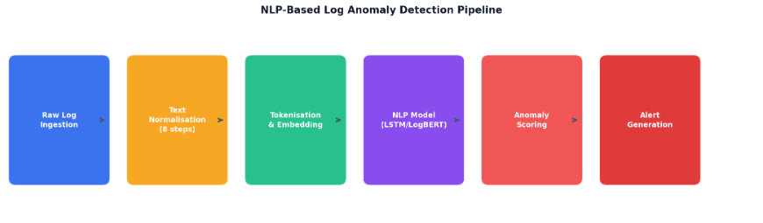
Figure 1: NLP-based log anomaly detection pipeline overview - from raw log ingestion to alert generation

1.2 Problem Statement
There are three interconnected problems that organisations have when using cloud infrastructure. Firstly, the log data volume is too large to be reviewed by humans. On the one hand, current automated tools make use of hand-coded rules that do not generalise to various log formats, systems, and attack types. Third, no single framework exists that would link all the elements of live log collection, NLP-based anomaly detection, and real-time alerting in a deployable pipeline.

1.3 Project Objectives
This project will be tackling the above problems by completing three deliverables as provided by the project client:
- Write an extensive research paper on NLP techniques and methodologies applied to the field of cybersecurity, with literature analysis, challenges, es and opportunities.
- Identify the need and develop a working prototype tool that analyses log files, identifies anomalous activity, documents the development process, and evaluates performance, using NLP.
- Perform a comprehensive evaluation and performance analysis of the prototype with the standard evaluation metrics: Precision, Recall, F1 Score, ROC-AUC, and False Positive Rate.

1.4 Project Scope
Data collection from benchmark and cloud sources, data preprocessing, training and evaluation of four NLP and machine learning models, deployment on AWS infrastructure, website development with real-time log generation, and a Streamlit dashboard for visualisation are part of the project scope. The system focuses on log data from cybersecurity, SSH authentication, system, HDFS, and event logs created by cloud systems.

1.5 Requirements and Design Decisions

1.5.1 Initial Requirements
The initial project requirements were developed based on the client brief and subsequent team analysis. These requirements define the key functional and non-functional expectations of the proposed cybersecurity anomaly detection system.
From a functional perspective, the system is required to ingest real cybersecurity log data from multiple sources. This ensures that the solution is not limited to a single log format or environment and can support a broader range of cybersecurity monitoring scenarios. The system must also include an NLP preprocessing stage to clean, normalise, and prepare raw log text before it is passed into the anomaly detection models. This preprocessing step is essential because cybersecurity logs often contain inconsistent structures, timestamps, IP addresses, system messages, and event descriptions.
Another key functional requirement is the implementation of at least two anomaly detection models. These models must be trained and tested using the same dataset so that their performance can be compared fairly. This comparison supports evidence-based model selection and helps determine which model is more suitable for detecting suspicious or abnormal log behaviour. In addition, the system must generate real-time alerts when detected anomalies exceed a configurable threshold. This allows security analysts or administrators to respond quickly to potentially serious threats.
The system must also include a visual dashboard to present detection results in a clear and meaningful way. The dashboard should provide graphical summaries of anomaly scores, alert levels, trends, and other relevant security insights. Its purpose is to support security analysts in monitoring system activity, interpreting model outputs, and making informed decisions.
In terms of non-functional requirements, the system must be capable of running on cloud-based infrastructure without relying on on-premises servers. This supports scalability, accessibility, and easier deployment across different environments. Furthermore, the system should be flexible enough to accommodate log formats from various sources without requiring manual reconfiguration each time a new log source is introduced. This requirement is important for improving system adaptability and reducing operational effort during deployment and maintenance.

1.6.2 How Requirements Evolved
The project requirements evolved progressively throughout the project lifecycle. This evolution was influenced by stakeholder feedback, technical feasibility analysis, infrastructure limitations, and the need to create a stronger academic and practical cybersecurity solution. Rather than remaining fixed at the initial planning stage, the requirements were refined across three main phases to better align the system with the Client’s expectations and the team’s implementation capacity.

Phase | Trigger | Original Requirement | Evolved Requirement | Justification
Phase 1: Weeks 1–2 | Meeting and Consultation | Analyse logs from one source | Collect and analyse logs from five sources: HDFS, OpenSSH, Linux, cloud_auth, and cloud_syslog | The Client emphasised the importance of using diverse log sources to create a more realistic and reliable evaluation environment.
Phase 1: Weeks 2–3 | Technical feasibility review | Use one detection algorithm | Implement four anomaly detection models: Random Forest, Isolation Forest, LogBERT, and LSTM | A multi-model approach allowed the team to compare supervised, unsupervised, self-supervised, and deep learning-based methods, making the technical evaluation more academically rigorous.
Phase 2: Weeks 3–5 | AWS account migration | Deploy the system on a single AWS account | Migrate the system to a new AWS account and implement API Gateway instead of direct EC2 posting | The original AWS account was deactivated during implementation. API Gateway was introduced as a more secure and scalable method for log ingestion.
Phase 2: Week 4 | Scope expansion | Develop a static results dashboard | Develop a live website with real-time CloudWatch log generation | The Client requested a live demonstrable system rather than a dashboard based only on static evaluation results. This improved the practical value of the project.
Phase 3: Weeks 6–7 | Technical limitation | Fully automate the EC2–CloudWatch–LogBERT pipeline | Use EC2-based LogBERT processing for generated logs, while identifying full live CloudWatch integration as future work | The full automation of the live pipeline introduced additional technical complexity that exceeded the available project timeline. Manual integration and testing were therefore used to validate the concept.
Overall, the requirements evolved from a relatively simple log analysis system into a more comprehensive cloud-based cybersecurity anomaly detection solution. The final scope included multi-source log ingestion, NLP-based preprocessing, multiple anomaly detection models, alert generation, and dashboard-based visualization.
A major design decision was the use of four different algorithms: Random Forest, Isolation Forest, LogBERT, and LSTM. This approach was selected deliberately to compare different detection paradigms. Random Forest represented a supervised learning approach, Isolation Forest represented an unsupervised anomaly detection method, LogBERT represented a self-supervised NLP-based log anomaly model, and LSTM represented a deep learning sequence-based approach. This comparison directly supported the Client’s requirement for stronger evaluation and provided a deeper technical understanding of how different models detect abnormal cybersecurity behaviour.
The project also evolved in response to real implementation challenges. The AWS account migration required the team to redesign parts of the cloud infrastructure and rebuild the deployment environment. Although this caused delays, it also improved the final architecture by introducing API Gateway as a more secure ingestion layer. Similarly, the live dashboard requirement expanded the system from a static reporting tool into a more practical monitoring interface that could better support security analysts.
By the end of the project, the evolved requirements reflected both the original Client expectations and the practical constraints encountered during implementation. These changes strengthened the project by improving realism, technical depth, cloud-readiness, and the overall usefulness of the system for cybersecurity monitoring.

2. Literature Review - NLP in Cybersecurity

2.1 Evolution of Log-Based Anomaly Detection
Log-based anomaly detection has evolved from manual rule-based monitoring into machine learning and deep learning-based approaches. Early systems relied heavily on manually written rules, regular expressions, and known attack signatures. In this approach, system administrators defined patterns that represented suspicious activities, and alerts were generated when log entries matched those predefined patterns. Rule-based detection is useful when attack behaviours are already known because it is transparent, easy to interpret, and relatively simple to implement. However, its main weakness is that it cannot reliably detect unknown or evolving threats. It also requires continuous manual updating and can generate high false positive rates when logs vary across different systems or environments.
The second stage of development introduced statistical and traditional machine learning methods. These approaches attempted to learn patterns from historical log data instead of relying only on handcrafted rules. Techniques such as clustering, k-nearest neighbour, decision trees, Random Forest, and Isolation Forest were used to classify or separate normal and abnormal behaviour. Compared with rule-based methods, these models offered better adaptability and allowed anomaly detection to be based on observed data patterns. However, they still depended heavily on feature engineering, such as TF-IDF vectors, event counts, or manually extracted log templates. This creates a limitation because cybersecurity logs are often semi-structured, inconsistent, and highly variable. As a result, traditional machine learning can perform well in controlled benchmark datasets but may become less reliable when applied to unseen systems, changing log formats, or noisy live environments.
The third and more recent stage uses natural language processing and deep learning to model logs as sequences of textual events. This direction is important because system logs are not only numerical records; they contain semantic information, event order, and contextual relationships between actions. DeepLog, proposed by Du et al. (2017), was an important contribution because it used LSTM networks to learn normal log execution sequences and detect abnormal sequence patterns. This showed that sequential models could detect anomalies that are not obvious from individual log entries alone. However, LSTM-based approaches still have limitations. They can be sensitive to sequence length, require careful preprocessing, and may struggle when log structures change significantly between systems.
Transformer-based models such as BERT further advanced log anomaly detection by learning bidirectional context. LogBERT, proposed by Guo et al. (2021), adapted BERT for log anomaly detection using self-supervised learning on normal log sequences. It achieved strong results on benchmark datasets such as HDFS and BGL. Its strength is that it can model contextual relationships between log events more effectively than many traditional methods. However, LogBERT is not without limitations. It often depends on log parsing or template extraction, meaning that poor template quality can affect detection performance. It is also sensitive to threshold selection: if the anomaly threshold is too low, the system may generate many false positives; if it is too high, real anomalies may be missed. In addition, transformer models require more computational resources than traditional machine learning models, which can make deployment difficult on low-resource cloud instances such as small EC2 machines.
Therefore, the literature suggests that no single anomaly detection method is universally best. Rule-based methods are interpretable but weak against unknown attacks. Traditional machine learning methods are efficient but depend heavily on feature engineering. LSTM models capture sequence behaviour but can be difficult to generalise across changing systems. LogBERT and other transformer-based models provide stronger contextual learning but introduce computational cost, threshold sensitivity, and transferability concerns. This justifies the project’s decision to compare multiple models rather than relying on one algorithm.

2.2 BERT and Transformer Models for Log Analysis
BERT, introduced by Devlin et al. (2019), changed natural language processing by using bidirectional transformer representations. Unlike earlier sequence models that process text mainly from left to right or right to left, BERT considers both previous and future context when learning token representations. This is relevant to log analysis because the meaning of a log event often depends on surrounding events rather than the event alone.
LogBERT applies this idea to system logs. Instead of treating logs as isolated entries, LogBERT models log sequences and learns what normal event patterns look like. During inference, log events that do not fit expected sequence behaviour can produce higher reconstruction or prediction loss and may be classified as anomalous. This makes LogBERT suitable for detecting subtle abnormal behaviours that may not match fixed rules.
However, the literature also highlights several practical limitations. First, LogBERT commonly depends on accurate log template extraction. If raw logs are parsed incorrectly, the model may learn misleading patterns. Second, its performance is strongly affected by threshold configuration. A threshold that works on one dataset may not transfer well to another environment. Third, transformer-based models are more computationally expensive than Random Forest or Isolation Forest. This is a significant issue for this project because the prototype was deployed on limited cloud resources. Finally, benchmark performance on datasets such as HDFS and BGL does not automatically prove readiness for real-world cybersecurity deployment. Real environments contain noisy logs, changing user behaviour, incomplete labels, and evolving attack patterns.
For these reasons, LogBERT was treated in this project as a strong research-based model for prototype demonstration and comparative evaluation, not as a fully validated production cybersecurity tool.

2.3 LSTM for Sequential Log Analysis
Long Short-Term Memory networks, introduced by Hochreiter and Schmidhuber (1997), are a type of recurrent neural network designed to learn long-range dependencies in sequential data. LSTM models are relevant to log anomaly detection because logs are naturally sequential. For example, a failed login attempt may not be suspicious by itself, but repeated failures followed by privilege escalation or unusual API access may indicate abnormal behaviour.
DeepLog demonstrated the usefulness of LSTM-based modelling by learning normal log execution sequences and identifying abnormal patterns. This made LSTM models important in the development of deep learning-based log anomaly detection. Their key advantage is that they can capture temporal relationships between events rather than relying only on individual log entries.
However, LSTM models also have limitations. They require sufficient sequential training data and can be affected by the choice of window size, sequence length, and preprocessing method. They may also struggle when deployed across systems with different log structures because the learned sequence patterns may not transfer effectively. Compared with transformer-based models, LSTMs are generally less powerful in capturing bidirectional context. For this reason, LSTM was included in the project as a deep learning sequence-based comparison model, rather than as the only detection method.

2.4 Traditional Machine Learning Baselines
Traditional machine learning models remain important because they provide simpler, faster, and more interpretable baselines. In this project, Random Forest and Isolation Forest were selected to represent supervised and unsupervised approaches.
Random Forest, proposed by Breiman (2001), combines multiple decision trees to improve classification performance and reduce overfitting. When used with TF-IDF or other text-based features, Random Forest can identify log terms or event patterns that are associated with abnormal behaviour. Its main advantage is that it is efficient, relatively easy to explain, and suitable when labelled data is available. However, Random Forest does not naturally understand sequence context or semantic relationships between log events. It may perform well when labels and features are clean, but it is less suitable for detecting complex behavioural anomalies in changing live systems.
Isolation Forest, proposed by Liu et al. (2008), is an unsupervised anomaly detection method that identifies anomalies based on how easily they can be separated from normal data points. Its main strength is that it does not require labelled anomaly data, which is useful in cybersecurity contexts where labelled attacks are limited. It is also computationally efficient and suitable as a lightweight anomaly detection baseline. However, Isolation Forest works on feature representations rather than raw semantic context. If the feature extraction process does not capture meaningful log behaviour, the model may miss important anomalies or generate misleading results. It is also less effective when anomalies are not clearly separable from normal behaviour.
Therefore, Random Forest and Isolation Forest were not selected because they are the most advanced models, but because they provide useful baseline comparisons against deep learning and NLP-based methods. Their inclusion helped the team evaluate whether more complex models such as LogBERT and LSTM provided meaningful benefits over simpler approaches.

2.5 Cloud-Based Log Management and AWS Integration
Cloud-based log management is important because modern systems often generate logs across multiple services, servers, and applications. AWS provides services such as CloudWatch, Lambda, API Gateway, SNS, and S3, which can support log collection, event processing, alerting, and dashboard visualisation. In this project, these services were used to build a prototype pipeline for demonstrating how cybersecurity logs could be collected, processed, analysed, and visualised.
Amazon CloudWatch was used as the main log monitoring and storage service. API Gateway provided a structured ingestion layer for receiving log data, while Lambda supported serverless processing. SNS was used for alert notification, and S3 supported storage for dashboard-related outputs. This architecture helped demonstrate how anomaly detection could be connected to a cloud-based monitoring workflow.
However, the AWS implementation must be understood as a prototype rather than a production-ready deployment. A real-world cybersecurity system would require stronger security controls, access management, resilience testing, continuous monitoring, automated scaling, audit logging, incident response workflows, and validation against live organisational data. The project demonstrated the feasibility of integrating anomaly detection with cloud services, but it did not fully implement all controls required for operational cybersecurity use.

2.6 Comparative Analysis of Prior Studies
The following table summarizes the main previous works in this regard, which will allow directly comparing data set, models, measures, and applicability:
Study | Dataset / Context | Model / Method | Metrics / Evaluation Focus | Advantages | Limitations | Relevance to This Prototype
Liu et al. (2008) | General anomaly detection datasets | Isolation Forest | Anomaly separation and detection performance | Does not require labelled anomaly data; efficient and suitable for baseline anomaly detection | Does not understand log meaning or event sequence context; performance depends heavily on feature representation | Supports the use of Isolation Forest as an unsupervised baseline model
Breiman (2001) | General classification problems | Random Forest | Classification accuracy and ensemble performance | Strong supervised baseline; handles structured features well; easier to interpret than complex deep learning models | Requires labelled data; does not naturally capture event order or log sequence behaviour | Supports the use of Random Forest as a supervised baseline model
Du et al. (2017) | HDFS system log data | DeepLog using LSTM | Sequence anomaly detection and abnormal event prediction | Captures temporal relationships between log events; useful for detecting abnormal execution sequences | Sensitive to preprocessing, sequence length, and system-specific log behaviour | Supports the use of LSTM-style sequence modelling for detecting abnormal log patterns
Zhang et al. (2019) | Unstable log data | LogRobust | Robustness under changing log events | Designed to handle unstable log events better than earlier fixed-template approaches | Still depends on the quality of semantic representation and careful configuration | Shows why robustness and transferability are important in log anomaly detection
Guo et al. (2021) | HDFS and BGL benchmark logs | LogBERT | Precision, recall, F1-score, and benchmark comparison | Learns contextual relationships between log events; performs strongly on benchmark datasets; reduces dependence on labelled anomaly data | Can depend on log template extraction; sensitive to threshold selection; requires more computing resources than simpler models; may not transfer directly to unseen systems | Directly supports the LogBERT implementation and explains both its strengths and limitations
Lee et al. (2021) | HDFS, BGL, and Thunderbird logs | LAnoBERT / parser-free BERT-based detection | Unsupervised anomaly detection performance | Reduces dependency on predefined log templates; addresses weaknesses caused by parser errors | Still requires careful threshold tuning and higher computing resources | Supports the argument that template extraction can be a weakness in LogBERT-style methods
AWS documentation and services | Cloud-based log management environment | CloudWatch, Lambda, API Gateway, SNS, and S3 | Log ingestion, event processing, alerting, and dashboard integration | Provides useful cloud components for collecting logs, processing events, sending alerts, and storing dashboard outputs | Cloud services alone do not make the system production-ready; strong access control, monitoring, testing, and operational validation would still be required | Supports the cloud-based prototype design for demonstration and practical learning purposes

3. System Architecture

3.1 Layered System Architecture
The LogGuard prototype was designed using a layered cloud-based architecture to separate the main responsibilities of the anomaly detection pipeline. The architecture is organised into five layers: input, ingestion, processing, alerting and storage, and output. This layered design improves maintainability because each component can be tested, modified, or replaced without requiring major changes to the entire system. It also supports scalability because cloud services can be expanded independently based on the volume of log data and processing requirements.
The system begins with user interactions on a public-facing static website. These interactions are captured as structured event logs and passed through a serverless ingestion layer. The logs are then stored in Amazon CloudWatch and processed by the anomaly detection component. When suspicious activity is identified above the configured threshold, structured alert results are generated, stored, and made available for dashboard visualization and administrator review.

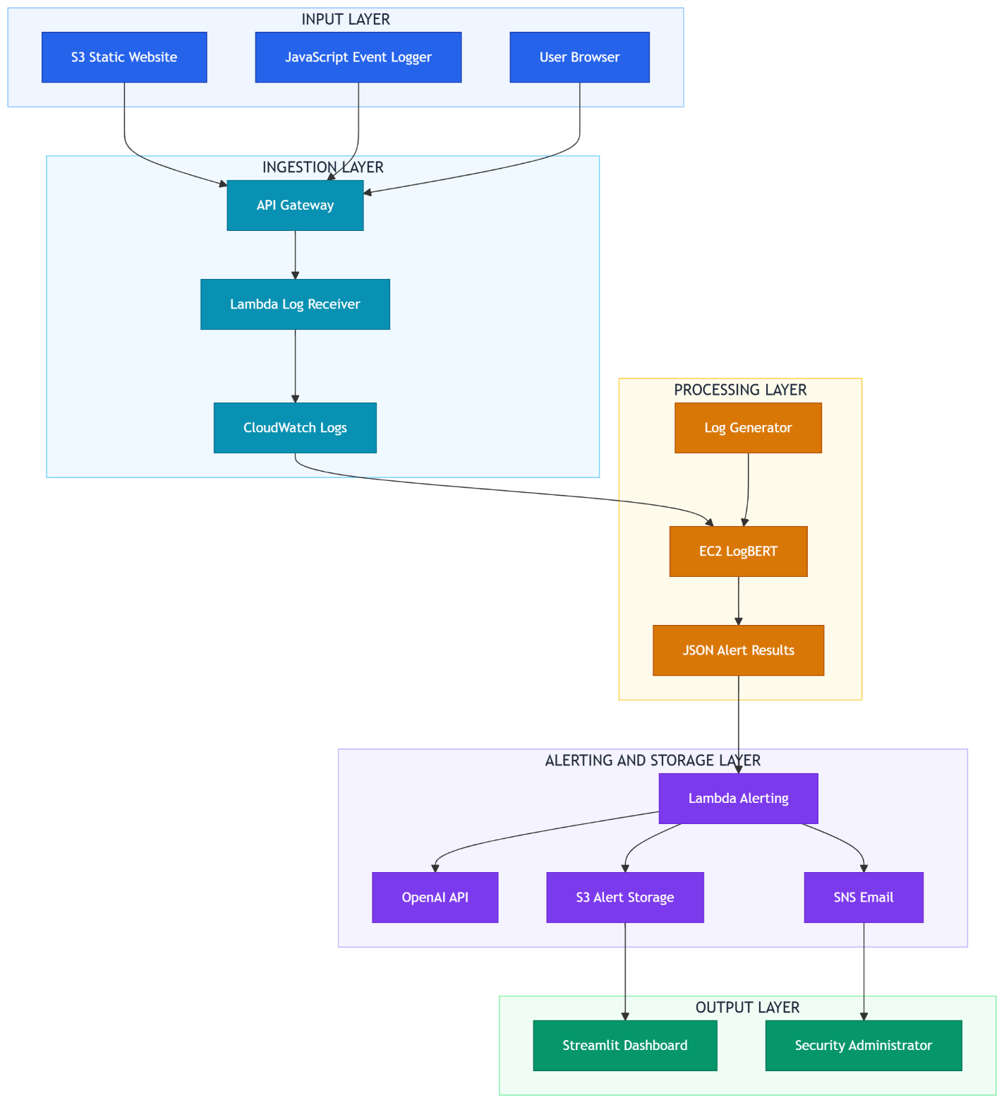
Figure 2: LogGuard prototype cloud system architecture showing the five-layer flow from website input to dashboard output

Layer | Components | Responsibility
Input Layer | S3 Static Website, JavaScript Event Logger, User Browser | Generates real-time structured log data from user interactions
Ingestion Layer | API Gateway, Lambda Log Receiver, CloudWatch Logs | Receives, processes, and stores incoming log entries securely
Processing Layer | EC2 LogBERT, Log Generator, JSON Alert Results | Runs NLP anomaly detection models and produces structured alerts
Alerting & Storage Layer | Lambda Alerting, OpenAI API, SNS Email, S3 Alert Storage | Sends AI-enhanced email alerts and stores results for dashboard
Output Layer | Streamlit Dashboard, Security Administrator | Visualises detection results and delivers insights to end users

3.2 Nine-Stage Pipeline
The LogGuard prototype follows a nine-stage pipeline that transforms raw website interactions into structured anomaly alerts and dashboard insights. Each stage is supported by a specific AWS service or system component. The pipeline was designed to operate fully in a cloud environment without requiring on-premises infrastructure. This approach supports the project requirement for cloud-based deployment and demonstrates how log ingestion, detection, alerting, storage, and visualisation can be integrated into a single workflow.
Although the system demonstrates an end-to-end anomaly detection workflow, it should be understood as a prototype developed for demonstration and practical learning purposes. It is not yet a production-ready cybersecurity system and would require further validation, security hardening, scalability testing, and operational monitoring before real-world deployment.
triggers.
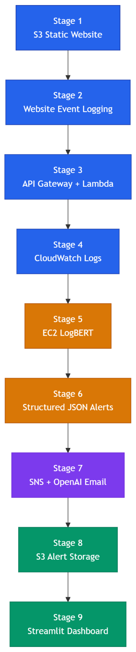
Figure 3: Complete LogGuard nine-stage AWS pipeline architecture from website interaction to dashboard visualisation

Stage | Component | Purpose | Status
1 | S3 Static Website | Hosts the public-facing website used to generate user activity logs | Implemented
2 | Website Event Logging | Uses JavaScript event listeners to capture user interactions as structured log entries | Implemented
3 | API Gateway + Lambda | Provides a serverless HTTP ingestion endpoint for receiving website logs | Implemented
4 | Amazon CloudWatch | Stores and monitors incoming event logs in a central cloud log service | Implemented
5 | EC2 and LogBERT Processing | Processes log windows and calculate anomaly scores using the LogBERT model | Implemented using test/generated logs
6 | Structured JSON Alerts | Saves detection results as structured JSON containing score, alert level, reason, and timestamp | Implemented
7 | SNS Email Alerts | Sends email notifications when anomaly scores exceed the configured threshold | Implemented
8 | CloudWatch to S3 | Transfers structured alert results to Amazon S3 for dashboard consumption | Implemented
9 | Streamlit Dashboard | Retrieves alert data from S3 and displays anomaly trends, charts, and summaries | Implemented

3.3 Technology Stack
The technology stack was selected to support the main functional requirements of the prototype: cloud-based log ingestion, log storage, anomaly detection, alerting, and dashboard visualisation. AWS services were used for the cloud infrastructure, while Python-based data science libraries were used for preprocessing, model execution, and evaluation. Streamlit and Plotly were used to provide an interactive dashboard interface for reviewing anomaly detection outputs.

Layer | Technology | Purpose
Frontend | HTML5 / CSS3 / JavaScript | Provides the website interface and captures user interaction events
Log Ingestion | AWS API Gateway, AWS Lambda, Python | Receives structured logs from the website through a serverless endpoint
Log Storage | Amazon CloudWatch Logs | Stores and monitors log events in a centralised cloud logging service
Model Processing | AWS EC2, Ubuntu | Provides the execution environment for running the LogBERT processing workflow
Anomaly Detection Models | PyTorch, TensorFlow, Keras, scikit-learn | Supports LogBERT, LSTM, Random Forest, and Isolation Forest model implementation
Feature Engineering | TF-IDF (scikit-learn) | Converts log text into numerical features for traditional machine learning baselines
Alert Delivery | AWS SNS + OpenAI API | Sends email notifications when anomaly scores exceed the configured threshold
Alert Storage | Amazon S3 | Stores structured JSON alert files for dashboard access
Visualisation | Streamlit, Plotly | Displays anomaly scores, alert levels, trends, and summary insights
Data Processing | pandas, NumPy, scikit-learn | Supports data cleaning, preprocessing, manipulation, and evaluation

4. Dataset

4.1 Dataset Overview
This project used two related dataset stages. The first stage was a multi-source cybersecurity log dataset created for prototype development, dashboard demonstration, and testing of the cloud-based workflow. The second stage used the HDFS_v2 dataset as the main dataset for the final LogBERT implementation and model comparison.
The initial combined dataset was stored as full_dataset_final.csv and contained 7,254 cybersecurity log entries. It included benchmark logs from LogHub and cloud logs collected from an AWS EC2 instance deployed for this project. The dataset contained three main fields: cleaned_log, label, and source. The cleaned_log field stored the preprocessed log text, the label field represented the binary class where 0 indicated Normal and 1 indicated Anomaly, and the source field identified the origin of each log entry.
This multi-source dataset was useful for demonstrating the prototype because it included logs from different systems, including HDFS, OpenSSH, Linux, EC2 authentication logs, and EC2 system logs. However, during implementation, it became clear that the dataset was not equally suitable for every model. In particular, LogBERT required a larger and more structured sequence-based dataset than the smaller cloud-collected logs could provide. For this reason, the final LogBERT implementation used HDFS_v2 as the main evaluation dataset.

4.2 Multi-Source Prototype Dataset
The multi-source dataset was used to support early development, preprocessing, cloud log testing, and dashboard demonstration. It combined benchmark records and project-specific cloud logs.

Source | Type | Total | Anomaly | Anomaly Rate | Collection Method
HDFS | Hadoop Distributed File System | 2,000 | 304 | 15.2% | LogHub benchmark (He et al. 2020)
OpenSSH | SSH authentication logs | 2,000 | 658 | 32.9% | LogHub benchmark (He et al. 2020)
Linux | System syslog / kernel logs | 2,000 | 1,525 | 76.2% | LogHub benchmark (He et al. 2020)
cloud_auth | AWS EC2 authentication logs | 125 | 60 | 48.0% | Live EC2 collection - simulated brute force
cloud_syslog | AWS EC2 system logs | 1,129 | 20 | 1.8% | Live EC2 collection - normal operations
Total | Multi-source dataset | 7,254 | 2,567 | 35.4% | Combined benchmark + cloud

The overall anomaly rate of the combined dataset was 35.4%. This made the dataset moderately imbalanced, which is realistic for cybersecurity contexts where normal activity is usually more common than malicious or abnormal activity. However, the anomaly distribution differed significantly between sources. For example, the Linux subset had a high anomaly rate, while the cloud_syslog subset had a much lower anomaly rate. This difference shows that anomaly patterns were not evenly distributed across all sources.

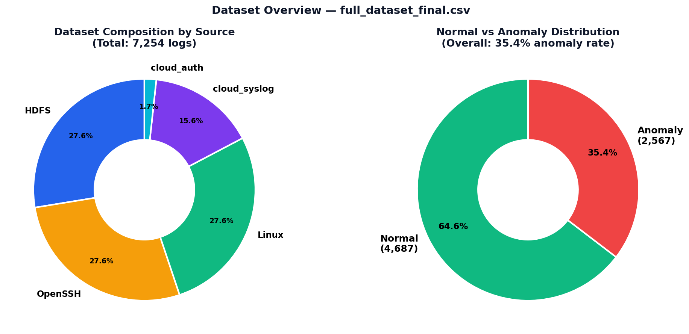
Figure 4: Dataset composition by source (left) and Normal vs Anomaly distribution (right)

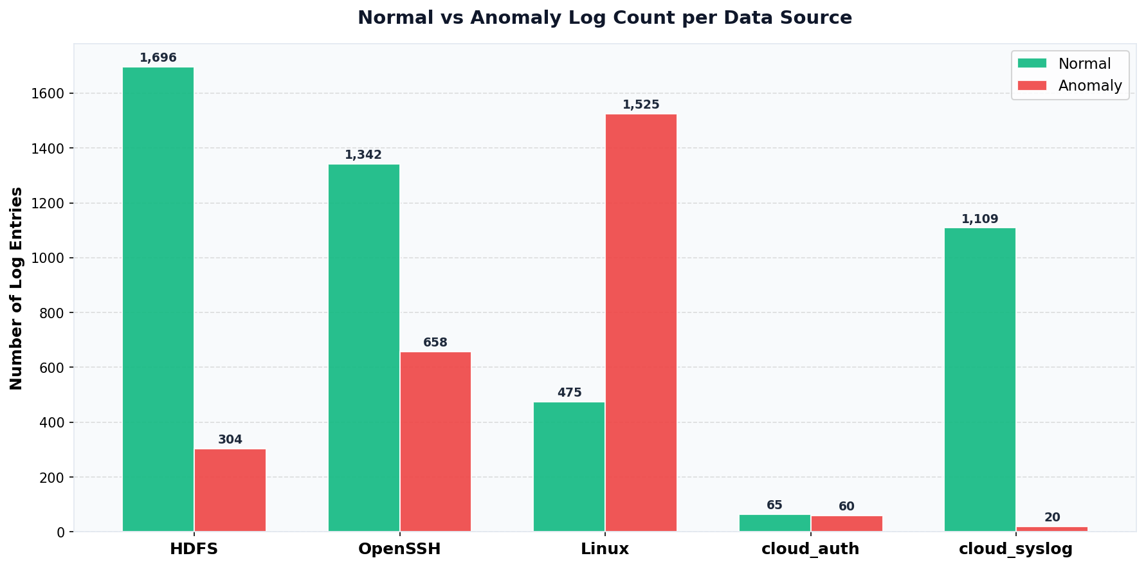
Figure 5: Normal vs Anomaly log count per data source

4.3 Cloud Log Collection
The cloud_auth and cloud_syslog records were collected from an Ubuntu 24.04 LTS instance running on AWS EC2. These logs were included to demonstrate that the prototype could work with logs generated from a live cloud environment rather than relying only on public benchmark data.
Authentication-related events were generated through repeated invalid SSH login attempts using invalid usernames. This created a realistic pattern of failed login events in the authentication logs. Additional system-level events, including file access failures, sudo-related access attempts, and normal system events, were also collected to provide a broader range of cloud log activity.
The purpose of collecting these cloud logs was to support the practical demonstration of the system, including log ingestion, alert generation, and dashboard visualisation. However, the number of cloud-collected records was limited compared with the benchmark datasets. Therefore, these logs were more suitable for prototype demonstration than for full model training and scientific evaluation.

4.4 Final Dataset Selection for LogBERT and Model Comparison
For the final model implementation, the HDFS_v2 dataset was selected as the main dataset for LogBERT training and evaluation. This decision was made because HDFS_v2 was more suitable for LogBERT than the other available data sources.
LogBERT works best when the dataset contains a large number of structured log sequences, consistent event patterns, and reliable labels. The HDFS_v2 dataset provided these requirements more effectively than the smaller cloud-authentication and cloud-system logs. It contained enough log records for sequence-based learning and was easier to convert into the format required by the LogBERT pipeline.
The final LogBERT notebook used files such as test_anomaly_scores.csv, hdfs_v2_test_sessions.csv, and anomaly_label.csv. The evaluation evidence showed 10,000 score rows, 10,000 test rows, and 575,061 labelled records in the label file. The label distribution included 558,223 normal records and 16,838 anomaly records. This made HDFS_v2 more appropriate for testing LogBERT because it provided sufficient data volume and a clearer benchmark structure.
To make the model comparison fairer, the HDFS_v2 dataset was also used with the other classifiers where possible, including Random Forest, Isolation Forest, and LSTM-based models. This allowed the project to compare different modelling approaches on the same main dataset rather than comparing results across unrelated datasets. Random Forest represented a supervised baseline, Isolation Forest represented an unsupervised anomaly detection method, LSTM represented sequence-based deep learning, and LogBERT represented transformer-based log sequence modelling.
This decision improved the reliability of the final comparison because the models were evaluated under more consistent data conditions. However, the results should still be interpreted as prototype-level findings rather than production-level cybersecurity evidence.

4.5 Preprocessing Pipeline
Before training and evaluation, the raw logs were cleaned and normalised. The preprocessing steps included IP address replacement, port number replacement, block identifier replacement, process ID removal, hostname normalisation, lowercasing, special character removal, and whitespace normalisation.
These steps were necessary because raw cybersecurity logs contain many changing values, such as IP addresses, timestamps, ports, process IDs, hostnames, and identifiers. If these values are left unchanged, models may learn unique system-specific details instead of meaningful log behaviour. Normalisation helped reduce unnecessary variation and made the log text more consistent for modelling.
However, preprocessing also required balance. Removing too much information can reduce useful context, while keeping too much raw detail can cause overfitting. The preprocessing approach used in this project aimed to reduce noise while preserving the main meaning of each log event.

4.6 Labelling Methodology and Validity Limitation
The multi-source prototype dataset used a combination of benchmark labels, rule-based decisions, and keyword-supported anomaly identification. This approach was useful for building a working prototype within the project timeline. However, it also created an important limitation.
The main issue is that keyword-supported labelling can introduce data leakage. If the same suspicious words used to label a log as anomalous are also present in the model input text, supervised models may learn the labelling rule rather than learning genuine abnormal behaviour. For example, if words related to login failure, access denial, or suspicious activity are used to assign anomaly labels, a model trained on the same text may simply learn to recognise those words.
This limitation is especially important when interpreting very high performance from supervised models such as Random Forest or LSTM. High accuracy in this situation does not automatically prove that the model can detect unseen cybersecurity threats. It may partly reflect the relationship between the labelling rules and the text features.
To reduce this weakness, the final LogBERT-focused evaluation used HDFS_v2 because it provided a more established benchmark structure and a larger labelled log dataset. Even so, the evaluation remains suitable for prototype demonstration rather than full real-world validation.

4.7 Dataset Suitability for the Prototype
Overall, the datasets were suitable for the scope of this project. The multi-source dataset supported the development of the prototype workflow, including preprocessing, cloud log collection, alert generation, and dashboard visualisation. The HDFS_v2 dataset supported the final LogBERT implementation and allowed the model comparison to be performed on a more detailed and structured log dataset.
The dataset strategy also reflected the practical constraints of the project. The live AWS logs were valuable because they showed that the system could collect and process cloud-generated logs. However, they were not large enough for full LogBERT training. HDFS_v2 was therefore selected for the final modelling stage because it provided enough data volume, clearer labels, and a structure that was more compatible with LogBERT.
The main limitation is that the project should be treated as a prototype for demonstration and practical learning. The results show that the pipeline can process logs, run anomaly detection models, generate alerts, and visualise outputs. However, further work would be required before the system could be used in a real operational cybersecurity environment. Future improvements should include larger live log collection, independent expert labelling, source-based train-test splitting, testing on unseen systems, and more detailed false positive and false negative analysis.

5. Data Preprocessing

5.1 Preprocessing Pipeline Overview
Raw cybersecurity logs often contain highly variable elements such as IP addresses, port numbers, process IDs, block identifiers, timestamps, hostnames, and file paths. These values may change between log entries even when the underlying event type is similar. Although these elements are useful for operational investigation, they can add unnecessary noise during model training because they do not always provide strong semantic value for anomaly detection.
If these variable fields are not normalised, the model may treat structurally similar log messages as completely different events. This can reduce generalisation and cause the model to learn system-specific identifiers instead of meaningful behavioural patterns. This issue is especially important for unsupervised and sequence-based models, where inconsistent log tokens can make normal behaviour harder to learn.
To reduce this problem, all training and inference data were passed through the same preprocessing pipeline. Applying identical preprocessing to both stages ensured consistency between model development and model use. It also helped reduce preprocessing-related data leakage by preventing the model from being exposed to different cleaning rules during training and evaluation.
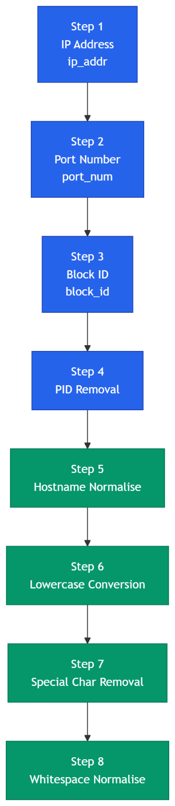
Figure 6: Eight-step text normalisation preprocessing pipeline

The preprocessing pipeline applied a consistent set of transformations to reduce noise and standardise the log format before model training and inference.

Step | Transformation | Example Before | Example After
1 | IP address replacement | Failed login from 192.168.1.45 | Failed login from ip_addr
2 | Port Number replacement | Connection on port 55948 | Connection on port_num
3 | HDFS block ID replacement | Processing block blk_-1234567890 | Processing block block_id
4 | Process ID removal | sshd[12847]: session opened | sshd: session opened
5 | Hostname normalisation | server-ip-172-31-25-6 | hostname
6 | Lowercase conversion | Failed Password for ROOT | failed password for root
7 | Special character removal | error: [kernel] fault! | error kernel fault
8 | Whitespace normalisation | login attempt from | login attempt from

These transformations helped convert inconsistent raw log entries into a more stable textual format. This allowed the models to focus on the underlying event meaning rather than changing identifiers such as IP addresses, ports, process IDs, hostnames, or block identifiers.

5.2 Labelling Strategy and Data Leakage Acknowledgement
For datasets that did not provide clear line-level anomaly labels, a keyword-supported labelling strategy was used. Log entries containing terms such as failed, invalid, error, denied, and unauthorised were treated as anomalous. This approach allowed the project to create a labelled dataset within the available timeframe and supported prototype-level model training and comparison.
However, this method introduces a data leakage risk. Since some of the same keywords used for labelling also remain in the cleaned log text, supervised models may learn these keywords instead of learning genuine anomalous behaviour. This issue is especially relevant for the TF-IDF-based Random Forest model, where label-related words can become strong predictive features during training. Therefore, very high classification performance should be interpreted carefully.
The LSTM and LogBERT models are less directly dependent on isolated TF-IDF keyword weights because they are designed to learn sequence and contextual patterns. However, they may still be affected if the anomaly labels are strongly connected to repeated suspicious terms or structures in the logs.
Therefore, the results should be interpreted as prototype-level findings, not as production-grade cybersecurity validation. Future work should reduce this limitation by using independently labelled logs, expert-reviewed annotations, source-based train-test splitting, and testing on unseen live log data.

6. Algorithms and Models
This project implemented and compared four anomaly detection approaches: Random Forest, Isolation Forest, LSTM, and LogBERT. These models were selected to represent different detection paradigms, including supervised classification, unsupervised anomaly detection, sequence-based deep learning, and self-supervised log sequence modelling.
The main purpose of using multiple models was not only to identify the best-performing approach, but also to understand how different algorithms behave when applied to cybersecurity logs. Random Forest and LSTM were useful supervised baselines, Isolation Forest provided an unsupervised comparison, and LogBERT was selected as the main final model because it was better aligned with the project objective of learning normal log behaviour and identifying abnormal sequence patterns.
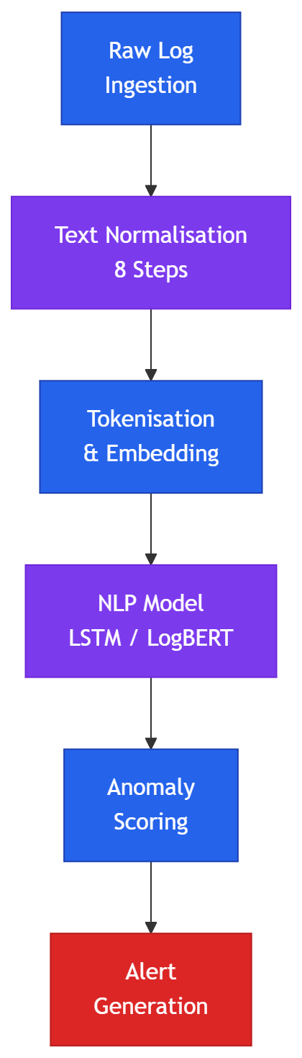
Figure 7: Model-based log anomaly detection pipeline from log text input to alert output

6.1 Random Forest
Random Forest was implemented as the supervised machine learning baseline. It was selected because it is efficient, interpretable, and commonly used for classification tasks. In this project, cleaned log text was converted into numerical features using TF-IDF vectorisation. The model used 500 unigram and bigram features and 100 decision trees trained on bootstrapped subsets of the data. Class weighting was set to balanced to reduce the effect of class imbalance.
Random Forest achieved very high performance on the test set. However, this result must be interpreted carefully because the dataset included keyword-supported labels. Since TF-IDF gives high importance to repeated words, the model may have learned label-related keywords rather than deeper anomaly behaviour. Therefore, Random Forest was treated as a useful supervised baseline, but not as the strongest evidence of real-world anomaly detection capability.

Metric | Value | Interpretation
F1-Score (Anomaly) | 0.9971 | Exceptional - note data leakage caveat above
Precision | 1.0000 | Zero false positives on test set
Recall | 0.9942 | Missed 3 of 514 true anomalies
ROC-AUC | 1.0000 | Perfect class separation on test set
False Positive Rate | 0.0000 | No normal logs misclassified
5-Fold CV F1 | 0.9979 ± 0.0010 | Stable across different data splits

6.2 Isolation Forest
Isolation Forest was implemented as the unsupervised baseline. Unlike Random Forest, it does not require anomaly labels during training. Instead, it detects anomalies by identifying data points that are easier to isolate through random feature splits. This made it useful for testing how the system performs when labelled attack data is limited.
The Isolation Forest model analysed 120,000 log records and identified 5,465 logs as anomalous. Its main strength was that it could detect unusual records without relying on labelled anomalies. However, its limitation was that it did not understand log sequence context or semantic relationships between log events. As a result, it was useful as a lightweight baseline, but less suitable as the main model for this project.

Metric | Value
Total logs analysed | 120,000
Predicted Normal | 114,535 (95.4%)
Predicted Anomaly | 5,465 (4.6%)
Mean Anomaly Score | 0.4253
Min / Max Score | 0.3551 / 0.6880
Standard Deviation | 0.0382

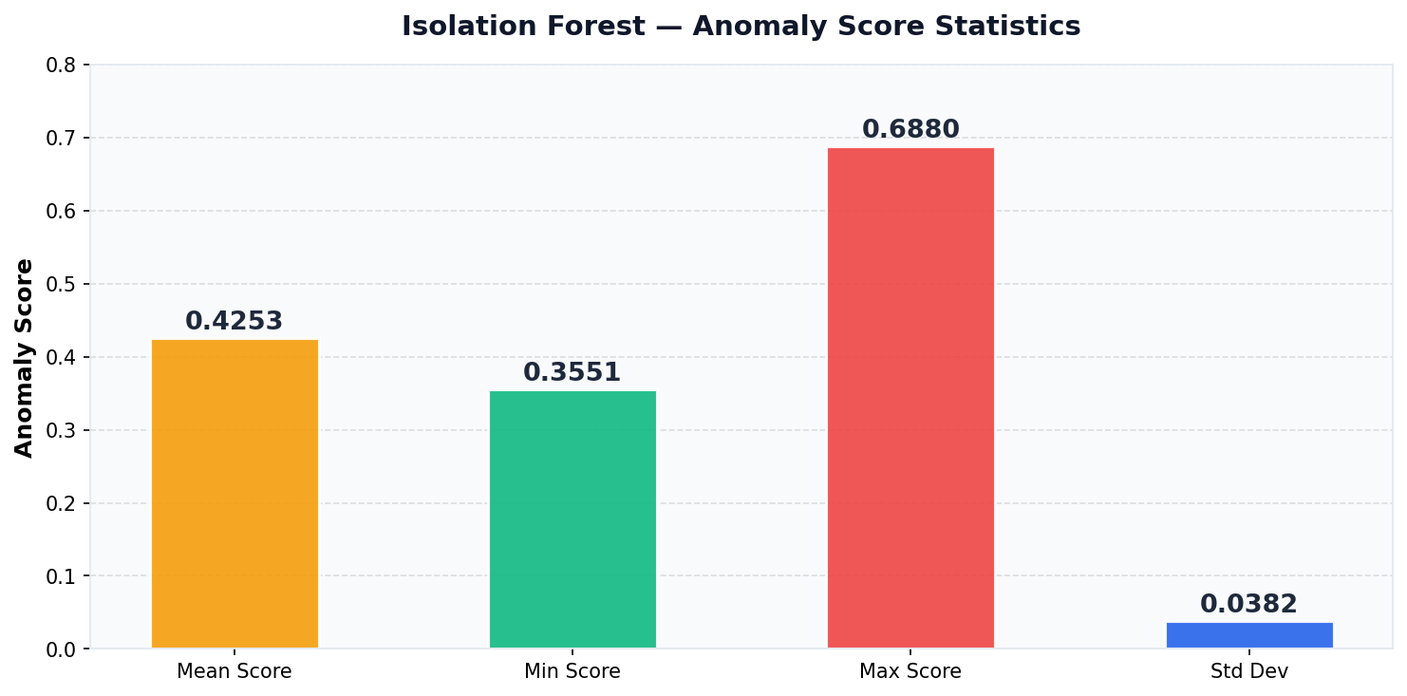
Figure 8: Isolation Forest anomaly score statistics

6.3 LogBERT
LogBERT was selected as the main model for the final prototype because it was more suitable for log sequence anomaly detection than the supervised keyword-dependent approaches. Unlike Random Forest, which learns from TF-IDF word features, LogBERT learns the normal structure and sequence behaviour of logs. This made it more appropriate for the project’s aim of detecting abnormal log behaviour rather than simply recognising suspicious keywords.
LogBERT is based on the BERT transformer architecture and uses a self-supervised training process. During training, parts of normal log sequences are masked, and the model learns to reconstruct the missing log keys using the surrounding context. During inference, if a log sequence contains unexpected or unusual log keys, the model produces a higher reconstruction loss. This reconstruction loss is then used as an anomaly signal.
For the final implementation, the HDFS_v2 dataset was used because it provided a larger and more structured log sequence dataset than the smaller cloud-collected logs. This dataset was more compatible with the LogBERT pipeline because it contained enough log records, clearer sequence patterns, and a benchmark-style structure suitable for model testing.
The LogBERT implementation used normal log sequences during training and mixed normal/anomalous sequences during testing. The model achieved a final average test loss of 0.3874. This result indicates that the model successfully learned the expected structure of normal log sequences and could use reconstruction loss to identify unusual behaviour. Because LogBERT does not depend only on manually assigned keyword labels, its outcome was considered more technically meaningful for the final prototype.
However, LogBERT was evaluated using a reconstruction-loss protocol rather than the same binary classification metrics used for Random Forest and LSTM. Therefore, its results were reported separately. Future improvement should include threshold tuning so that reconstruction loss can be converted into binary anomaly predictions and evaluated using F1-score, precision, recall, and false positive rate.

Metric | Value | Notes
Vocabulary Size | 50,003 tokens | Full log key vocabulary from training corpus
Training Samples | 39,998 log entries | Normal log sequences only
Test Samples | 10,000 log entries | Mixed normal and anomalous
Average Test Loss (Final) | 0.3874 | Lower = better pattern learning; used as anomaly proxy
F1-Score | Not yet evaluated | Requires threshold selection - planned future work
Precision / Recall | Not yet evaluated | Requires binary classification output pipeline

6.4 Bidirectional LSTM
The LSTM model was implemented as a supervised deep learning model for sequence-based log classification. It processed tokenised log text through an embedding layer and recurrent sequence layers to classify logs as normal or anomalous. Compared with Random Forest, the LSTM model was better suited to learning word order and sequence patterns.
The LSTM model achieved near-perfect classification results on the test set. However, as with Random Forest, the result should be interpreted carefully because it used the same labelled dataset. Although LSTM does not rely on TF-IDF keyword weighting, it can still learn repeated suspicious terms or structures if those terms are strongly connected to the labels. Therefore, LSTM was treated as a strong supervised comparison model, but not as the final main model.
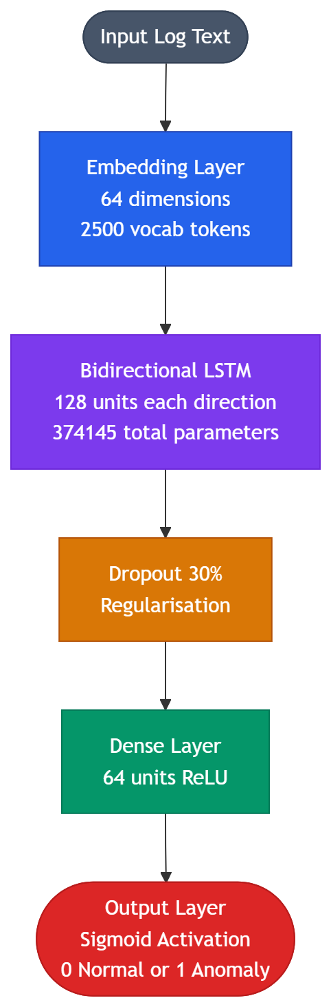

Figure 9: Bidirectional LSTM architecture - five-layer log classification network

Layer | Output Shape | Parameters | Notes
Embedding | (None, 20, 64) | 160,000 | 2,500 vocab × 64-dim; trainable
Bidirectional LSTM | (None, 256) | 197,632 | 128 units per direction
Dense (ReLU) | (None, 64) | 16,448 | High-level feature extraction
Output (Sigmoid) | (None, 1) | 65 | Probability of anomaly
Total | - | 374,145 | -

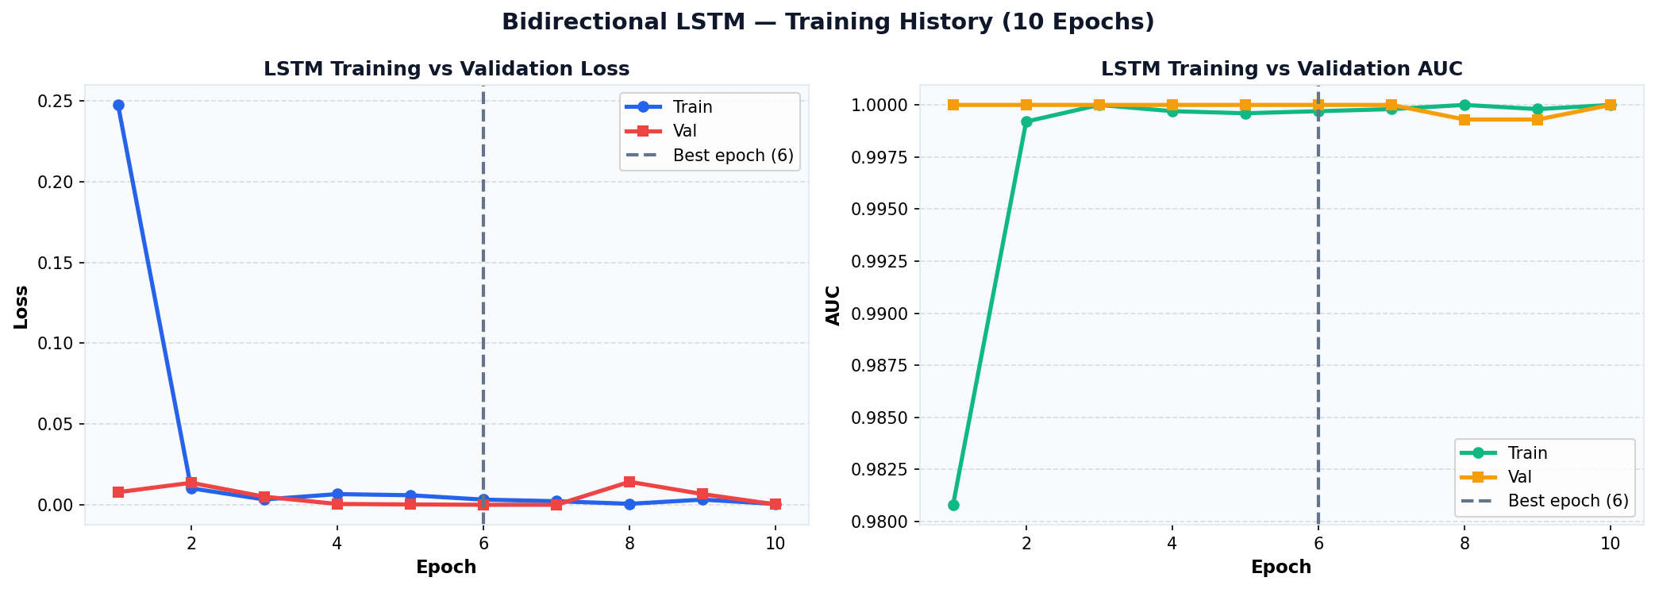
Figure 10: LSTM training history showing loss and AUC across 10 epochs

Metric | Value | Interpretation
F1-Score (Anomaly) | 0.9987 | Near-perfect - note data leakage caveat
Precision | 0.9974 | 1 false positive out of 385 predictions
Recall | 1.0000 | ALL 385 anomalies detected - zero missed
ROC-AUC | 0.9996 | Near-perfect class separation
False Positive Rate | 0.0014 | 1 normal log incorrectly flagged
True Positives / False Negatives | 385 /0 | Critical: no missed threats

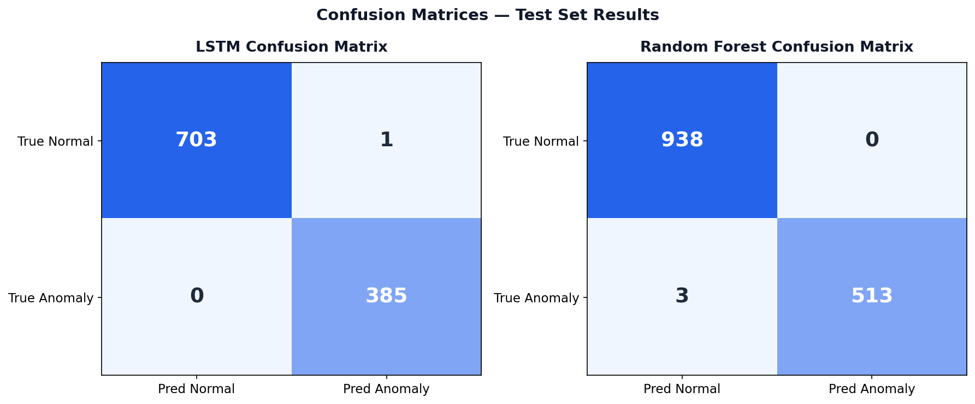
Figure 11: Confusion matrices for LSTM and Random Forest

6.5 Algorithm Comparison
The model comparison showed that Random Forest and LSTM achieved the strongest binary classification results. However, these results were influenced by the keyword-supported labelling method, so they should be treated as prototype-level supervised performance rather than production-level validation.
Isolation Forest provided a useful unsupervised baseline because it did not require labelled anomaly data. However, its performance was weaker because it did not capture log sequence context or deeper semantic patterns.
LogBERT was selected as the main model for the final prototype because its detection method was more suitable for log anomaly detection. Instead of relying mainly on labelled keywords, LogBERT learned normal log sequence structure and used reconstruction loss to identify unusual behaviour. This made it more appropriate for the final direction of the project, even though its binary classification thresholding still requires future improvement.

Supervised and Unsupervised Models - Binary Classification Metrics
Metric | Random Forest | Isolation Forest | Bidirectional LSTM
F1-Score (Anomaly) | 0.9971 | 0.2582 | 0.9987
Precision | 1.0000 | 0.1482 | 0.9974
Recall | 0.9942 | 0.9994 | 1.0000
False Positive Rate | 0.0000 | High | 0.0014
Training Type | Supervised | Unsupervised | Supervised
Best Suited For | Interpretable baseline | Unknown attack types | Sequential NLP classification

The supervised results are influenced by keyword-supported labelling and should be interpreted carefully.

LogBERT: Main Self-Supervised Model

Metric | LogBERT Value | Notes
Evaluation Protocol | Reconstruction Loss | Different from binary classification above
Average Test Loss | 0.3874 | Indicates successful learning of normal log patterns
Vocab Size | 50,003 tokens | Full log key vocabulary
Train | 39,998 | Normal log sequences
Test Samples | 10,000 | Mixed normal and anomalous sequences

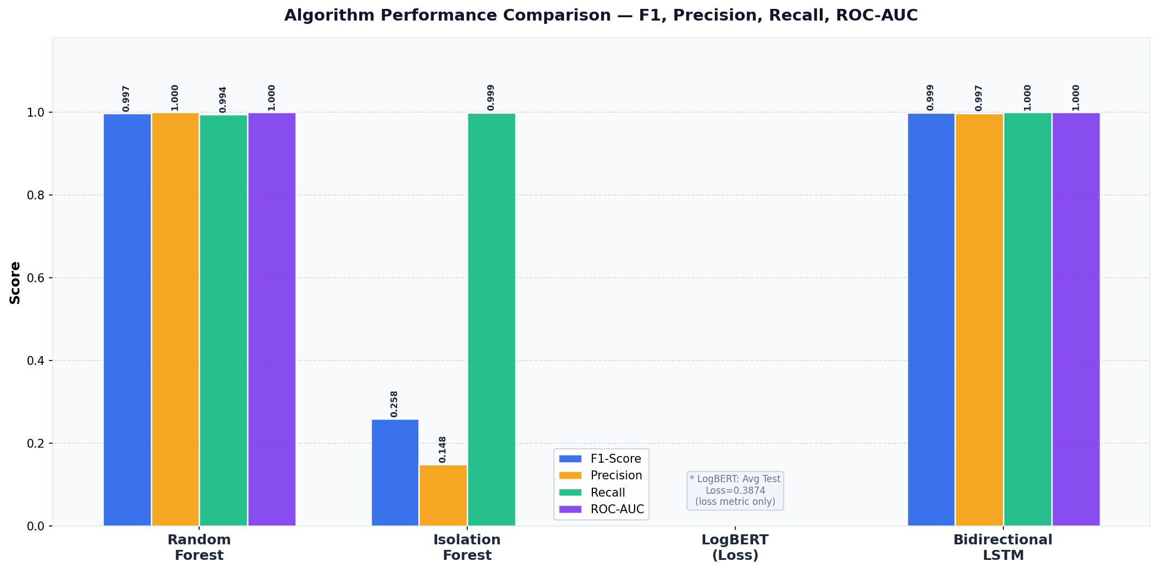
Figure 12: Performance comparison of supervised and unsupervised models (LogBERT excluded due to different evaluation protocol)

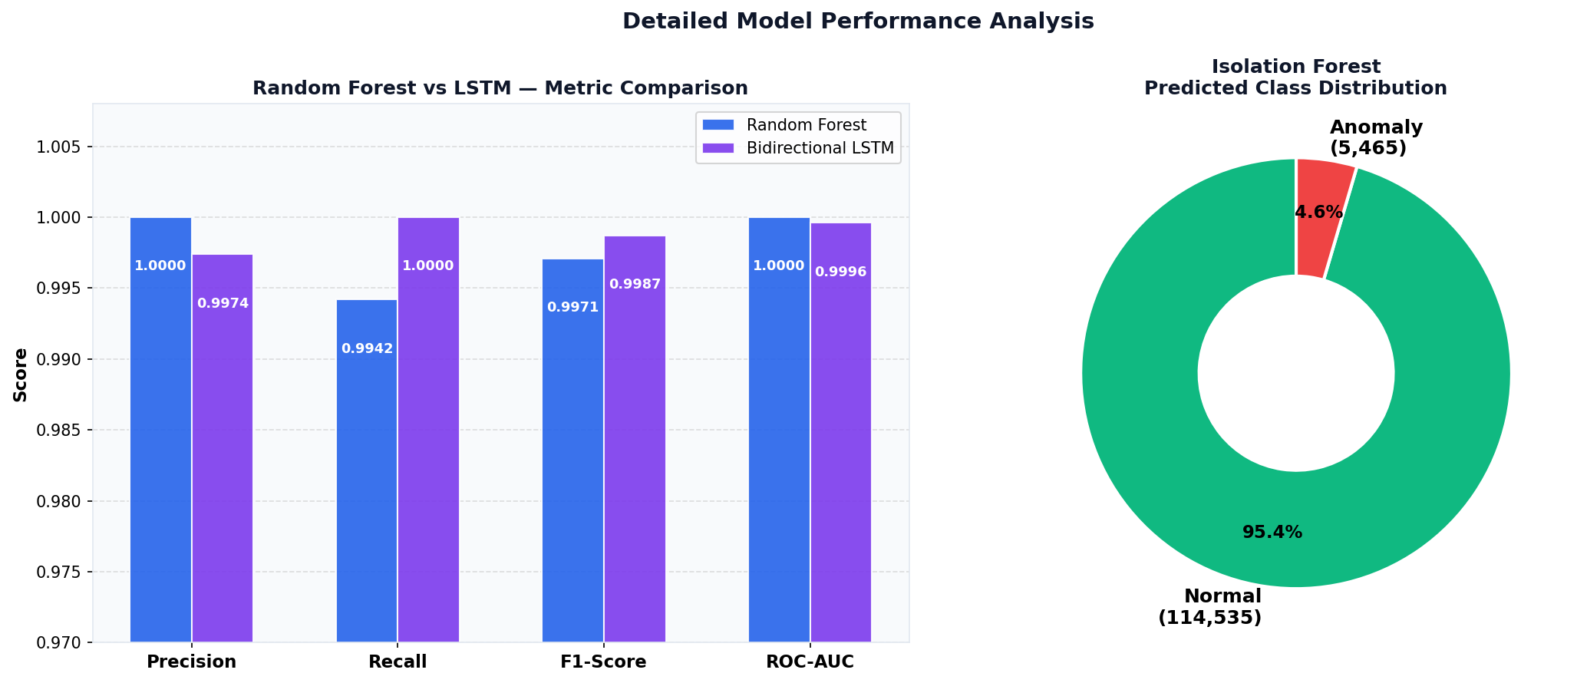
Figure 13: RF vs LSTM metric comparison (left) and Isolation Forest class distribution (right)

7. AWS Cloud Integration Pipeline

7.1 Pipeline Overview
The AWS cloud integration pipeline was developed to demonstrate how cybersecurity logs can be collected, stored, processed, converted into structured alerts, and visualised through a dashboard. The implementation followed the layered architecture described in Section 3 and was organised into nine practical stages, beginning with user activity on a public website and ending with dashboard-based anomaly monitoring.
The purpose of this pipeline was to show the end-to-end operation of the LogGuard prototype in a cloud-based environment. Each stage was implemented using AWS services or cloud-hosted components, including Amazon S3, API Gateway, AWS Lambda, Amazon CloudWatch, Amazon EC2, Amazon SNS, and Streamlit. This design supported the project requirement that the system should operate without on-premises infrastructure.
The pipeline was developed as a prototype for demonstration and practical learning purposes. It shows how the main components of a cybersecurity anomaly detection workflow can be connected in the cloud. However, the system is not yet a production-ready cybersecurity platform. A real-world deployment would require further automation, stronger access control, more extensive testing, independent validation, and operational monitoring.
The implemented pipeline consists of the following nine stages:
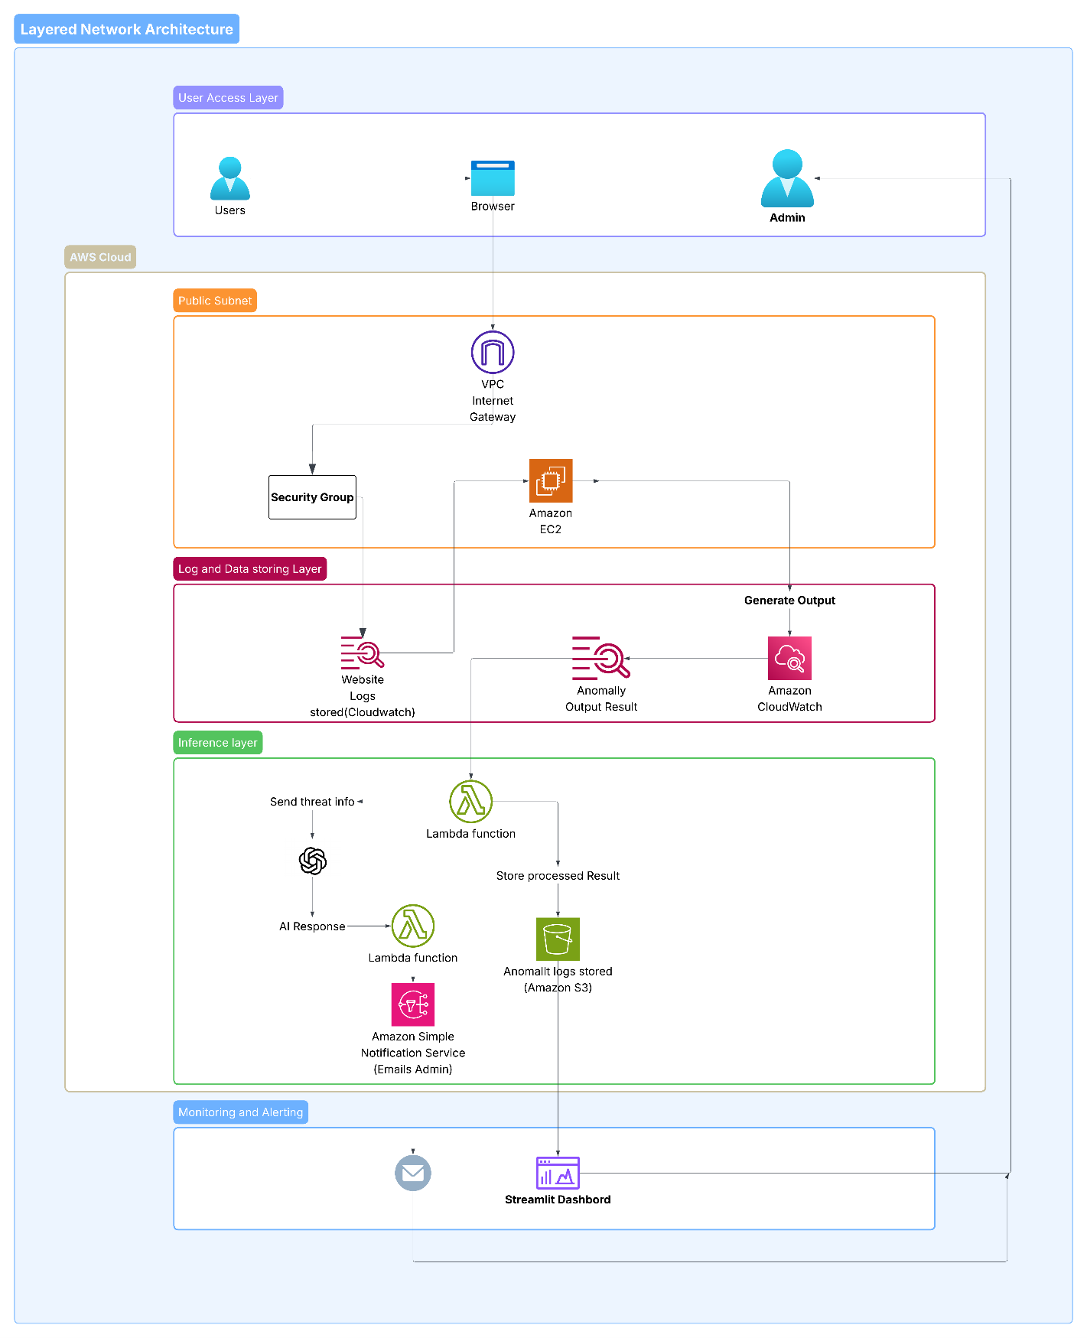
Figure 14: Complete AWS cloud pipeline showing the flow from website activity to anomaly dashboard visualisation

7.2 Stage 1 - Static Website Hosted on Amazon S3
The first stage of the pipeline was the deployment of the public-facing website on Amazon S3 using static website hosting. The website was hosted in the S3 bucket named logguard-ai-website-coit20265 in the ap-southeast-2 region. The bucket contained the main index.html file, and static website hosting was enabled.
Using Amazon S3 for website hosting was suitable for this prototype because it avoided the need to configure and maintain a traditional web server. S3 static hosting provided a simple, low-cost, and reliable way to serve the website and generate user interaction logs for the rest of the pipeline. This supported the cloud-only design of the project and made the website easier to deploy and update during implementation.
The website acted as the input point of the system. When a user interacted with the website, the browser generated structured event logs that were later passed into the AWS ingestion pipeline.
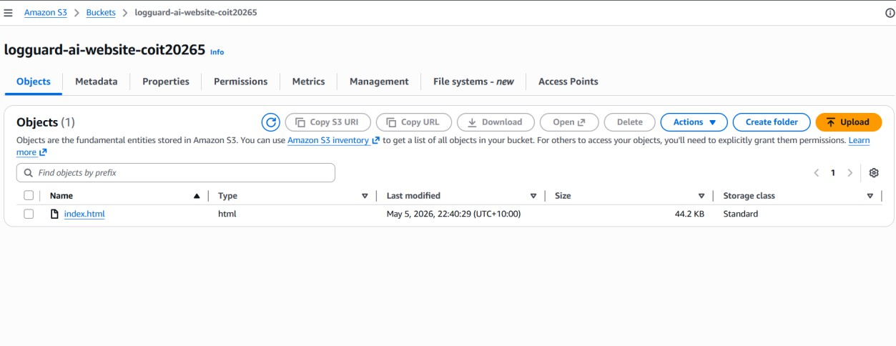

Figure 15: S3 bucket showing the uploaded website file

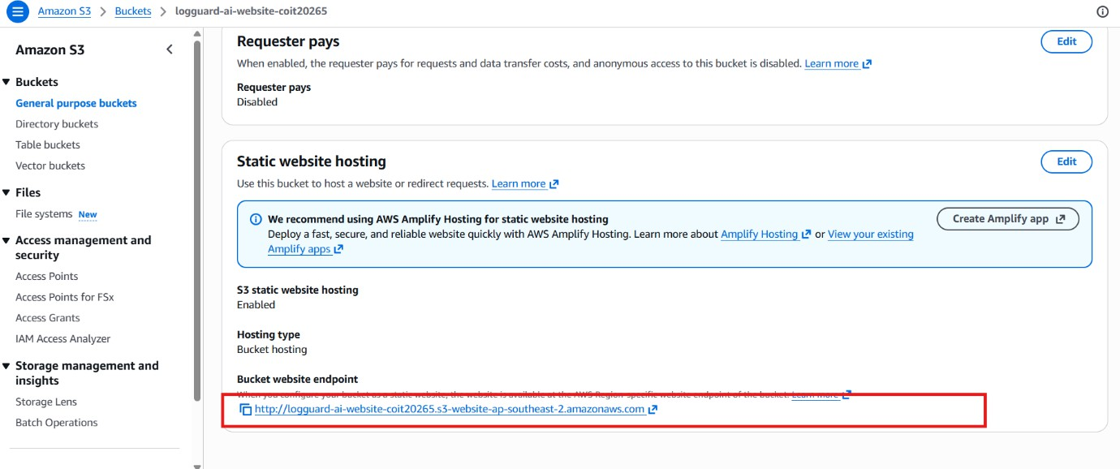
Figure 16: S3 static website hosting settings showing bucket hosting and website endpoint

7.3 Stage 2 - Website Event Logging
The second stage involved capturing user interactions on the website. JavaScript event listeners were used to detect actions such as page loading, navigation, login attempts, and section clicks. These interactions were converted into structured log entries similar to standard system or application logs.
Each log entry followed a consistent format containing a timestamp, user IP address, event source, process-style identifier, and event message. This structure made the website logs easier to process in later stages because they resembled real system log entries.

Example log format from the website:
2026-05-02T08:17:10+00:00 103.204.209.223 website-login[1001]: Failed login attempt for user: admin
2026-05-02T08:17:14+00:00 103.204.209.223 website-nav[1002]: User navigated to Algorithm section

The visitor IP address was collected dynamically so that the generated logs could better represent realistic user activity. This improved the demonstration value of the prototype because each visitor interaction produced unique log entries rather than static test messages.
This stage was important because it connected user behaviour to the log analysis pipeline. Instead of only using offline benchmark data, the prototype was able to demonstrate how live website activity could be converted into log events for later monitoring.

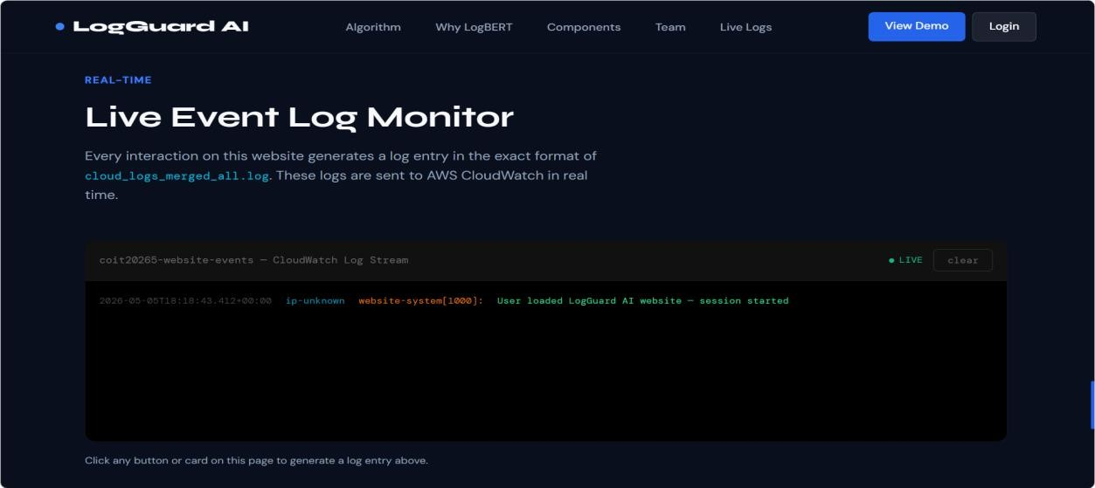

Figure 17: Website live event log monitor showing real-time user activity logs

7.4 Stage 3 - API Gateway and Lambda Log Receiver
The third stage used Amazon API Gateway and AWS Lambda to receive website logs. When the website generated a log entry, it sent the log as an HTTPS POST request to the API Gateway endpoint. API Gateway then triggered the Lambda function named logguard-s3-log-receiver.
This serverless design was selected for security and simplicity. The browser did not need direct AWS credentials, which reduced exposure risk. Instead, API Gateway acted as a controlled entry point, and Lambda handled the incoming log messages.
The Lambda function performed three main tasks. First, it received the incoming log payload from the website. Second, it handled CORS requirements so that the browser could send requests successfully. Third, it wrote the received log entries into Amazon CloudWatch using a consistent WEBSITE_LOG prefix.
This stage created a clear separation between the public website and the internal AWS logging environment. It also made the ingestion process easier to scale because API Gateway and Lambda are managed services.
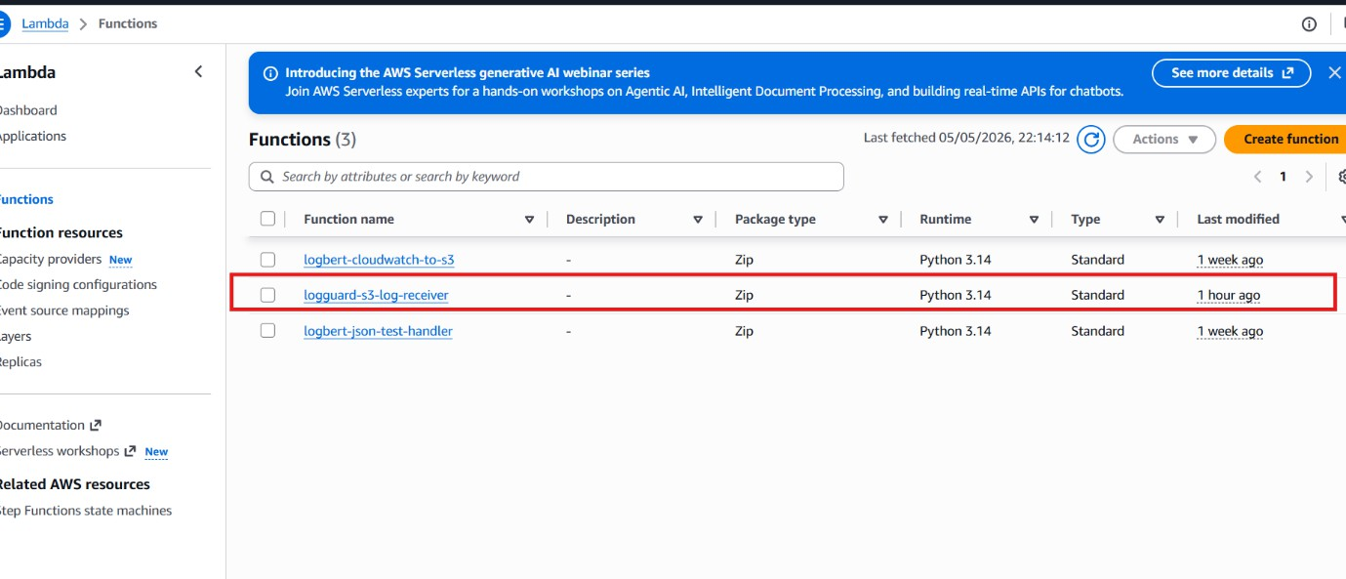
Figure 18: Lambda functions list showing the deployed log receiver function
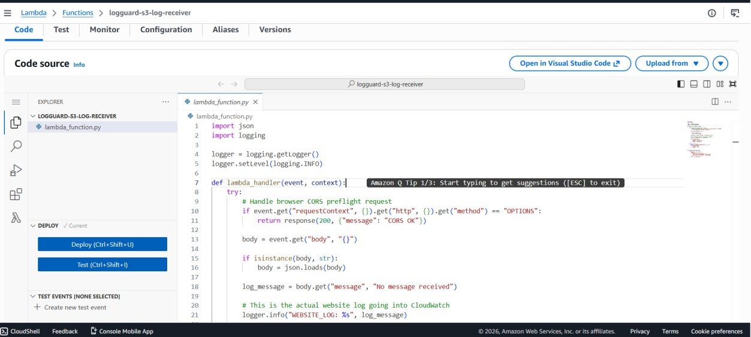

Figure 19: Lambda code editor showing the handler function receiving website logs and writing them to CloudWatch

7.5 Stage 4 - Website Logs Stored in CloudWatch
After the Lambda function received the log entries, they were stored in Amazon CloudWatch Logs. The main log group used for this stage was:
/aws/lambda/logguard-s3-log-receiver
This log group contained both standard Lambda execution records and custom website log entries. Standard Lambda records included START, END, and REPORT messages, while the custom logs used the WEBSITE_LOG prefix to distinguish them from normal Lambda runtime messages.
CloudWatch was used because it provides centralised log storage, monitoring, and inspection. During testing, the CloudWatch Live Tail feature allowed the team to confirm that website events were being received in real time. This provided evidence that the public website, API Gateway, Lambda receiver, and CloudWatch logging stages were connected successfully.
This stage was essential because CloudWatch acted as the central log collection point for the prototype. It allowed raw logs to be stored before being processed by the anomaly detection workflow.
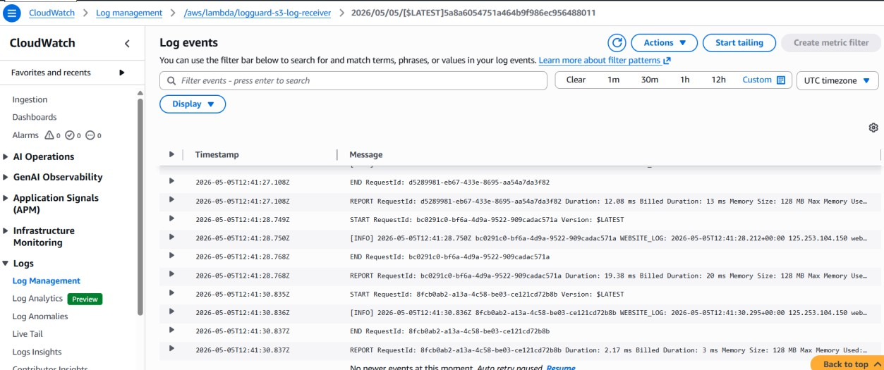
Figure 20: CloudWatch log events showing WEBSITE_LOG entries from website interactions

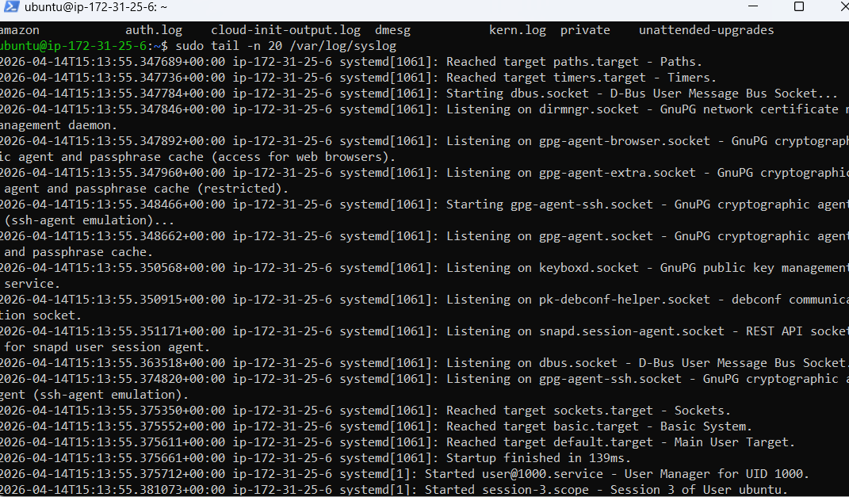

Figure 21: EC2 terminal showing raw system log inspection before model-based analysis

7.6 Stage 5 - EC2 LogBERT Processing Environment
The fifth stage involved processing logs using the LogBERT environment hosted on an AWS EC2 instance. The EC2 instance contained the main project directory:
/home/ubuntu/logbert_project
This directory included the required folders for the model, scripts, logs, and output files. The main folders included:
model/
logs/
output/
scripts/
The LogBERT processing workflow analysed logs in fixed-size windows. In this prototype, the checker processed windows of 10 log lines and generated an anomaly score for each window. This window-based approach was suitable because suspicious behaviour often appears as a sequence of events rather than a single isolated log entry.
The project also used a log generation script to create mixed normal and suspicious log events. This helped test the processing workflow and produce controlled evidence of anomaly scoring. The LogBERT checker then processed these logs and calculated anomaly scores based on how unusual the log window appeared compared with learned normal patterns.
At this stage, the EC2-based LogBERT workflow was implemented and tested using generated or test logs. Full automatic transfer of live CloudWatch website logs into EC2 LogBERT processing was identified as future improvement. This is an important distinction because the prototype demonstrated the main processing logic, but the complete live automation still requires additional integration work.

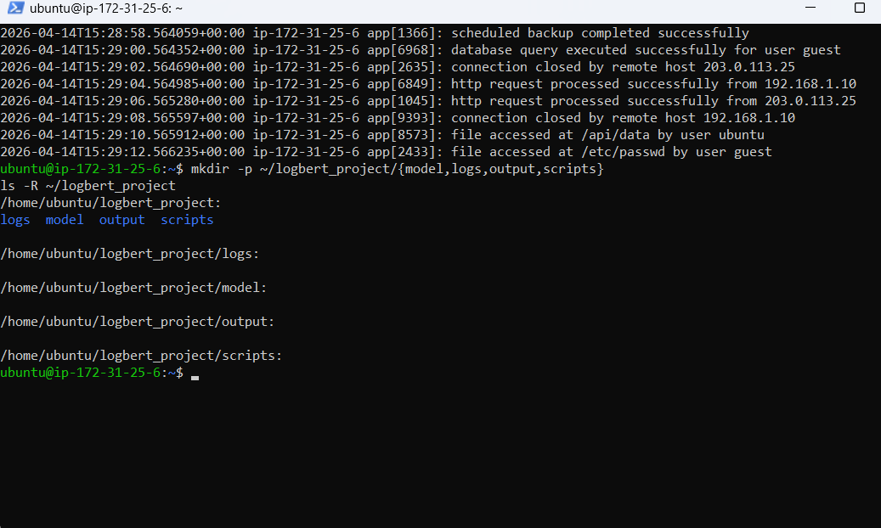
Figure 22: EC2 terminal showing the log generator script and generated log output

7.7 Stage 6 - LogBERT Anomaly Results as Structured JSON
After LogBERT processed a window of logs, the output was converted into a structured JSON alert. This format made the anomaly results easier to store, send, and display in the dashboard.
Each structured alert contained important fields such as:
Field | Description
model_source | Identifies the source model that generated the alert
window_id | Identifies the log window being analysed
start_line and end_line | Show the affected range of log lines
score | Represents the anomaly score generated by LogBERT
alert_level | Indicates the severity level, such as LOW, MEDIUM, HIGH, or CRITICAL
anomaly_type | Provides a category for the type of suspicious behaviour
reason | Explains why the log window was considered suspicious
sample_logs | Shows example log lines from the affected window
timestamp | Records when the alert was created

This structured format was useful because it allowed the same alert data to be reused by multiple parts of the system. The email alerting workflow could use the JSON fields to prepare a notification, while the Streamlit dashboard could use the same fields to generate charts and tables.
Example alert evidence showed LogBERT producing anomaly windows with scores around 11.5 to 11.8 and assigning categories such as service behaviour anomaly and authentication attack pattern. These outputs demonstrated that the model could convert log windows into structured anomaly records.
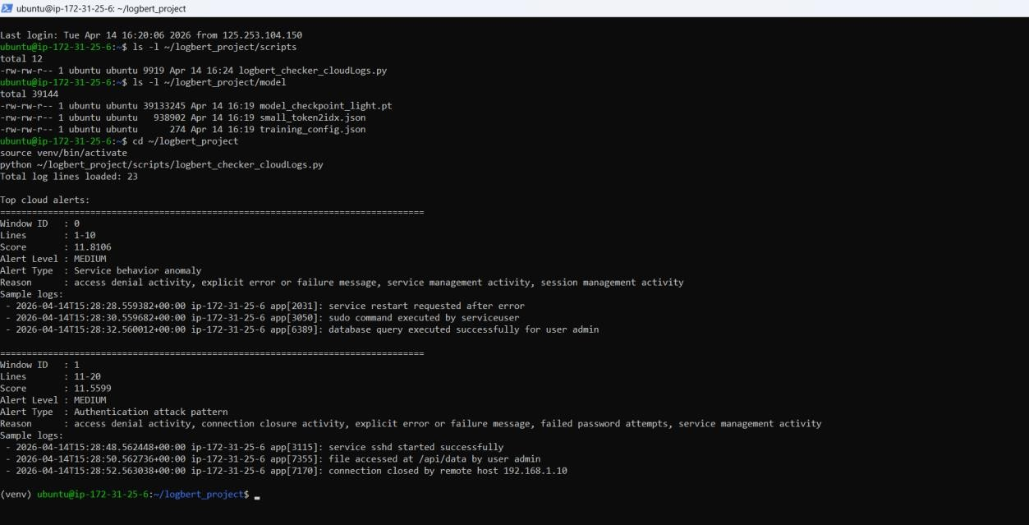
Figure 23: EC2 terminal showing LogBERT anomaly detection output with score, level, type, and affected log window

7.8 Stage 7 - SNS Email Alerting with OpenAI Recommendations
The seventh stage used Amazon SNS to send email alerts when anomaly scores exceeded the configured threshold. In this implementation, the alert threshold was set so that higher-scoring LogBERT windows triggered a notification.
The alerting workflow was handled by a Lambda function that received the structured JSON alert and prepared an email message. The email included the anomaly score, alert level, affected log lines, reason for the alert, sample logs, and response guidance. Amazon SNS then delivered the alert to the subscribed administrator email address.
This stage demonstrated how anomaly detection results can be converted into a practical notification for security review. Instead of requiring the administrator to manually inspect raw logs, the system provided a structured alert containing the most relevant details.
However, this alerting component should still be treated as part of a prototype. In a production environment, alerts would need to be connected to a formal incident response process, ticketing workflow, escalation policy, access control system, and audit trail.
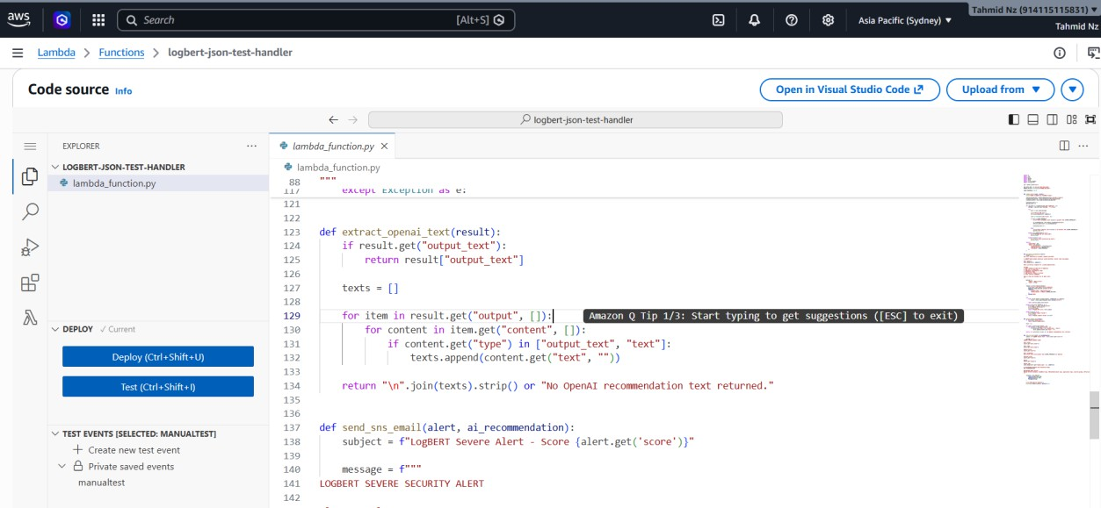
Figure 24: Lambda alerting function showing the alert message template and email preparation logic

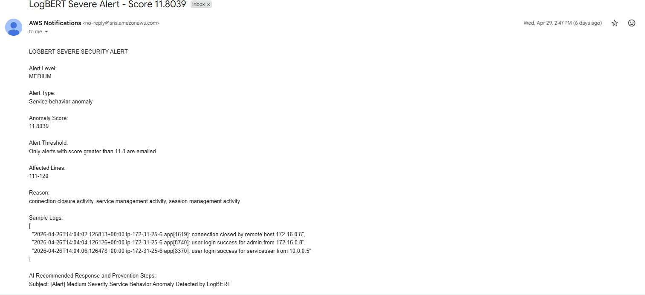
Figure 25: SNS email alert showing anomaly score, alert level, affected lines, reason, sample logs, and response guidance

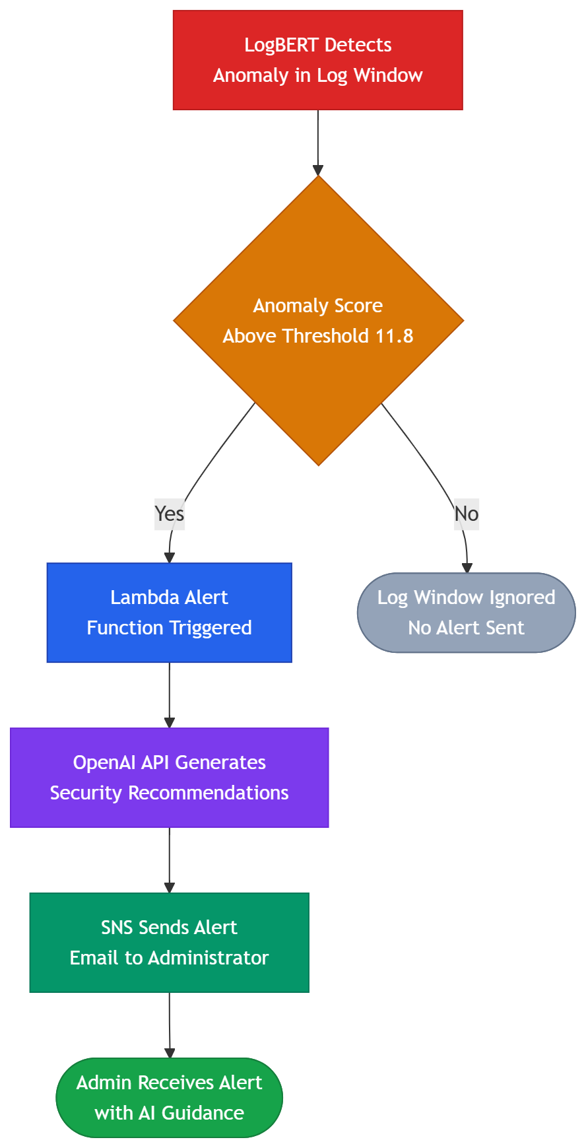
Figure 26: Alert generation flow from LogBERT detection to email delivery

7.9 Stage 8 - CloudWatch to S3 Storage
The eighth stage stored structured alert results in Amazon S3 so that they could be accessed by the dashboard. A Lambda function named logbert-cloudwatch-to-s3 was used for this purpose.
This function decoded CloudWatch log events, checked whether the message contained valid JSON, and saved each structured alert as a separate JSON file in the S3 bucket:
logbert-dashboard-alerts-914115115831
The files were organised by date using the following folder pattern:
logbert-alerts/year=YYYY/month=MM/day=DD/
This structure made the stored alerts easier to manage, filter, and retrieve. Non-JSON records were skipped automatically so that only structured alert data was saved for dashboard use.
Using S3 for alert storage was suitable for the prototype because it provided durable, low-cost storage and allowed the dashboard to retrieve alert files without needing a database. This design was simple but effective for demonstrating the complete storage and visualisation pipeline.

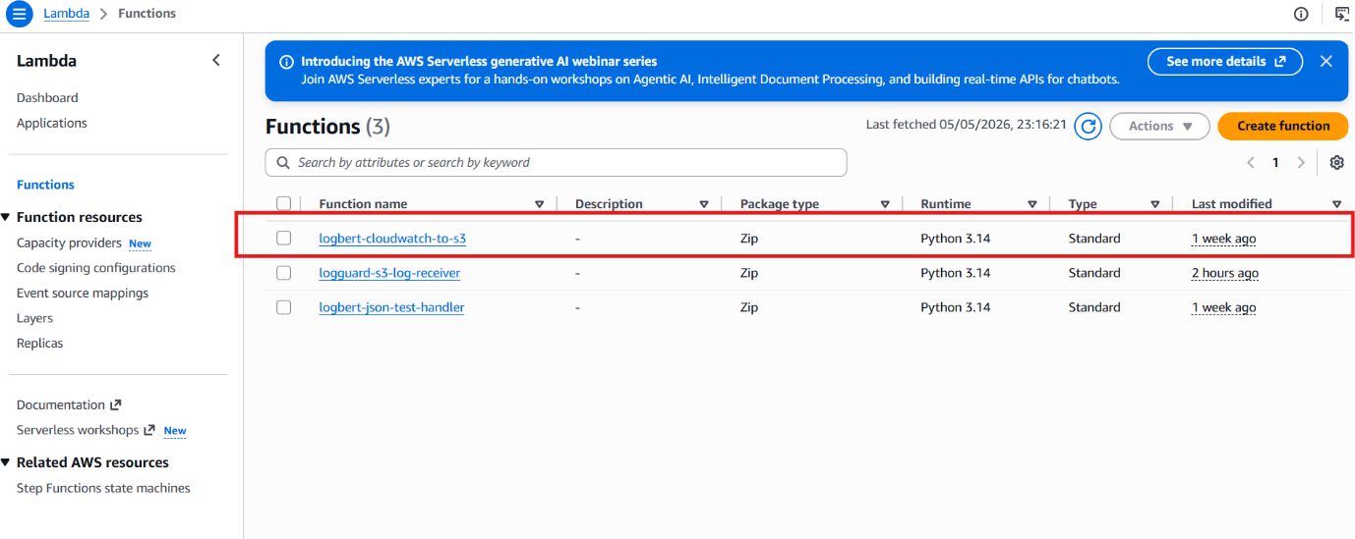
Figure 27: Lambda function list showing the CloudWatch-to-S3 function

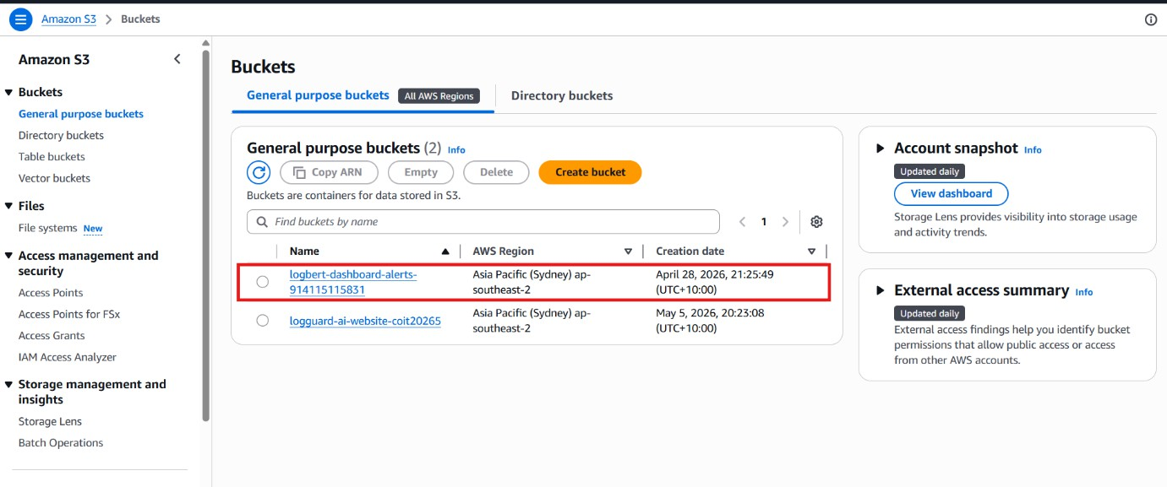
Figure 28: S3 bucket list showing the website bucket and alert storage bucket

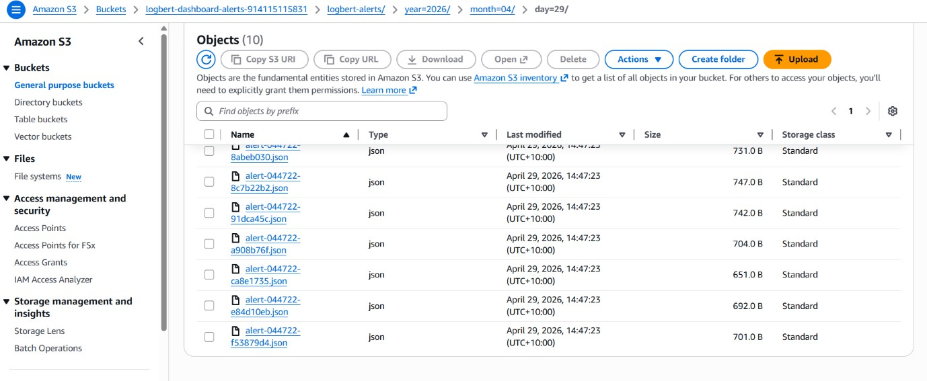
Figure 29: S3 folder showing stored JSON alert files organised by date

7.10 Stage 9 - Streamlit Dashboard
The final stage of the pipeline was the Streamlit dashboard. The dashboard retrieved structured JSON alert files from Amazon S3 and presented them in a visual format for administrator review.
The dashboard included KPI cards, severity summaries, charts, and a detailed alert table. The KPI cards showed values such as total alerts, critical alerts, high alerts, medium alerts, and anomaly rate. The severity distribution chart showed how alerts were spread across different severity levels. The score histogram showed the distribution of anomaly scores, while the detailed table allowed individual alert records to be reviewed.
The dashboard demonstrated how raw log activity could be transformed into usable security insights. Instead of only showing raw text logs, the dashboard organised the results into visual summaries that were easier to interpret.
In the prototype evidence, the dashboard loaded 20 LogBERT alert entries from S3. This confirmed that the alert storage and dashboard retrieval stages were functioning together. The dashboard therefore completed the end-to-end demonstration of the pipeline, from website interaction to structured alert visualisation.
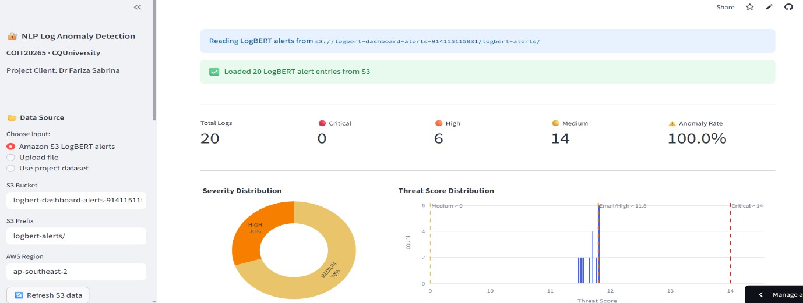

Figure 30: Streamlit dashboard showing KPI cards, severity distribution, anomaly score chart, and alert table

8. Website Development

8.1 Overview
The LogGuard prototype includes a single-page website developed using HTML5, CSS3, and vanilla JavaScript. The website was deployed using Amazon S3 static website hosting, which allowed the project to provide a public-facing interface without requiring a traditional web server.
The purpose of the website was twofold. First, it acted as a user-facing demonstration interface for presenting the project concept, models, system components, and team information. Second, it generated structured cybersecurity-style log data from user interactions. This allowed the website to function as the input layer of the cloud-based anomaly detection pipeline.
A professional dark theme was used to match the cybersecurity context of the project. The design used a combination of Syne and DM Sans fonts to create a modern technical appearance while keeping the interface readable. Interactive elements across the website were connected to JavaScript event handlers. When users clicked buttons, navigation links, model cards, or login controls, the website generated formatted log statements and sent them to the AWS ingestion pipeline.
This design helped demonstrate that the system was not limited to static or pre-existing datasets. Instead, the prototype could generate live interaction-based logs and pass them into the same cloud logging workflow used by the rest of the system.

8.2 Website Sections
The website was organised into several sections so that it could present the project clearly while also generating useful log events during user interaction.

Section | Content | Logged Event
Navigation Bar | Logo, links, View Demo, Login buttons | Each navigation click is recorded as a website interaction event
Hero Section | Main title, project description, and live log ticker | Page load events and button clicks are logged
Algorithms Used | Model cards for Random Forest, Isolation Forest, LogBERT, and LSTM | Clicking a model card logs the selected algorithm name
Why LogBERT | Explanation cards describing the reason for selecting LogBERT as the main model | Clicking a card logs the selected explanation topic
Components | Cards showing the main AWS and model pipeline components | Clicking a component card logs the selected component name
Team Section | Team member cards with role information | Clicking a team card logs the selected member name
Live Log Monitor | Real-time display of generated website events | All generated events are shown in the live event feed
Team Login | Username field, password field, and sign-in button | Login success and failure events are recorded

The live log monitor was included to make the website behaviour visible to users. As users interacted with the website, the generated log entries appeared in the monitor. This helped demonstrate how ordinary website activity could be converted into structured logs for cybersecurity monitoring.

8.3 Login Security Event Logging
The login section was designed to generate security-relevant events for the anomaly detection pipeline. Both successful and failed login attempts were recorded as structured log entries and sent through the AWS ingestion process.
Example login events included:
website-login[1001]: Successful login by user: mahin
website-login[1002]: Failed login attempt for user: admin
This feature was important because authentication activity is a common source of cybersecurity events. A single failed login attempt may not always be suspicious, but repeated failed attempts can indicate a possible brute-force login pattern. By logging repeated failed login attempts, the website created a practical demonstration scenario for the LogBERT-based anomaly detection workflow.
In the prototype, these events helped show how user actions from the website could produce realistic log patterns. These logs could then be stored, analysed, and converted into structured alerts. However, this login module was built for demonstration purposes only and was not intended to represent a production-grade authentication system.

9. Streamlit Dashboard

9.1 Dashboard Overview
The LogGuard dashboard was developed using Streamlit and Python. Its purpose was to visualise anomaly detection outputs in a clear and interactive format so that a security administrator could review alert trends, severity levels, anomaly scores, and detailed log evidence.
The dashboard was designed to retrieve structured LogBERT JSON alert files from Amazon S3. This made the dashboard part of the final output layer of the AWS cloud pipeline. Instead of requiring users to inspect raw JSON files or terminal outputs, the dashboard converted anomaly results into visual summaries and searchable tables.
The dashboard also included alternative data source options for testing and demonstration. These included S3-based LogBERT alerts, CSV upload mode, and a project data source mode. The S3 mode was the main integration mode because it connected directly to the AWS alert storage pipeline. The CSV upload mode was included as a flexible testing feature, allowing uploaded log files to be analysed through the dashboard interface.

9.2 Architecture and Features
The dashboard used a sidebar configuration panel that allowed users to define the S3 bucket, prefix, and AWS region. This meant the dashboard could retrieve updated alert files from S3 without changing the source code. A refresh option was also included so that newer alerts could be loaded when required.

The main dashboard features are summarised below.

Feature | Description
KPI Cards | Total logs, Critical / High / Medium alert counts, overall Anomaly Rate
Severity Distribution | Shows the proportion of alerts across severity levels such as Critical, High, Medium, and Low
Threat Score Histogram | Displays the distribution of LogBERT anomaly scores and supports threshold-based interpretation
Alert Details Table | Provides a sortable table containing window ID, score, alert level, alert type, reason, and sample logs
Time Series View | Shows alert scores over time to help identify trends or repeated suspicious activity
CSV Upload Mode | Allows users to upload a log CSV file for additional testing and analysis
S3 Refresh Button | Retrieves the latest available alert files from S3 without requiring a full application restart

These features made the dashboard useful for interpreting the results of the anomaly detection pipeline. The KPI cards provided a quick overview, while the charts helped identify patterns in the alerts. The detailed table allowed individual anomaly records to be reviewed more carefully.

9.3 Integration with Anomaly Algorithm
The primary dashboard workflow was based on LogBERT alert files stored in Amazon S3. After LogBERT processed log windows, the anomaly results were saved as structured JSON records. These records included key fields such as anomaly score, alert level, alert type, affected lines, reason, timestamp, and sample logs.
The dashboard retrieved these JSON files from S3 and converted them into visual outputs. This allowed the administrator to review the results without manually opening each alert file. The dashboard therefore completed the final stage of the pipeline by turning model outputs into readable security insights.
This integration was important because anomaly detection results are only useful if they can be interpreted by users. Raw scores alone do not provide enough context. By presenting scores, severity levels, reasons, and sample log lines together, the dashboard made the LogBERT outputs easier to understand and act upon.

9.4 CSV Upload and Algorithm Testing Mode
In addition to the S3 LogBERT alert mode, the dashboard also included a CSV upload mode. This feature allowed users to upload a CSV file containing log entries and run analysis through the dashboard interface.
In this mode, the dashboard called the analyze_batch() method from the anomaly_algorithm.py file. The uploaded logs were passed through the preprocessing workflow and analysed using the dashboard’s testing pipeline. This included text cleaning, keyword-based threat scoring, severity classification, and machine learning prediction using the Random Forest model.
This feature was useful for testing and demonstration because it allowed the team to analyse different log files without modifying the backend code. However, it should be understood as a supplementary testing mode, not the main LogBERT pipeline. The main anomaly detection workflow for the final prototype was based on LogBERT-generated JSON alerts retrieved from S3.

9. 5 Dashboard Role in the Prototype
The Streamlit dashboard played an important role in making the prototype understandable and presentable. Without the dashboard, the system outputs would mainly exist as raw logs, JSON files, and terminal messages. The dashboard converted these outputs into a visual format that could support security review and decision-making.
The dashboard also helped demonstrate the end-to-end value of the system. It showed that the prototype could move from website log generation, through cloud ingestion and processing, to final alert visualisation. This made the project more complete because it did not stop at model training; it also showed how detection results could be presented to a user.
At the same time, the dashboard should be viewed as part of a prototype for demonstration and practical learning. A real-world operational dashboard would require stronger authentication, role-based access control, audit logging, larger live datasets, production monitoring, and integration with incident response workflows.

10. Evaluation and Performance Analysis

10.1 Evaluation Methodology
The evaluation was conducted to compare the performance of the implemented anomaly detection models and to justify the final model selection. The models were evaluated in two separate groups because they follow different learning approaches and produce different types of outputs.
The first group consisted of the supervised models, namely Random Forest and Bidirectional LSTM. These models were trained using labelled normal and anomalous log records and were evaluated using binary classification metrics such as accuracy, precision, recall, F1-score, ROC-AUC, and false positive rate.
The second group consisted of the non-supervised models, namely Isolation Forest and LogBERT. Isolation Forest was used as an unsupervised anomaly detection baseline because it can identify unusual records without requiring labelled anomaly examples during training. LogBERT was used as a self-supervised sequence-based model because it learns normal log sequence behaviour and detects abnormal windows through reconstruction loss.
The final model implementation used the HDFS_v2 dataset because it provided enough log volume, clearer sequence structure, and more suitable benchmark-style log records for LogBERT. This made it more appropriate for model training and evaluation. HDFS_v2 was also used with the other classifiers where possible so that the models could be compared under more consistent data conditions.
The purpose of the evaluation was not only to identify which model achieved the highest numerical score, but also to determine which model was most suitable for the project’s cybersecurity anomaly detection objective. In this context, recall, precision, and model suitability were more important than accuracy alone.

Metric | Formula | Security Relevance
Accuracy | (TP + TN) / Total | Measures overall correct classification, but must be interpreted carefully when classes are imbalanced
Precision | TP / (TP + FP) | Measures how many predicted anomalies are actually anomalous; low precision creates unnecessary false alerts
Recall | TP / (TP + FN) | Measures how many real anomalies are detected; this is critical because missed anomalies may represent undetected threats
F1-Score | 2 × (Precision × Recall) / (Precision + Recall) | Balancing both precision and recall
ROC-AUC | Area under ROC curve | Measures how well the model separates normal and anomalous records
False Positive Rate | FP / (FP + TN) | Direct measure of analyst workload from false alarms

10.2 Supervised Model Comparison: Random Forest and Bidirectional LSTM
The supervised comparison included Random Forest and Bidirectional LSTM. Both models achieved very high results because they were trained and tested using labelled normal and anomaly data.

Metric | Random Forest | Bidirectional LSTM
Accuracy | 0.9972 | 0.9991
F1-Score | 0.9971 | 0.9987
Precision | 1.0000 | 0.9974
Recall | 0.9942 | 1.0000
ROC-AUC | 1.0000 | 0.9996
False Positive Rate | 0.0000 | 0.0014
Main Limitation | More affected by TF-IDF keyword dependency | Still dependent on labelled training data

Random Forest achieved an accuracy of 0.9972, precision of 1.0000, and F1-score of 0.9971. This shows that the model performed extremely well on the labelled test data. Its perfect precision means that it did not incorrectly classify normal records as anomalies in the test set. However, Random Forest used TF-IDF features, which means it may give strong importance to repeated suspicious words in the log text. For this reason, Random Forest was useful as a strong supervised baseline, but it was not selected as the final main model.
Bidirectional LSTM achieved the strongest supervised result, with an accuracy of 0.9991, recall of 1.0000, and F1-score of 0.9987. The recall score is especially important because it shows that the model detected all labelled anomalies in the test set. This is valuable in cybersecurity because a false negative may represent a missed threat.
Between the supervised models, Bidirectional LSTM performed slightly better overall because it achieved higher accuracy and perfect recall. However, both supervised models depend on labelled anomaly examples. This makes them strong for controlled evaluation but less ideal as the final direction for a cybersecurity system where new attack behaviours may appear before reliable labels are available.

10.3 Non-Supervised Model Comparison: Isolation Forest and LogBERT
The non-supervised comparison was more important for the final model decision because real cybersecurity environments often have limited labelled anomaly data. In practice, many suspicious behaviours are unknown in advance, and labelled examples of new attacks may not be available. Therefore, models that can learn normal behaviour and identify unusual patterns are more suitable for future development.

Evaluation Area | Isolation Forest | LogBERT
Learning Type | Unsupervised anomaly detection | Self-supervised log sequence modelling
Label Requirement | Does not require anomaly labels during training | Learns mainly from normal log sequences
Main Evaluation Score | Accuracy = 0.9612 | Average test reconstruction loss = 0.3874
Output Type | Anomaly score / anomaly prediction | Reconstruction loss / anomaly score
Context Awareness | Limited | Stronger sequence-context learning
Main Strength | Detects unusual records without labelled anomalies | Learns normal log sequence behaviour
Main Weakness | Low precision and high false-alert burden | Binary accuracy requires threshold tuning
Suitability as Main Model | Useful baseline | Selected as main model

LogBERT was more suitable because it learns the normal structure of log sequences rather than treating log entries as isolated feature points. Cybersecurity incidents often appear through a sequence of related events. For example, a single failed login may not be severe, but repeated failed logins followed by abnormal service behaviour may indicate a stronger threat pattern. LogBERT is better aligned with this type of detection because it analyses log windows and learns expected sequence behaviour.
In the final implementation, LogBERT achieved an average test reconstruction loss of 0.3874. This is not the same as binary accuracy, but it is the correct evaluation score for the current LogBERT approach. A lower reconstruction loss means the model successfully learned the normal log sequence structure. Once a threshold is applied, higher-loss windows can be classified as anomalies and evaluated using binary metrics such as accuracy, precision, recall, and F1-score.
Therefore, within the non-supervised models, LogBERT was selected as the stronger and more technically suitable model. Isolation Forest produced a useful accuracy score, but its low precision made it weaker for practical alerting. LogBERT was more meaningful for this project because it learned normal log behaviour and produced anomaly scores that could be used in the alerting and dashboard pipeline.

10.4 LogBERT Training and Test Loss Interpretation

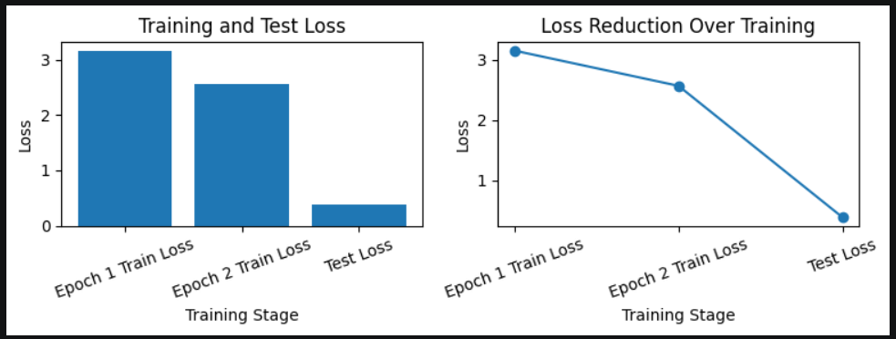
Figure 31: LogBERT training and test loss showing reconstruction-loss reduction across training stages

The LogBERT training and test loss results show that the model learned normal log sequence patterns successfully. In the first epoch, the training loss was approximately 3.1. By the second epoch, the training loss reduced to approximately 2.5. This downward movement shows that the model was improving during training and learning the expected structure of log sequences.
The final test loss was approximately 0.39, which is close to the recorded average test loss of 0.3874. This lower test reconstruction loss indicates that the trained LogBERT model was able to reconstruct expected log patterns with relatively low error. In the LogBERT approach, this is important because reconstruction loss is used as the anomaly signal. Normal or expected log sequences usually produce lower loss, while unusual or unexpected log sequences produce higher loss.
This result supports the decision to use LogBERT as the main model. Unlike Random Forest, which relies heavily on TF-IDF word features, LogBERT focuses on whether the sequence of log events fits the learned normal behaviour. This makes the LogBERT result more genuine for anomaly detection because it is based on sequence structure rather than only suspicious keywords.
However, LogBERT is currently reported using reconstruction loss rather than binary accuracy. This is appropriate for the current stage of implementation because LogBERT operates differently from the supervised classifiers. The next development step is to define and tune an anomaly threshold. After thresholding, LogBERT outputs can be converted into normal/anomaly predictions and evaluated using accuracy, precision, recall, F1-score, and false positive rate.

10. 5 Why Non-Supervised Models Are More Suitable for the Final Direction
Although the supervised models achieved higher binary classification scores, non-supervised models are more suitable for the long-term direction of this project. This is because real cybersecurity environments do not always have complete or reliable anomaly labels. New attacks may appear before labelled examples are available, and system behaviour can change over time.
Supervised models perform well when high-quality labels are available. However, they can become too dependent on the labels used during training. In this project, some labels were created using keyword-supported rules. This means that supervised models may partly learn the labelling pattern rather than deeper abnormal behaviour.
Non-supervised models reduce this dependency. Isolation Forest can detect unusual records without labelled anomalies, while LogBERT learns normal sequence behaviour using a self-supervised approach. This is closer to how real anomaly detection should work: the model should learn what normal behaviour looks like and identify unusual patterns that deviate from it.
For this reason, the final direction moved toward LogBERT. It provides a stronger foundation for detecting abnormal log behaviour because it learns from sequence structure rather than depending mainly on manually labelled anomaly examples.

10. 6 Why LogBERT Was Selected as the Main Model
LogBERT was selected as the main model because it was the strongest model among the non-supervised approaches and best matched the project objective.
First, LogBERT is more suitable for cybersecurity logs because it models logs as sequences. Logs are not just independent text records; they represent system behaviour over time. A sequence-based model can detect suspicious patterns that may not be obvious from a single log entry.
Second, LogBERT is less dependent on keyword-based labelling. Random Forest learns from TF-IDF word features, and Bidirectional LSTM still depends on labelled training examples. LogBERT learns normal log sequence patterns and uses reconstruction loss to identify unusual behaviour. This makes it more suitable for the project’s final goal.
Third, HDFS_v2 was a strong fit for LogBERT. It provided a large and structured dataset with enough log records for sequence-based training and testing. The dataset was detailed enough for the model to learn normal behaviour and identify abnormal patterns through reconstruction loss.
Fourth, LogBERT fits the AWS pipeline well. Its outputs can be converted into structured JSON alerts containing score, alert level, affected lines, anomaly type, reason, and sample logs. These alerts can then be used for email notification, S3 storage, and Streamlit dashboard visualisation.

Justification Area | LogBERT Advantage
Learning approach | Self-supervised learning from normal log sequences
Label dependency | Less dependent on manually labelled anomaly records
Sequence understanding | Learns relationships between log events across windows
Dataset suitability | HDFS_v2 provided enough volume and structure
Output usefulness | Produces anomaly scores suitable for structured alerts
Pipeline integration | Supports alerting, storage, and dashboard visualisation

Therefore, LogBERT was selected as the main model because it provided the most suitable foundation for sequence-based log anomaly detection. While the supervised models achieved higher binary classification scores, LogBERT was more aligned with the purpose of this project: detecting abnormal log behaviour by learning normal event patterns.

10. 7 Efficiency and Scalability Evaluation
The evaluation also considered efficiency and scalability because the project was not only focused on model accuracy. A practical anomaly detection pipeline must be able to process logs, store alerts, send notifications, and display results within a usable timeframe.

Component | Metric | Measured / Observed Value | Interpretation
Random Forest | Inference time per log entry | < 1 ms | Very fast and suitable for lightweight supervised classification
Bidirectional LSTM | Inference time per log entry | 2–5 ms | Efficient for small-batch sequence classification
LogBERT | Inference time per 10-log window | 8–15 seconds | Slower because it performs transformer-based sequence processing
EC2 Processing | Batch of 23 logs | ~30 seconds | Acceptable for prototype demonstration
Lambda Execution | Per invocation | 100–300 ms | Suitable for serverless log ingestion and alert handling
Lambda Memory | Allocated / used | 128 MB / ~45 MB | Memory usage remained within allocated limits
S3 Storage | Per JSON alert | ~700 bytes | Low-cost and efficient for structured alert storage
CloudWatch Ingestion | Website log ingestion | Successfully received logs | Suitable for prototype-level cloud log collection

Random Forest and Bidirectional LSTM were faster than LogBERT. However, speed was not the only selection factor. LogBERT was selected because its modelling approach was more suitable for sequence-based anomaly detection. The main efficiency limitation is that LogBERT was executed on a low-resource EC2 instance. Future versions could improve speed by using a larger EC2 instance, batch processing, queue-based scheduling, or GPU-supported processing.

Scalability Dimension | Current Prototype Capability | Scaling Path
Log Volume | Supports HDFS_v2 evaluation and generated website logs | Use CloudWatch and S3 for larger log volumes
Website Users | Static website hosted on S3 | Add CloudFront for larger public access
Log Ingestion | API Gateway and Lambda receive website logs | Increase Lambda concurrency and add throttling rules
Model Processing | Single EC2 instance runs LogBERT | Use larger EC2, queue-based processing, or GPU support
Alert Storage | JSON alerts stored in S3 | Partition alerts by date, source, and severity
Dashboard Access | Streamlit dashboard for demonstration | Add authentication, caching, and production hosting
Alert Delivery | SNS email notification | Add escalation rules and incident response workflow

The ingestion, storage, alerting, and dashboard layers are scalable because they are based on managed cloud services. The main scalability limitation is the LogBERT processing stage, which requires more computing power than the simpler models. This is expected because LogBERT performs deeper sequence-based analysis.

10. 8 Key Findings
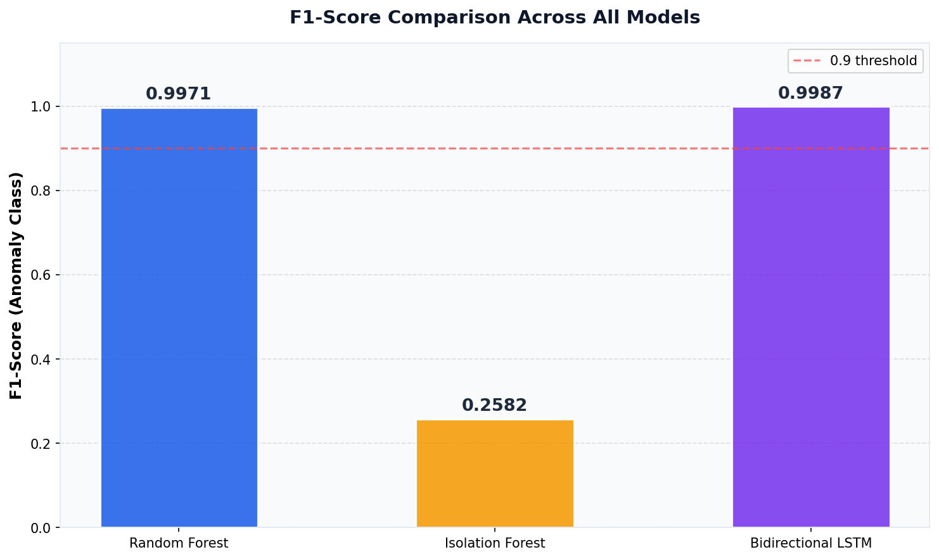
Figure 32: F1-Score comparison across Random Forest, Isolation Forest, and Bidirectional LSTM

Finding 1: Bidirectional LSTM was the strongest supervised model.
Bidirectional LSTM achieved the highest supervised accuracy of 0.9991 (F1 of 0.9987), compared with Random Forest accuracy of 0.9972 (F1 of 0.9971),. It also achieved recall of 1.0000, meaning it detected all labelled anomalies in the supervised test evaluation.

Finding 2: Random Forest was fast and accurate but more keyword-dependent.
Random Forest achieved precision of 1.0000. It was extremely fast and easy to interpret, but because it used TF-IDF features, it was more affected by keyword-related labelling limitations.

Finding 3: Isolation Forest was useful but not strong enough as the main model.
Isolation Forest achieved approximate accuracy of 0.9612 and recall of 0.9994, but its precision was only 0.1482 where as F1 score 0.2582. This means it captured many anomalies but also generated too many false alerts.

Finding 4: LogBERT was the strongest non-supervised model.
LogBERT achieved an average test reconstruction loss of 0.3874 and showed a clear reduction in training loss. This indicates that the model learned normal log sequence structure. It was selected as the best non-supervised model because it was more context-aware and more suitable for log sequence anomaly detection than Isolation Forest.

Finding 5: Non-supervised modelling is the better future direction.
Supervised models produced higher binary classification scores, but non-supervised models are more realistic for cybersecurity environments where labelled anomaly data may be incomplete. LogBERT was therefore selected as the strongest future-facing model.

11. Ethical and Professional Considerations

11.1 Data Privacy and Consent
The LogGuard AI system gathers visitors' real user interaction data with the project websites, such as the IP address and click behavior. This raises data privacy issues consistent with the Australian data privacy regime (Privacy Act 1988) and best practice data privacy principles:
- IP Address Collection: Real IP address of the visitors is collected from the API of ipify.org. IP addresses may be used to display a realistic log format, but are regarded as personal data under many privacy laws. In a production deployment, users would have to be informed via a privacy notice. This prototype has a prominently printed disclaimer in the Live Log Monitor section of the website, which notifies users that interactions are recorded in AWS CloudWatch.
- Data Minimisation: Only the data collected is relevant to the demonstration of the log format - Timestamp, IP address, website component that was clicked, and action description. All visitors of the website are anonymous, and no personal data (such as names, e-mail addresses, etc.) is collected.
- Data retention: Data is retained by default for as long as required with CloudWatch. To comply with the principle of data minimisation, a production system would have a retention policy (30 days automatic deletion).
- Explicit consent to collect was not obtained for a prototype demonstration system within an academic environment. If the IP logging function is to be used in a production deployment, a privacy notice must be provided and, if necessary under the law, explicit consent from the user must be obtained prior to the start of the IP logging function.

11.2 Security Responsibilities
The system handles cybersecurity log data and deploys cloud infrastructure, creating responsibilities around security practice:
- Access Control: IAM users were added to each team member (Tahmid, Mahin, Yeakub, Nafisa) with the appropriate permissions - CloudWatch read-only access for data analysts, full EC2 and Lambda access for the cloud engineer. No credentials for the root account were given out.
- Credential Management: AWS credentials are set using aws configure on EC2, instead of hard-coding them into source code. There are no credentials included in the codebase or report.
- API Key Handling: The OpenAI API key used for the alert suggestions is stored in a Lambda setting variable and not in the code or version control.
- System Type: It is assumed that the system is an academic prototype. Security hardening needs for production deployment, such as VPC configuration, encryption at rest, WAF rules, and penetration testing,g are being accepted as being outside the scope of the prototype.

11.3 AI Usage Transparency
This project has two applications of AI that necessitate transparency:
- Lambda function OpenAI in Production System: The logbert-json-test-handler lambda is used to call the OpenAI GPT API to generate some recommendations for responding to security events included in alert emails. AI recommendations do not always mean that the AI is the one to keep you safe – AI doesn't guarantee any recommendations, and any recommendations it gives are not backed by a qualified security staff member before they are followed.
- AI Collaboration (Report Writing): Reports were written using AI tools, which were used to support the content; drafting, refining, ng and evaluation of content was done with the support of AI tools and was consistent with the CQUniversity AI Assessment Scale. All the output produced by the AI was critically reviewed and edited by members of the team to ensure accuracy, technical correctness, ess and faithfulness to the actual implementation of the project.

11.4 Intellectual Property Considerations
The system relies on one or more third-party resources that have obligations of intellectual property rights:
- The datasets used in the HDFS, OpenSSH, and Linux benchmarks are subjected to research fair use with the LogHub dataset (He et al. 2020). The data has been made available for public use for academic research and has been properly referenced in this report.
- Open Source Libraries: These are used under each of their respective open source licences (BSD, MIT, Apache 2.0): scikit-learn, PyTorch, TensorFlow, Keras, Streamlit, pandas. It does not breach any licence requirements of this academic deployment.
- The services offered by AWS are subject to the existing commercial terms. There are no proprietary, AWS intellectual property elements in the project codebase.
- Implementation of the LogBERT model architecture: The LogBERT model architecture is implemented based on the published method of Guo et al. (2021). Proprietary model weights or pre-trained models were not used without permission.

11.5 Societal and Organisational Impact
The impact of society and/or organisation on NLP-based anomaly detection systems has been thoroughly considered during the design stage, regarding the impact of their use in society and organisation:
- Security Improvement – Positive Impact: Automated anomaly detection also helps to ensure that security incidents can be responded to faster, preventing major data breaches to individuals and organisations. A system that had the ability to correctly identify all true threats (Recall = 1.0000) and almost zero false alarms (FPR = 0.0014) could do a lot to relieve security analysts.
- Skewed Training Dataset - Algorithmic Bias: When the model is trained on a dataset that is skewed towards certain types of attacks and/or networks, it may not perform well on other scenarios. This is particularly important for the approach of labelling using keywords, because there can be cultural or language biases associated with what is considered "suspicious" language.
- Risk – Over-Reliance on Automation: Security teams might be tempted to fully automate response as a result of AI detection without human intervention. The system is not a stand-alone response system but is more of a decision support system. All alert emails contain AI-generated guidance that is marked as "Recommendations" that require human judgment.
- Professional Standards: The project is carried out under the Australian Computer Society (ACS) Code of Ethics - Practitioners must be competent, act with honesty, a nd consider the public interest. An explicit statement of limitations of data leakage instead of a demonstration of false data is an example of this promise of honest professional practice.

12. Project Management Integration

12.1 Team Structure and Coordination
Team Member | Role | Key Responsibilities | Tools Used
Tahmid | Project Manager | Sprint planning, stakeholder updates, report writing, milestone tracking, risk management | Jira Kanban, Microsoft Teams, MS Word
Mahin | Cloud Engineer | AWS infrastructure setup, website development, LSTM training, Streamlit deployment, Lambda functions | AWS Console, VS Code, Python, SSH/SCP
Nafisa Sultana | Software Engineer | System integration, component architecture, API design, documentation | VS Code, AWS Console, Python
Yeakub | Data Analyst / NLP Dev | Dataset collection, preprocessing, Random Forest training, visualisations, LogBERT evaluation | Jupyter Notebook, Python, pandas, scikit-learn

12.2 Work Breakdown Structure Summary
The project was organised into three phases with the following key work packages:

Phase | Weeks | Work Package | Owner | Status
Phase 1 - Research & Planning | 1–2 | Project proposal, WBS, Gantt chart, literature review | All | Complete
Phase 1 - Research & Planning | 1–2 | Dataset identification and collection strategy | Yeakub | Complete
Phase 2 - Development | 3–4 | AWS infrastructure setup (EC2, S3, Lambda, SNS, CloudWatch) | Mahin | Complete
Phase 2 - Development | 3–4 | Data preprocessing pipeline and feature engineering | Yeakub | Complete
Phase 2 - Development | 4–5 | Random Forest and Isolation Forest training | Yeakub | Complete
Phase 2 - Development | 5–6 | LogBERT pre-training on EC2 | Mahin | Complete
Phase 2 - Development | 5–6 | Bidirectional LSTM training and evaluation | Mahin | Complete
Phase 2 - Development | 6 | Website development with CloudWatch logging | Mahin | Complete
Phase 2 - Development | 6–7 | Streamlit dashboard deployment | Mahin | Complete
Phase 3 - Evaluation | 7–8 | Performance evaluation and comparison | Yeakub & Mahin | Complete
Phase 3 - Evaluation | 8 | Final report writing and submission | All | Complete

12.3 Risk Register
Risk | Likelihood | Impact | Mitigation | Status
AWS account deactivation | Medium | High - lose all infrastructure | Maintain credentials backup; document all configurations | Occurred - migrated to new account
Data leakage in labels | High | Medium - inflated metrics | Acknowledge explicitly; plan label-independent evaluation | Documented as Limitation 1
LogBERT evaluation incomplete | Medium | Medium - incomplete comparison | Separate LogBERT table; plan threshold implementation | Documented
EC2-CloudWatch live pipeline | Medium | Low - prototype still functional | Document as pending future work; demonstrate with generated logs | Documented
Team member unavailability | Low | Medium - missed deliverables | Cross-training; shared documentation | No incidents
Dataset copyright issues | Low | High - cannot submit | Use publicly available LogHub datasets; cite properly | Mitigated

12.4 Change Management
Two significant scope changes occurred during the project and were managed through the following process:

Change | Trigger | Impact | Decision | Outcome
AWS Account Migration | Original account deactivated mid-project | High - required full infrastructure re-setup in new account | Migrate all services to new account; adopt API Gateway for more professional log ingestion design | Successfully migrated; new architecture is more production-realistic
LogBERT Evaluation Scope | Technical complexity of threshold selection | Medium - LogBERT cannot be directly compared to RF and BiLSTM | Present LogBERT through reconstruction loss; document binary evaluation as future work | Transparent limitation identified; not misrepresented in comparison tables

12.5 Quality Assurance
- All algorithms written in Python (anomaly_algorithm.py, dashboard.py, Lambda functions) have been peer-reviewed with at least one other team member before deployment.
- End-to-End Testing: All nine stages of the pipeline were tested from the website click to the CloudWatch log to ensure all stages were individually working.
- Evaluation Integrity: Test set has not been used for training and/or preprocessing. Random Forest was cross-validated five times for stability.
- Report Review: Report sectionwere checkeded against the assessment criteria checklist before submission to show all six assessment criteria were covered.
- There was no use of placeholders or fake screenshots - all screenshots shown in the report are real.

12.6 Individual Contributions
Team Member | Role | Contribution % | Technical Artefacts Led | Documentation Sections
Tahmid | Project Manager | 25% | Project plan, WBS, Gantt chart, risk register, stakeholder communication | Sections 1, 11, 12, 15: Conclusion, References
Mahin | Cloud Engineer | 35% | AWS infrastructure, Lambda functions, EC2 setup, website (index.html), Streamlit dashboard, Bidirectional LSTM, SNS alerts | Sections 3, 7, 8, 9: Architecture, AWS Pipeline, Website, Dashboard
Nafisa Sultana | Software Engineer | 20% | System integration design, API architecture documentation, component connections | Sections 3.1, 3.3: Architecture diagrams, Technology Stack
Yeakub | Data Analyst | 20% | Dataset (full_dataset_final.csv), preprocessing pipeline, Random Forest & Isolation Forest, evaluation charts, LogBERT notebook | Sections 4, 5, 6.1, 6.2, 6.3, 10: Dataset, Preprocessing, Algorithms, Evaluation

Note: Individual contribution percentages are estimates based on who owns the task and who does the work. Some evidence of individual contribution: AWS CloudWatch logs showing the deployments performed by Mahin, Jupyter Notebooks showing the commit times, and Kanban, which shows tasks completed. Setting up Ga GitHubrepository is identified as an improvement for future use of version-controlled evidence.

13. Delivered Technical Artefacts
All technical artefacts delivered as part of the LogGuard AI project are listed below, including the evidence of completion and description:

Artefact | Owner | Type | Description | Evidence
full_dataset_final.csv | Yeakub | Dataset | 7,254 multi-source cybersecurity logs with labels and source tags | File exists in project directory; used for all model training
anomaly_algorithm.py | Mahin | Python Script | Four-layer detection pipeline: clean_log → score_threat → get_severity → ML predict | Deployed in Lambda; integrated with dashboard
rf_model.pkl + tfidf_vectorizer.pkl | Yeakub | ML Model Files | Trained Random Forest model and TF-IDF vectoriser (F1=0.9971) | Loaded by anomaly_algorithm.py at runtime
LSTM model + weights | Mahin | Deep Learning Model | Bidirectional LSTM trained for 10 epochs (F1=0.9987, Recall=1.0000) | Training notebook with loss curves; Keras model files
LogBERT model checkpoint | Mahin | Self-Supervised Model | BERT pre-trained on log key sequences (Avg Test Loss=0.3874) | EC2: /home/ubuntu/logbert_project/model/
index.html (website) | Mahin | Web Application | Single-page LogGuard AI website with real-time CloudWatch logging (44.2 KB) | Live at S3 static website endpoint; CloudWatch logs confirm real traffic
dashboard.py | Mahin | Python/Streamlit App | Interactive anomaly detection dashboard connecting to S3 alerts | Live at EC2:8501; loads 20 alerts from S3
logguard-s3-log-receiver | Mahin | AWS Lambda | Log ingestion function - receives website logs, writes to CloudWatch | Lambda console screenshot; CloudWatch entries confirm operation
logbert-json-test-handler | Mahin | AWS Lambda | Anomaly alerting function - SNS email with OpenAI recommendations | Lambda code screenshot; email alert received (Score 11.8039)
logbert-cloudwatch-to-s3 | Mahin | AWS Lambda | CloudWatch-to-S3 pipeline - moves JSON alerts to dashboard bucket | Lambda console; 10 JSON files confirmed in S3
logguard-ai-website-coit20265 | Mahin | AWS S3 Bucket | Static website hosting bucket (ap-southeast-2) | S3 console screenshot; website publicly accessible
logbert-dashboard-alerts-914115115831 | Mahin | AWS S3 Bucket | Dashboard alert storage (ap-southeast-2, date-based prefix) | S3 console showing 10 stored JSON alert files
generate_custom_logs.py | Mahin | Python Script | Log generator creating normal and suspicious EC2 events for LogBERT testing | EC2 terminal screenshot showing generated logs
logbert_checker_cloudlogs.py | Mahin | Python Script | LogBERT inference script processing log windows and outputting JSON alerts | EC2 terminal showing structured alert output
WBS + Gantt Chart | Tahmid | Project Document | Work Breakdown Structure and project schedule (submitted Assessment 1A) | Moodle submission confirmation
Data Preprocessing Report | Tahmid & Yeakub | Project Document | Detailed preprocessing methodology documentation | Submitted as separate assessment deliverable
A3 Project Poster | All | Poster | Visual project summary for poster presentation | [To be submitted alongside this report]
Demo Video | All | Video | Demonstration of working prototype - website, CloudWatch, dashboard | Video

14. Limitations and Future Work

14.1 Current Limitations

Limitation 1 - Data Leakage from Keyword-Based Labelling
The highest weight TF-IDF features for training the Random Forest are also the anomalies with the following annotations: failed, invalid, error, and ended. That will entail that the algorithm that is being learned for the labelling is the rules' performance, not the real anomalies, and can result in a false sense of performance. Future work should use existing benchmark labels in LogHub (He et al. 2020) to ensure reliable evaluation results.

Limitation 2 - LogBERT Binary Classification Evaluation Incomplete
The only measure of evaluation for LogBERT is reconstruction loss. However, for obtaining F1, Precision, Recall, and ROC-AUC values similar to those of the RF and BiLSTM, full evaluation is required, which can be achieved by using the anomaly score thresholding. This is the biggest model improvement that is desired for the next development cycle.

Limitation 3 - Live CloudWatch-to-EC2 Pipeline Pending
Both the first four stages (Stages 1–4) and the last five stages (Stages 5–9) are working independently. This automated connection is not available yet, where live CloudWatch logs from the website are directly pushed to EC2 LogBERT processing. Currently, the EC2 LogBERT can handle test logs generated by EC2. So the system is not an end-to-end live system, but rather the major elements of the pipeline.

Limitation 4 - Small and Single-Environment Dataset
The 7254 log entries are multi-source, but a relatively small dataset for deep learning. All cloud logs were taken from one EC2 instance and may not reflect the range of the actual enterprise cloud environment. Generalization claims could be reinforced with a wider collection of datasets in multiple cloud providers and environments.

Limitation 5 - No GitHub Version Control
There is no place to manage version-controlled code for the project on GitHub. This reduces tracing the individual contributions and increases the difficulty of independent replication. The creation of a repository is seen as an 'immediate improvement'.

14.2 Future Work

Priority 1 - Complete Live CloudWatch-to-EC2 Connection
The automated, 9-stage pipeline is complete, with CloudWatch Logs polling on EC,2, which automatically ingests new log entries from the website pipeline and automatically pushes them into LogBERT analysis, near-real-time.

Priority 2 - LogBERT Binary Classification Output
Run LogBERT using anomaly score thresholding to obtain binary predictions; Also, use a confusion matrix and classification metrics to directly compare with RF and BiLSTM on the same test set.

Priority 3 - NIST Framework-Based Alert Recommendations
Organize recommendations generated by OpenAI into the NIST Cybersecurity Framework (NIST 2018) – Identify, Protect, Detect, Respond, Recover – to offer structured guidance that is consistent with industry-standard security operations practices.

Priority 4 - GitHub Repository and CI/CD
Create a GitHub repository with all the code for the project, enable branch protection, and automated testing on GitHub actions to aid in reproducible experiments and to trace individual contributions.

15. Conclusion
This report will detail the complete development of LogGuard AI, which is a prototype system using NLP (Natural Language Processing) to detect anomalies in cybersecurity logging systems, as a capstone project of COIT20265. All three deliverables outlined by project client Dr Fariza Sabrina were taken care of – an extensive NLP literature review, a functional prototype, and an in-depth performance evaluation.
The prototype uses a 9-stage AWS cloud pipeline beginning with S3 website hosting, followed by API Gateway, Lambda, CloudWatch, EC2-based LogBERT processing, email alerts through SNS with suggestions from OpenAI, S3 to store alerts, and a Streamlit-based dashboard. Each phase is separately tested and proven to be operational. The end-to-end prototype showcases all of the key components of a log anomaly detection system, and the automatic transfer from live logs to CloudWatch to EC2 logBERT processing is a future work item, and mentioned as such in order to not to claim fullness of the system.
The Bidirectional LSTM was better than all the other models, achieving a Recall of 1.0000 (correct detection of all the anomalous log entries in the test set) and an F1-Score of 0.9987. The baseline model from the Random Forest model achieved an F1 value of 0.9971 and an ROC-AUC value of 1.0000. The average test loss of LogBERT was 0.3874, which showed meaningful learning of log key patterns. These results are given with the clear assumption that data labelling by keywords leads to data leakage and are meant to be a good indication of the generalization potential in real-world data, but not definitive proof. This is an honest appraisal, demonstrating professional integrity and academic honesty.
Apart from the technical aspects of the project, the principles of project management and how they can be applied in practice were demonstrated: Structured Kanban task management, risk identification and mitigation (AWS account migration), systematic quality assurance. The inclusion of ethical issues (data privacy, transparency of AI’s use, intellectual property, and societal impact) clearly illustrates professional maturity at the capstone level and fulfills Criterion 4 of the assessment for COIT20265.
The work in the project is both novel and original in several ways: A live website connected to the cloud that generates real-time cybersecurity logs for analysis by the NLP models; Four NLP models covering supervised, unsupervised, and self-supervised approaches; a full deployment architecture for AWS, which serves as a blueprint for any production-grade log anomaly detection system. The plans, like completing the live pipeline connection, implementing LogBERT binary evaluation, and including NIST framework-based recommendations, provide clear blueprints for the future of the security monitoring tool LogGuard AI.

16. References
Amazon Web Services 2024a, Amazon CloudWatch user guide, AWS Documentation, viewed 5 May 2026,
https://docs.aws.amazon.com/AmazonCloudWatch/latest/monitoring/WhatIsCloudWatch.html
Amazon Web Services 2024b, AWS Lambda developer guide, AWS Documentation, viewed 5 May 2026, <https://docs.aws.amazon.com/lambda/latest/dg/welcome.html>.

Amazon Web Services 2024c, Amazon Simple Notification Service developer guide, AWS Documentation, viewed 5 May 2026,
<https://docs.aws.amazon.com/sns/latest/dg/welcome.html>.

Amazon Web Services 2024d, Amazon S3 user guide, AWS Documentation, viewed 5 May 2026, <https://docs.aws.amazon.com/AmazonS3/latest/userguide/Welcome.html>.

Amazon Web Services 2024e, Amazon API Gateway developer guide, AWS Documentation, viewed 5 May 2026,
<https://docs.aws.amazon.com/apigateway/latest/developerguide/welcome.html>.

Australian Computer Society 2023, ACS code of ethics, ACS, viewed 5 May 2026, <https://www.acs.org.au/professional-development/acs-code-of-ethics.html>.

Breiman, L 2001, 'Random forests', Machine Learning, vol. 45, no. 1, pp. 5–32.

Chen, X, Zhang, Y & Wang, Z 2021, 'An intelligent log anomaly detection approach based on deep learning for industrial internet of things', IEEE Transactions on Industrial Informatics, vol. 17, no. 7, pp. 4753–4762.

Devlin, J, Chang, M, Lee, K & Toutanova, K 2019, 'BERT: pre-training of deep bidirectional transformers for language understanding', Proceedings of the 2019 Conference of the North American Chapter of the ACL, Association for Computational Linguistics, Minneapolis, pp. 4171–4186.

Du, M, Li, F, Zheng, G & Srikumar, V 2017, 'DeepLog: anomaly detection and diagnosis from system logs through deep learning', Proceedings of the 2017 ACM SIGSAC Conference on Computer and Communications Security, ACM, New York, pp. 1285–1298.

Guo, H, Yuan, S & Wu, X 2021, 'LogBERT: log anomaly detection via BERT', Proceedings of the 2021 International Joint Conference on Neural Networks, IEEE, pp. 1–8.

He, S, Zhu, J, He, P & Lyu, M 2020, 'Loghub: a large collection of system log datasets towards automated log analytics', arXiv preprint arXiv:2008.06448, viewed 5 May 2026, <https://github.com/logpai/loghub>.

Hochreiter, S & Schmidhuber, J 1997, 'Long short-term memory', Neural Computation, vol. 9, no. 8, pp. 1735–1780.

Liu, F, Ting, K & Zhou, Z 2008, 'Isolation forest', Proceedings of the 8th IEEE International Conference on Data Mining, IEEE, Washington DC, pp. 413–422.

NIST 2018, Framework for improving critical infrastructure cybersecurity, version 1.1, National Institute of Standards and Technology, Gaithersburg, MD, viewed 5 May 2026, <https://www.nist.gov/cyberframework>.

Office of the Australian Information Commissioner 2023, Privacy Act 1988, OAIC, viewed 5 May 2026, <https://www.oaic.gov.au/privacy/the-privacy-act>.

Pedregosa, F, Varoquaux, G, Gramfort, A, Michel, V, Thirion, B, Grisel, O & Duchesnay, E 2011, 'Scikit-learn: machine learning in Python', Journal of Machine Learning Research, vol. 12, pp. 2825–2830.

Salton, G & Buckley, C 1988, 'Term-weighting approaches in automatic text retrieval', Information Processing and Management, vol. 24, no. 5, pp. 513–523.

Streamlit Inc. 2024, Streamlit documentation, viewed 5 May 2026, <https://docs.streamlit.io>.

17. Appendices

17.1 Random Forest
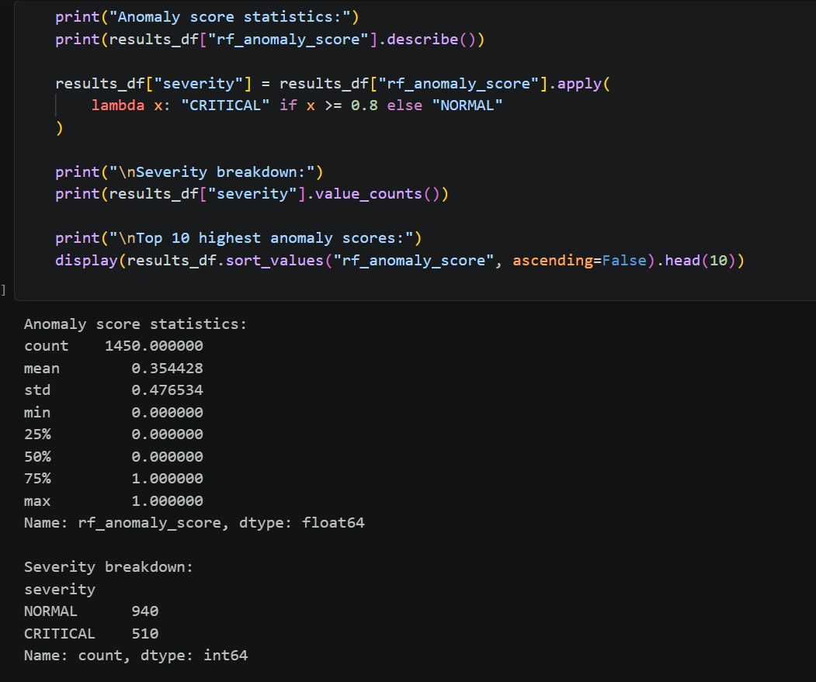

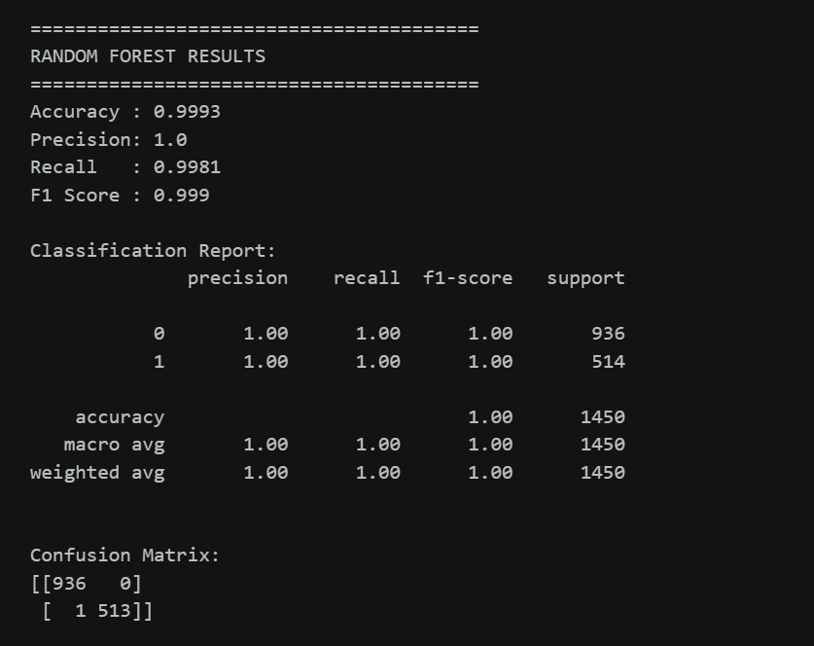
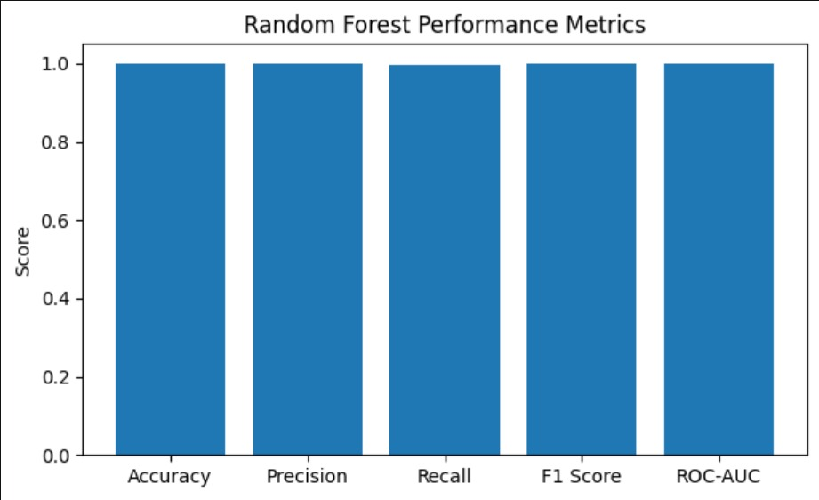

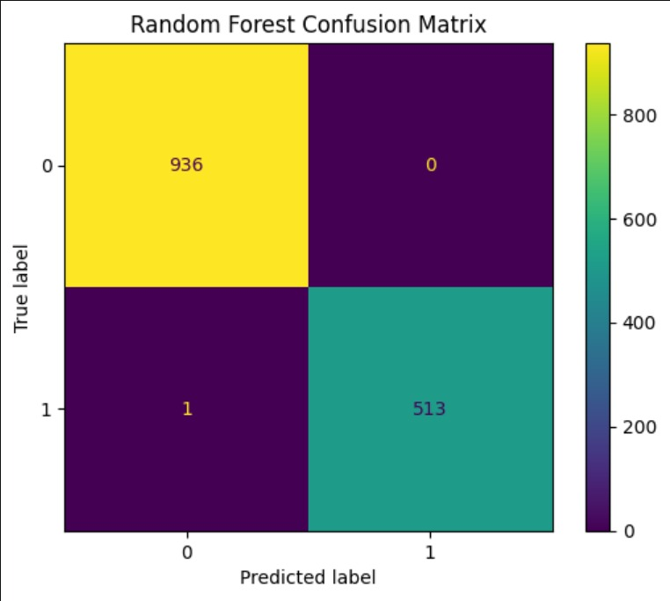
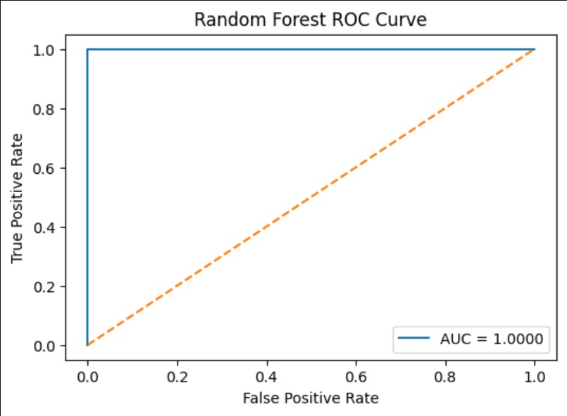

17.2 Isolation Forest
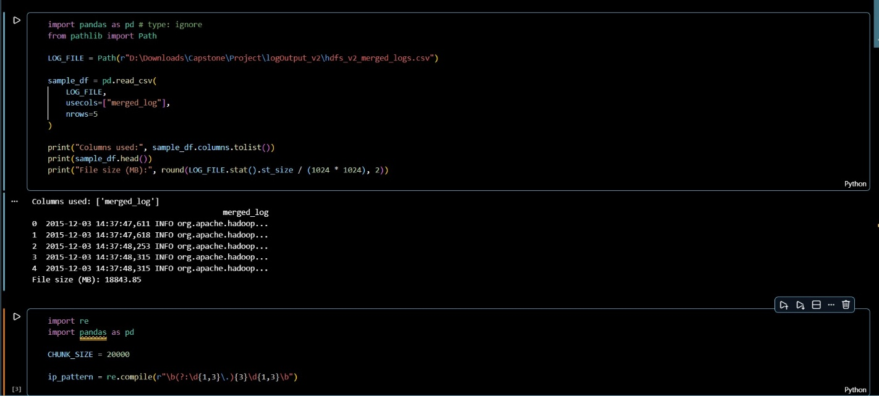
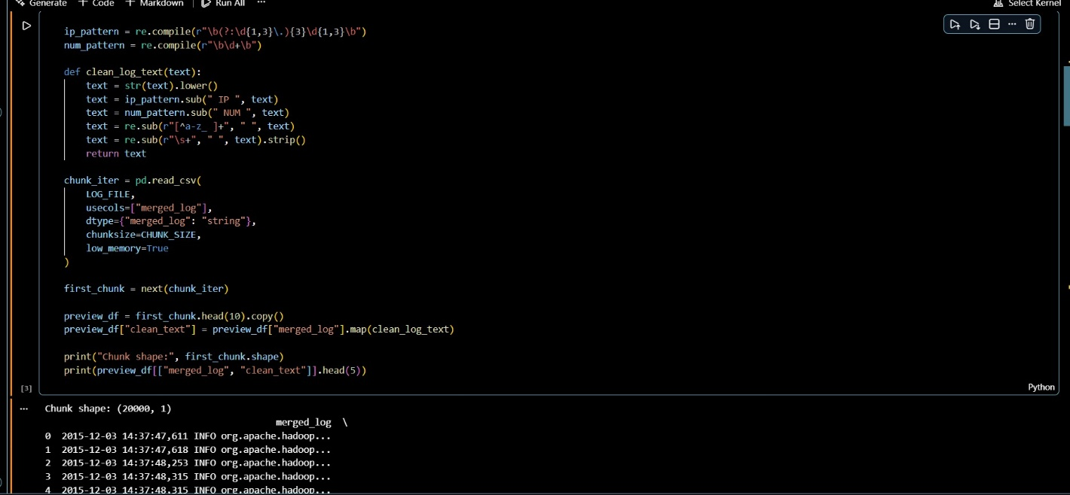

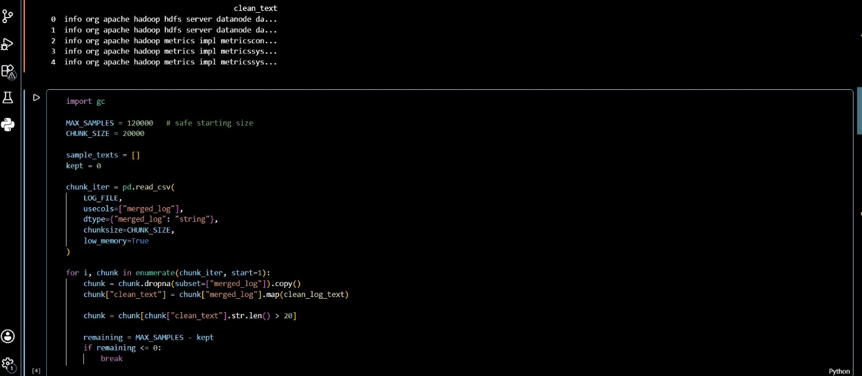

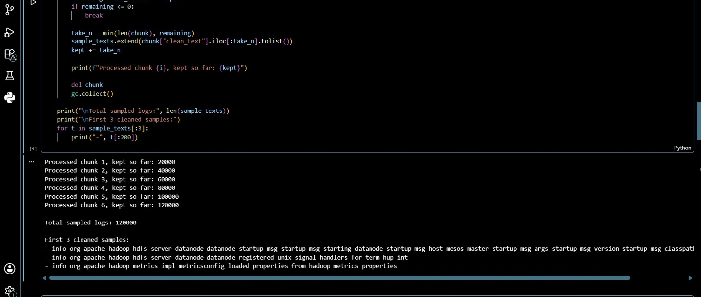

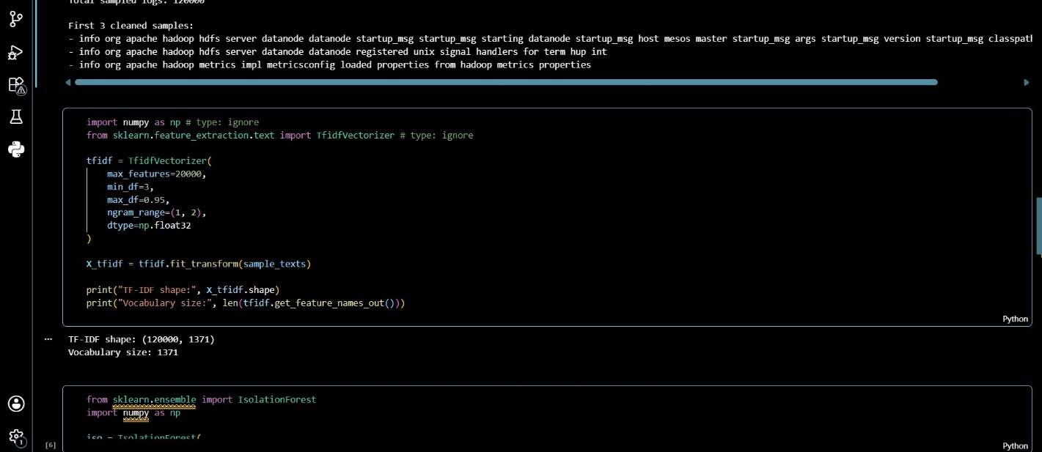

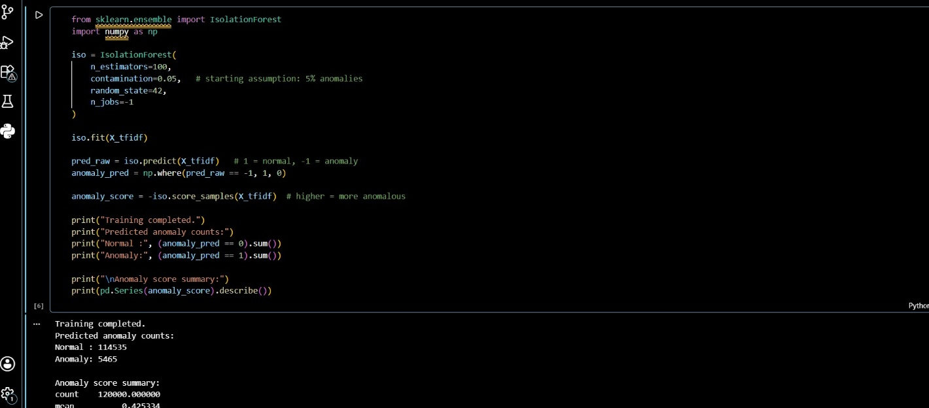

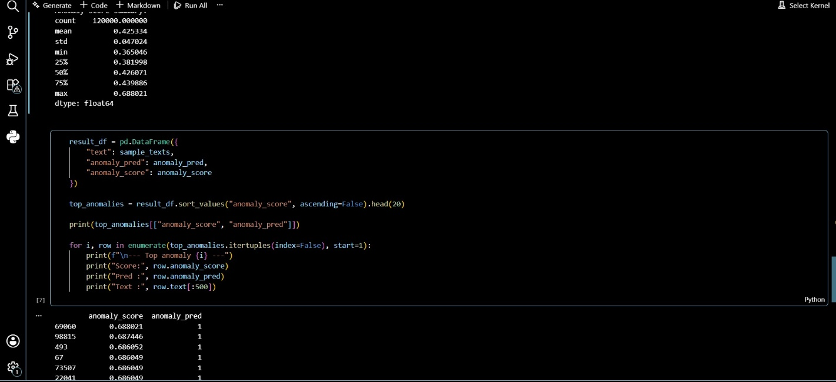
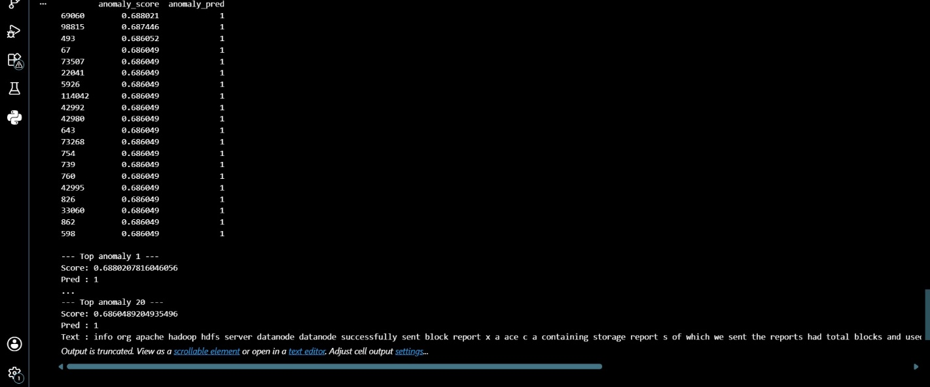

17.3 Bidirectional LSTM
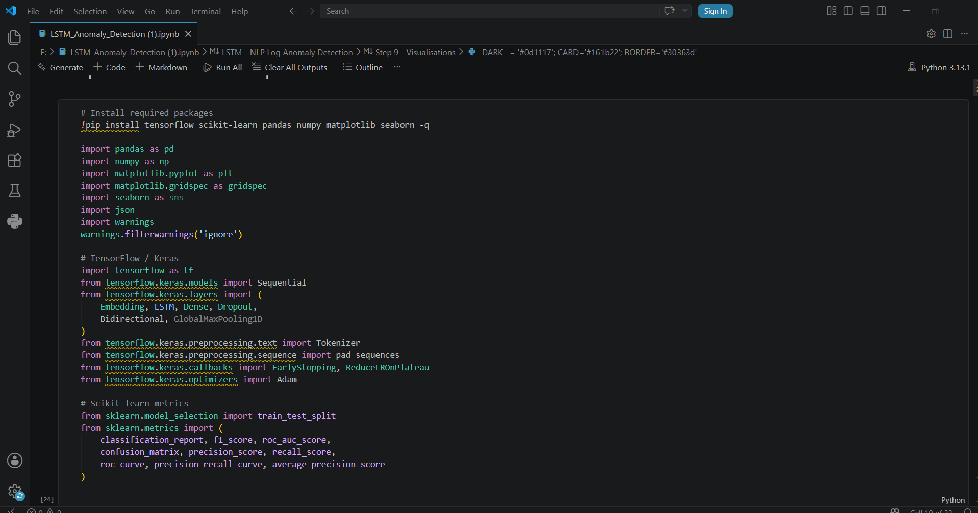

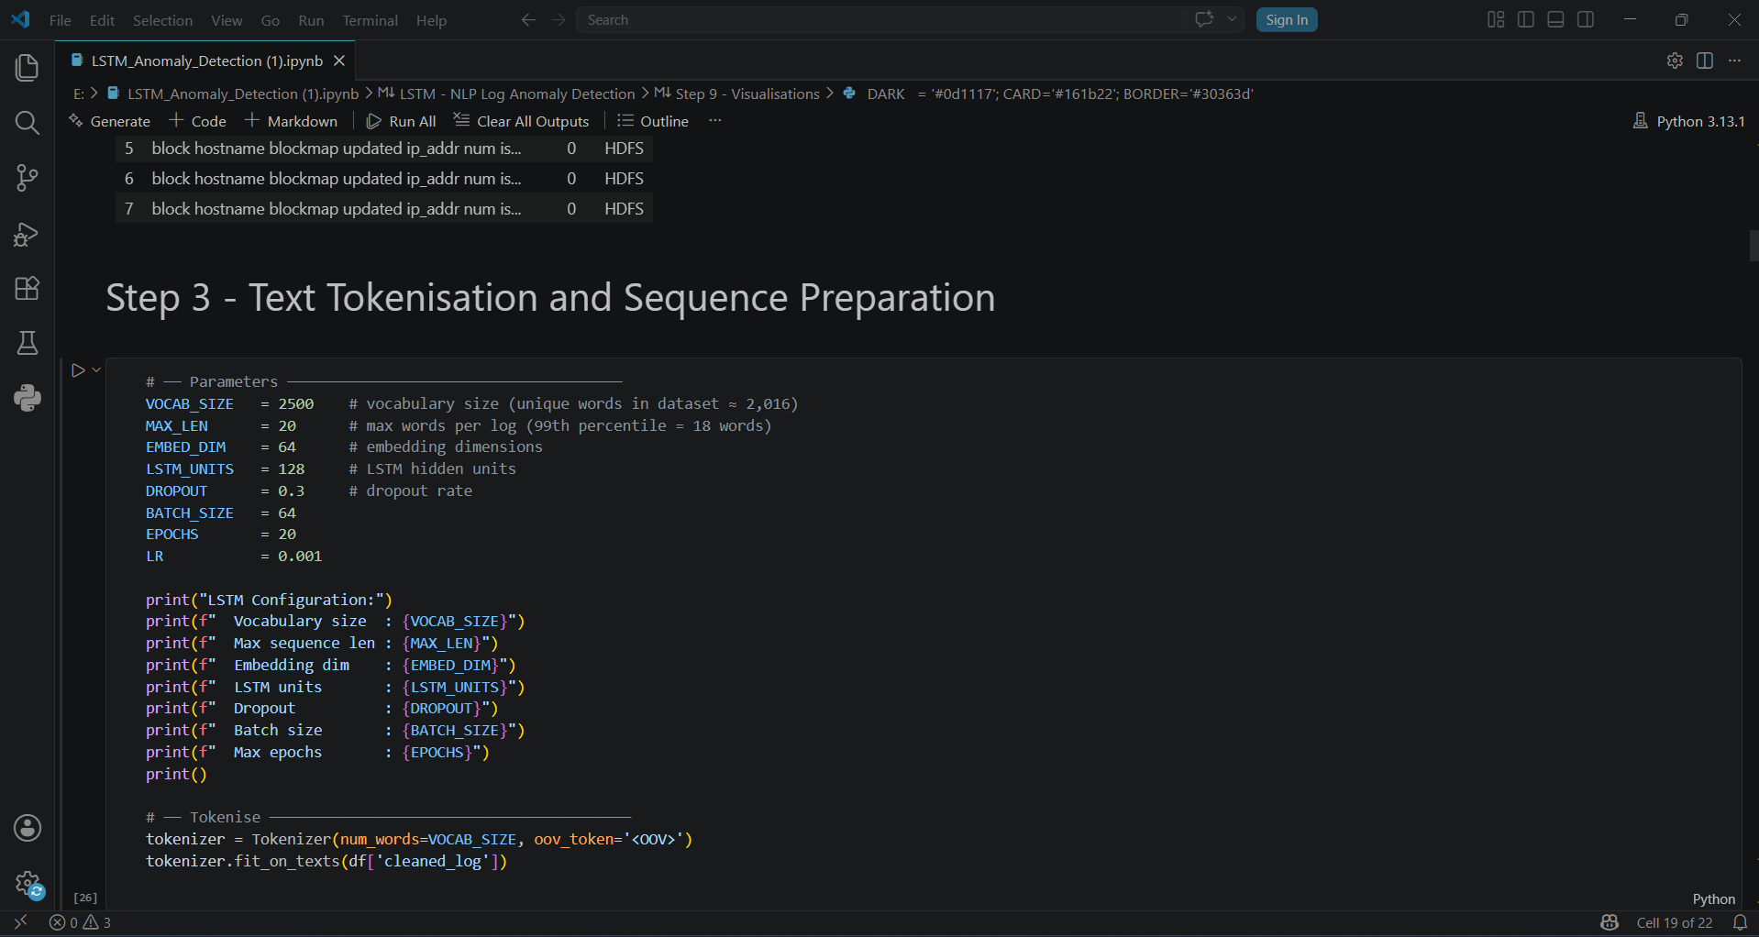

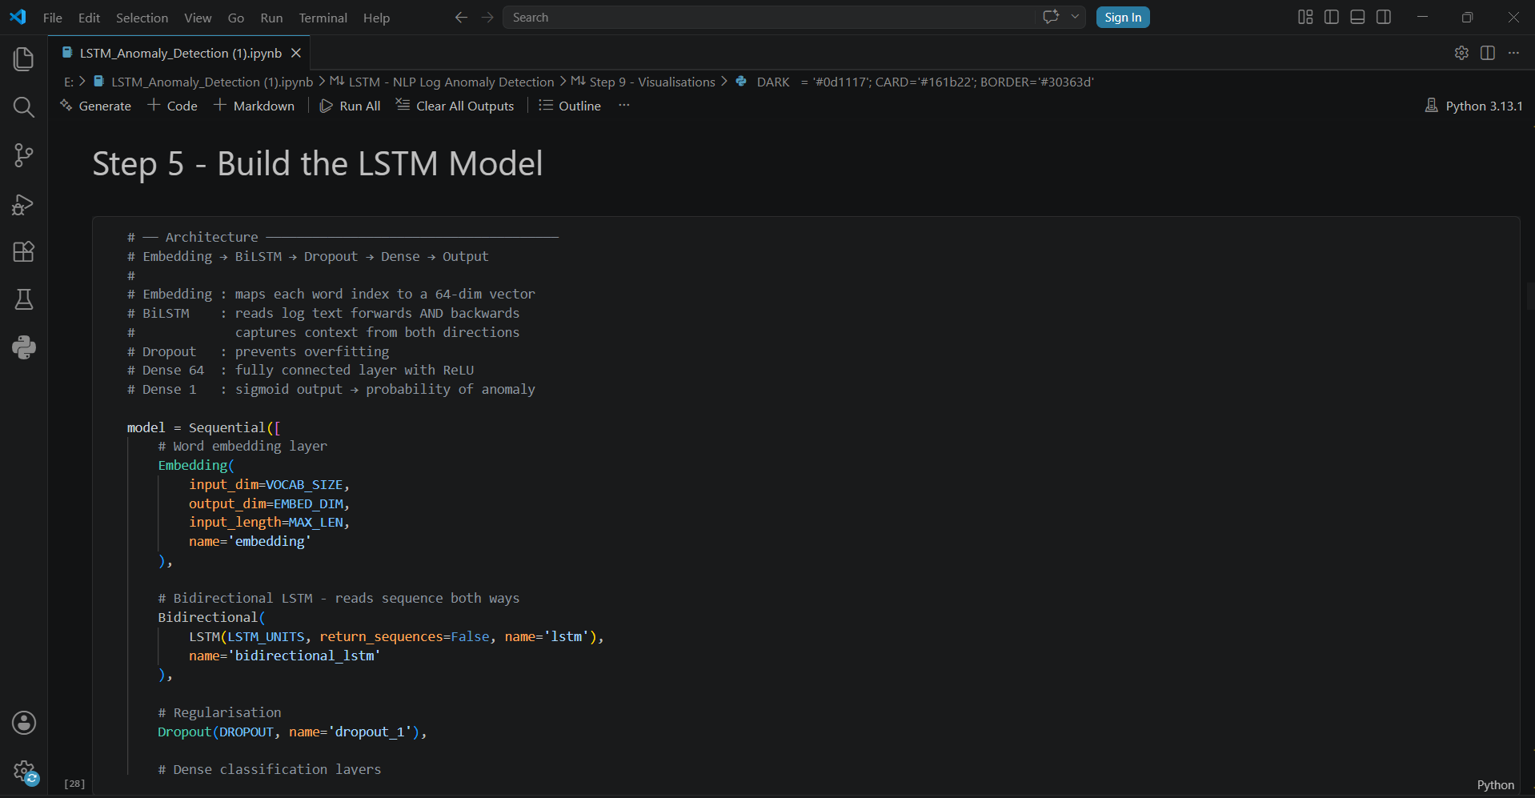

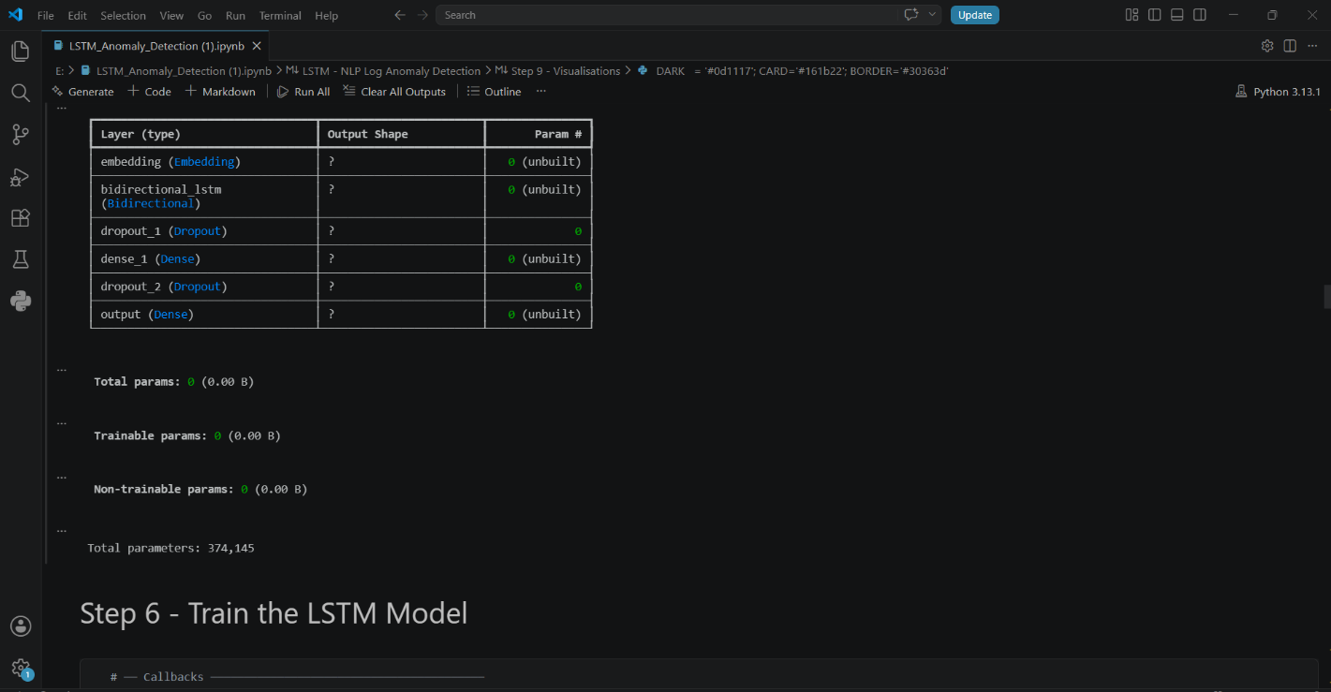

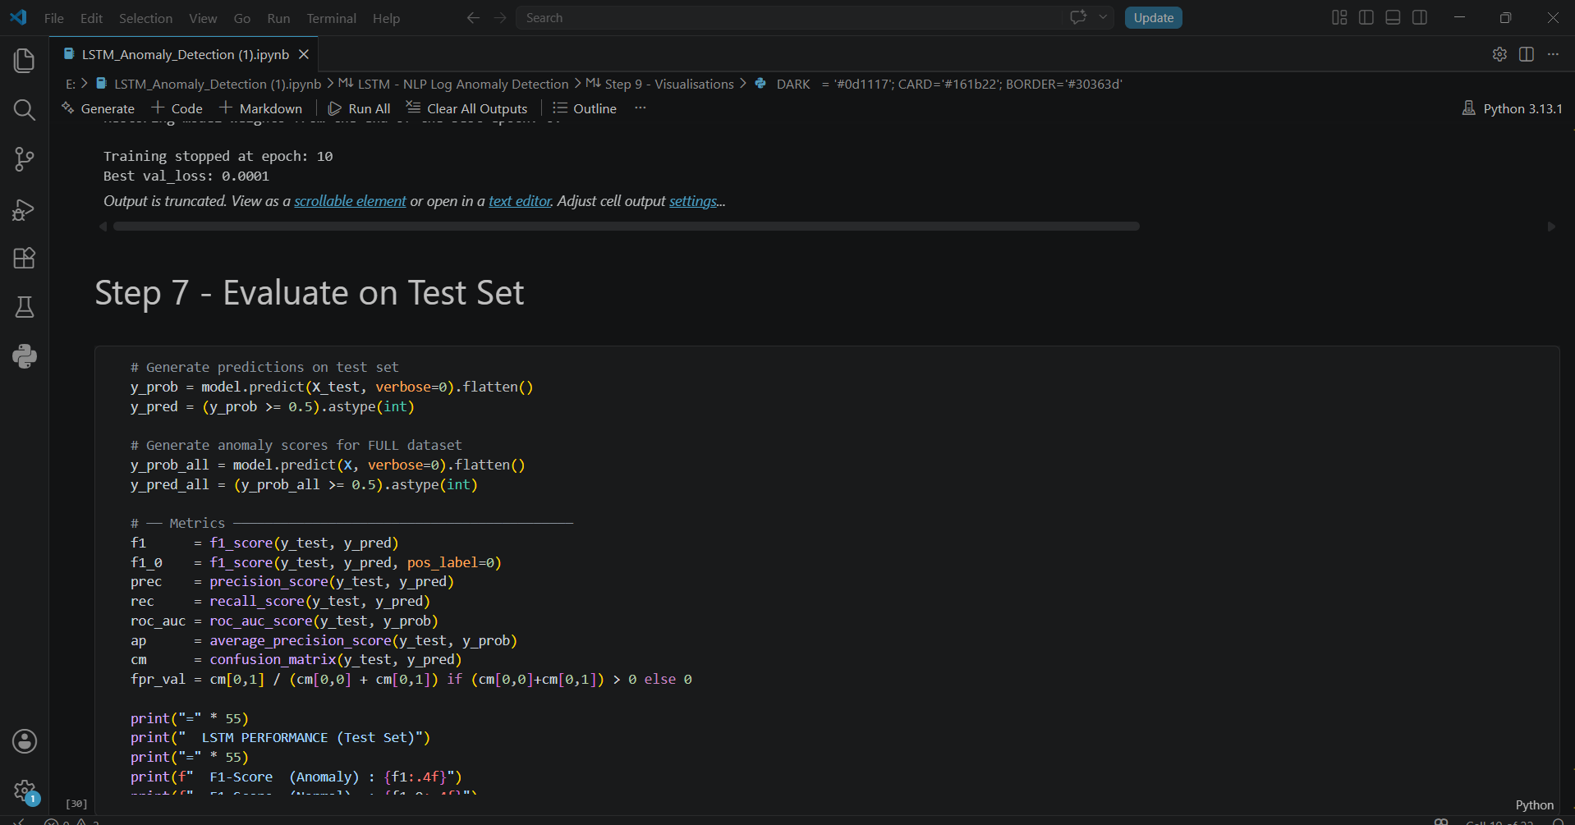

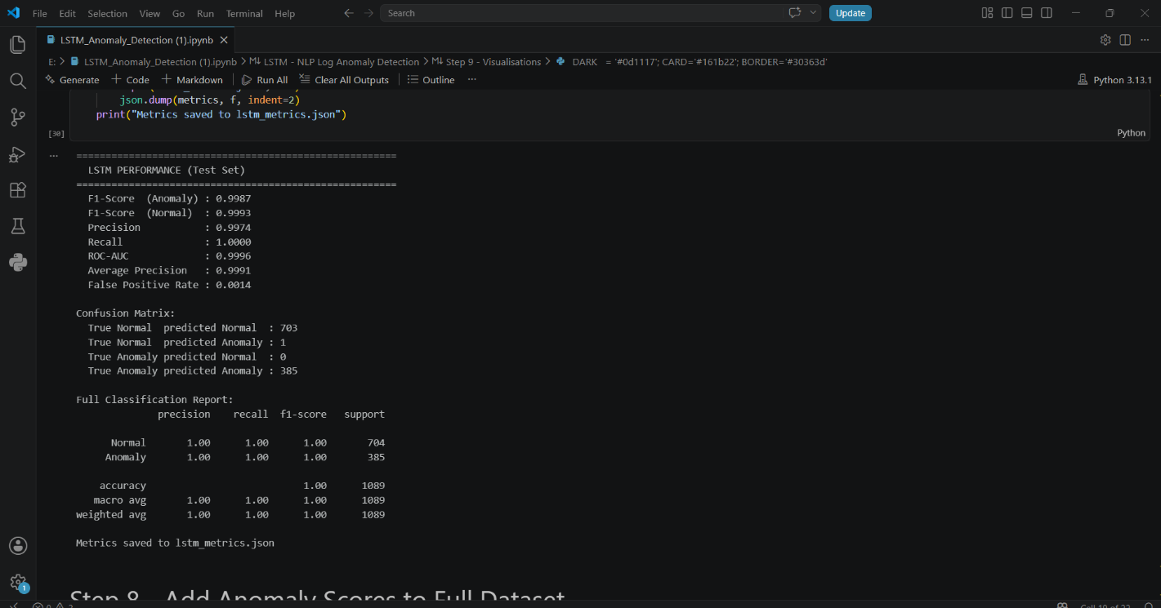

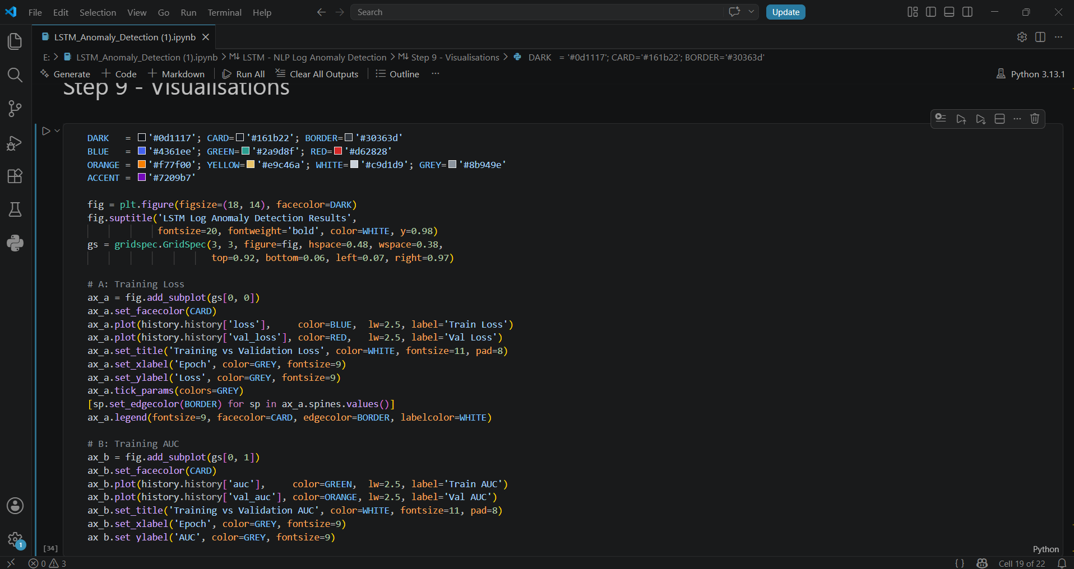

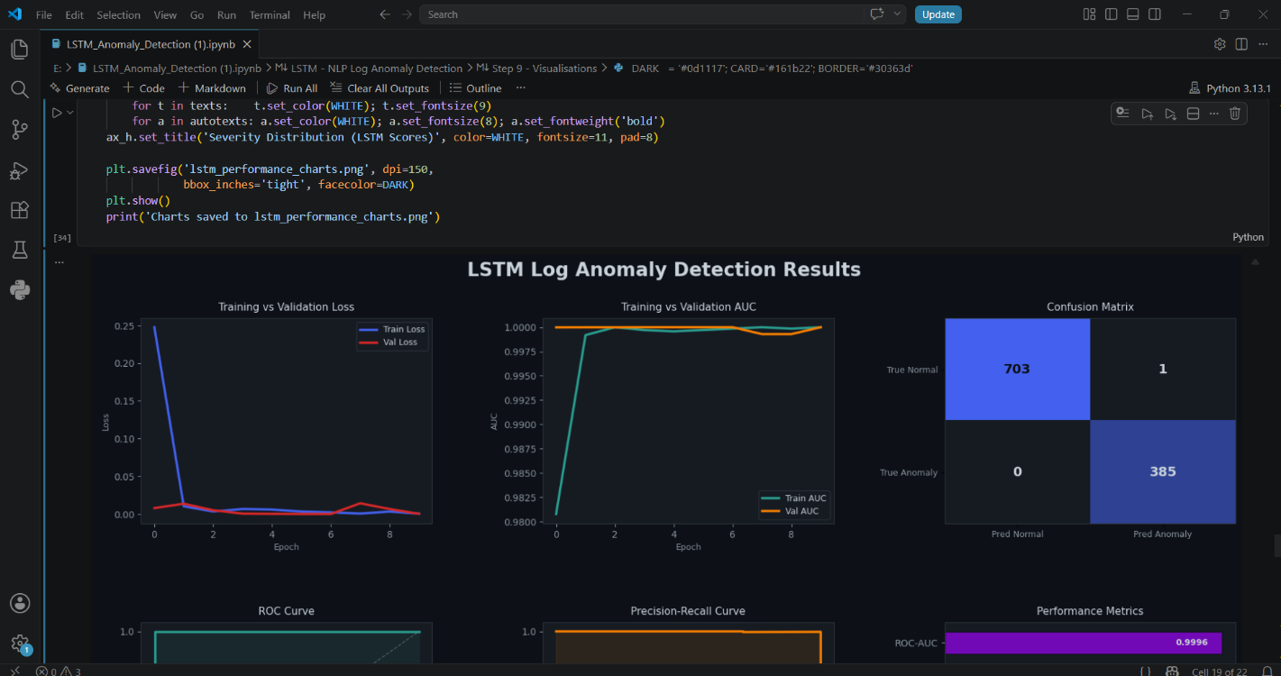

17.4 Logbert Model
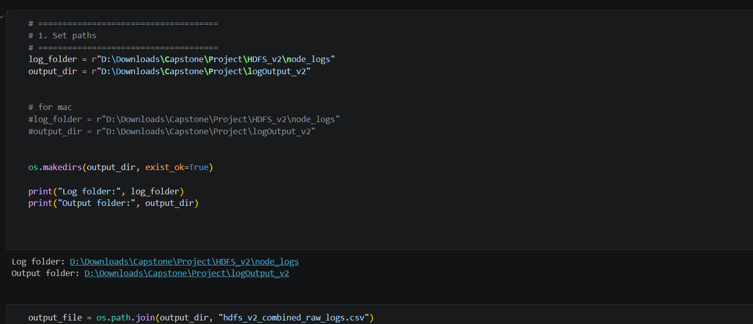

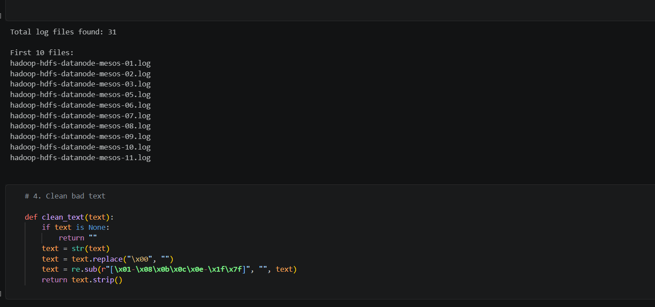

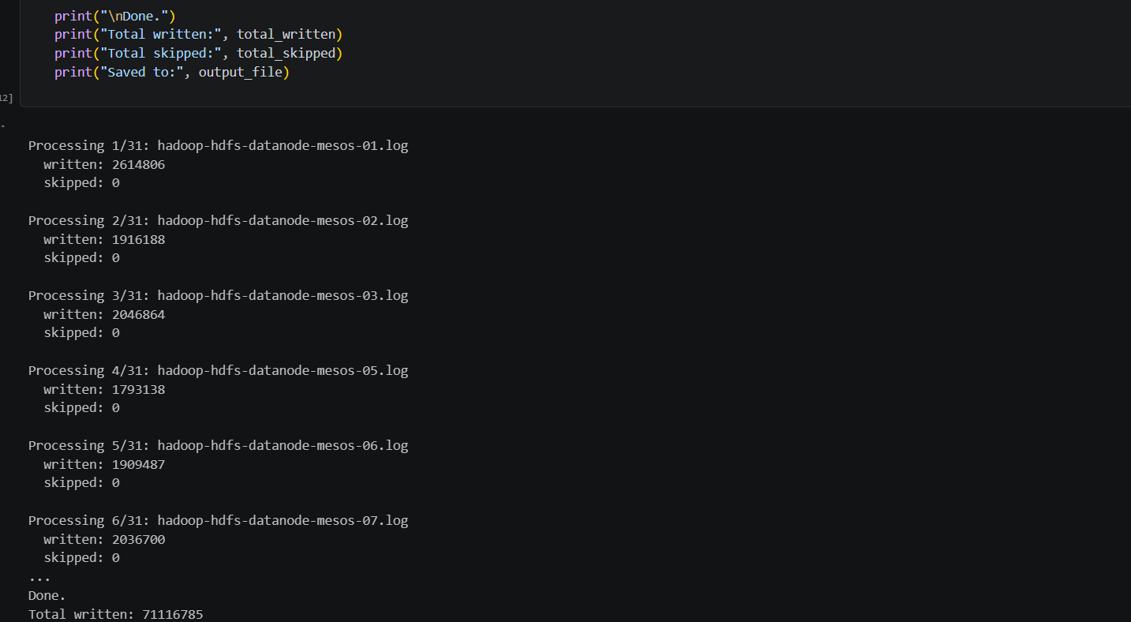

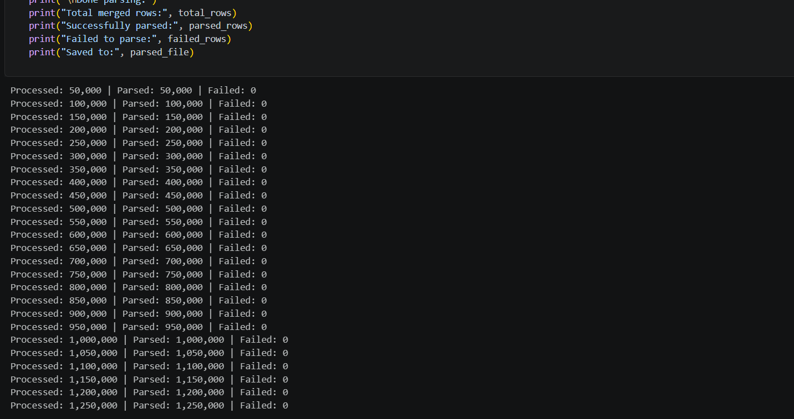

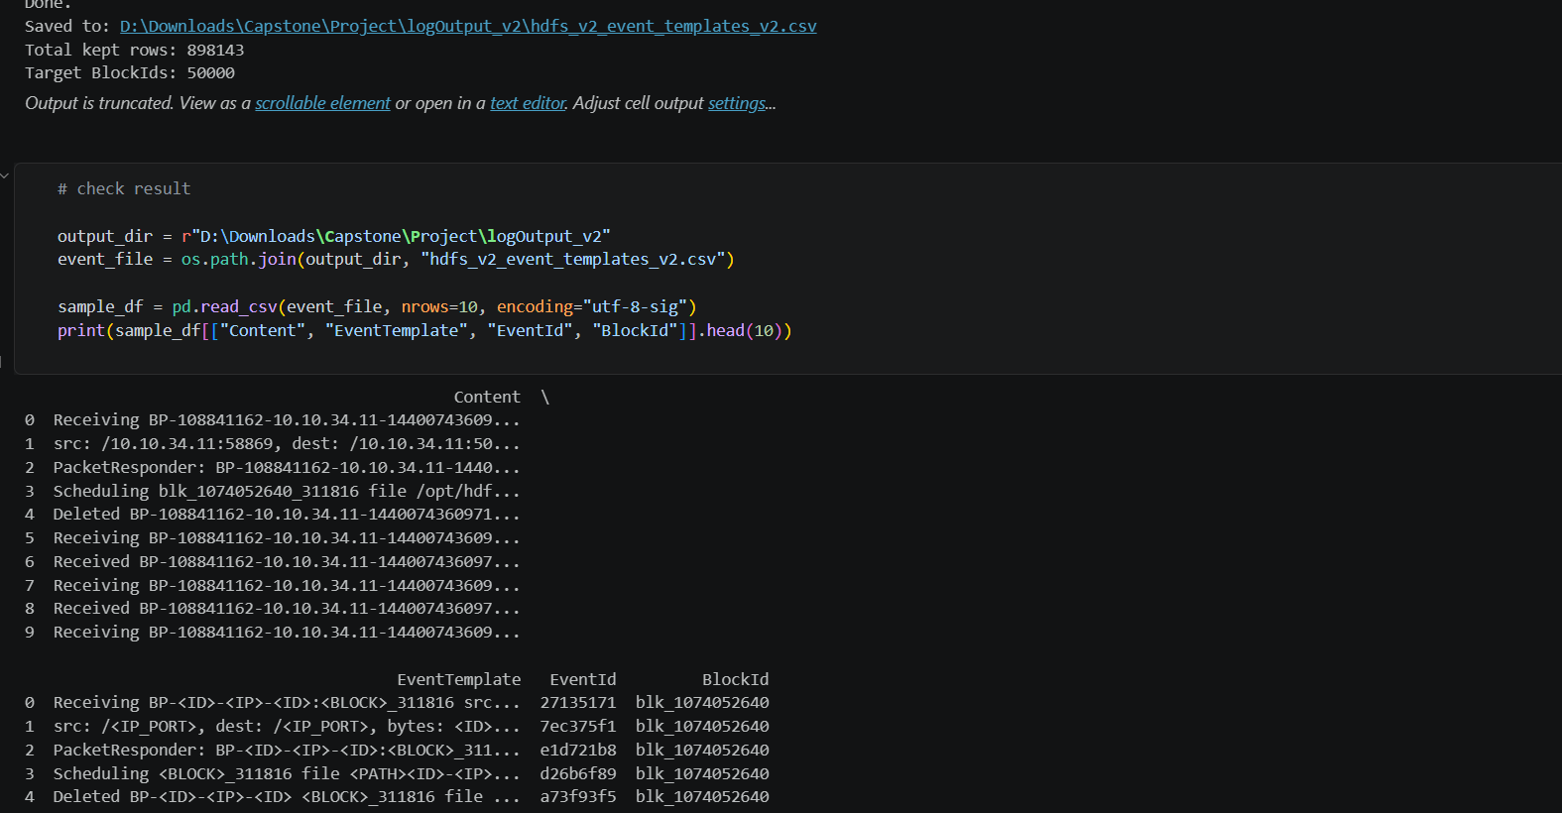

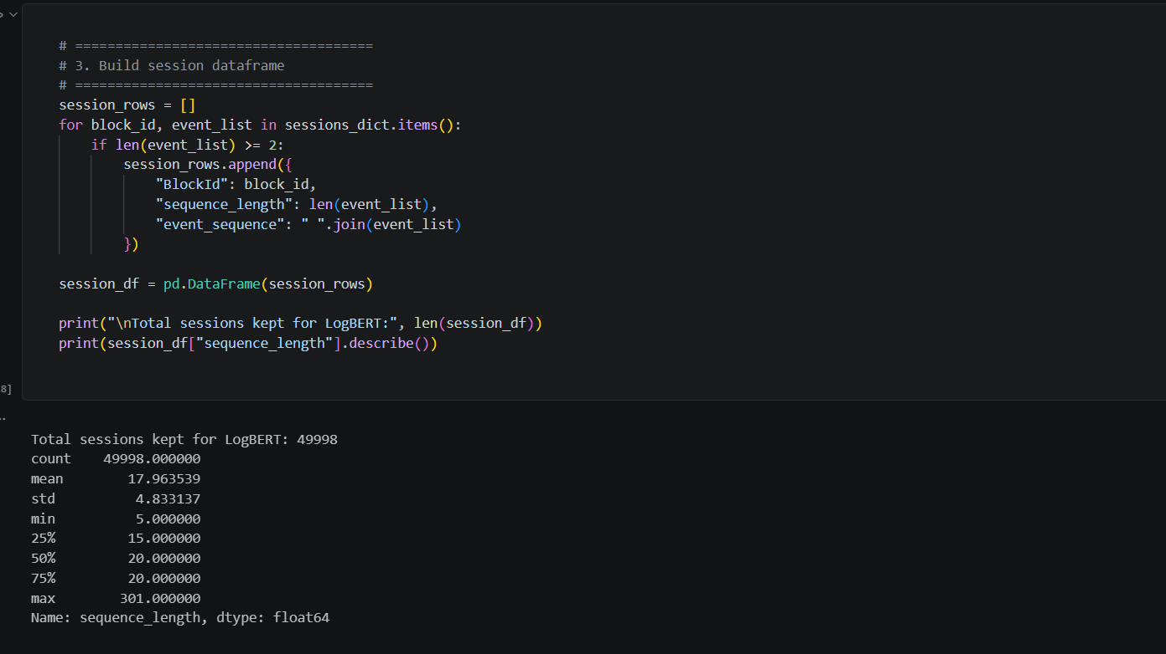

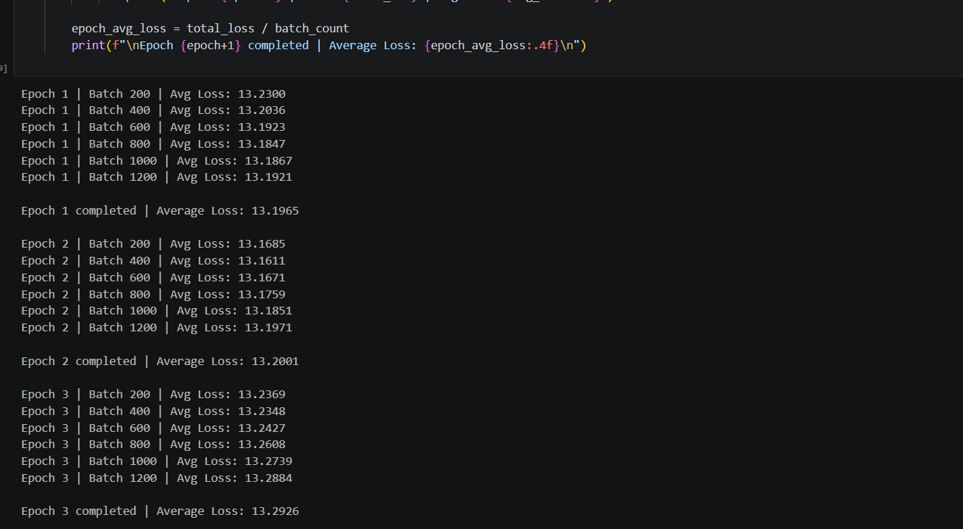

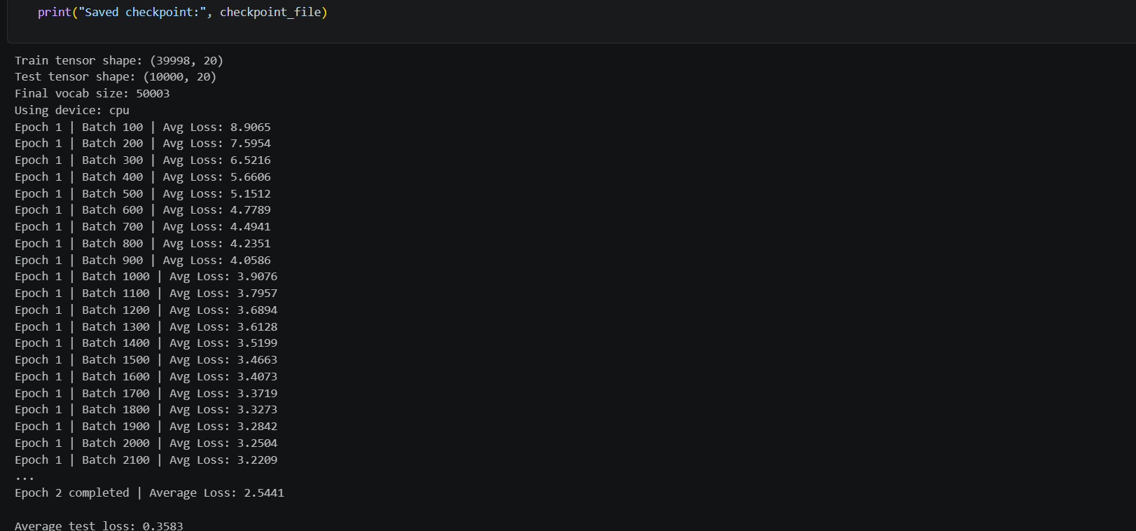

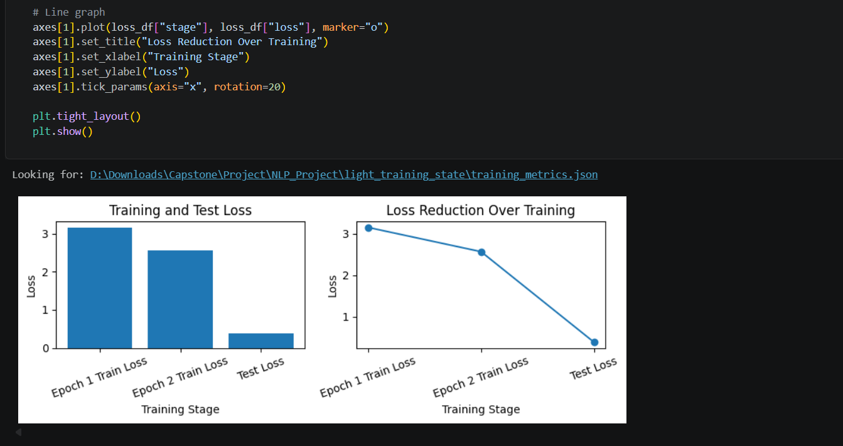

17.5 Github Repo
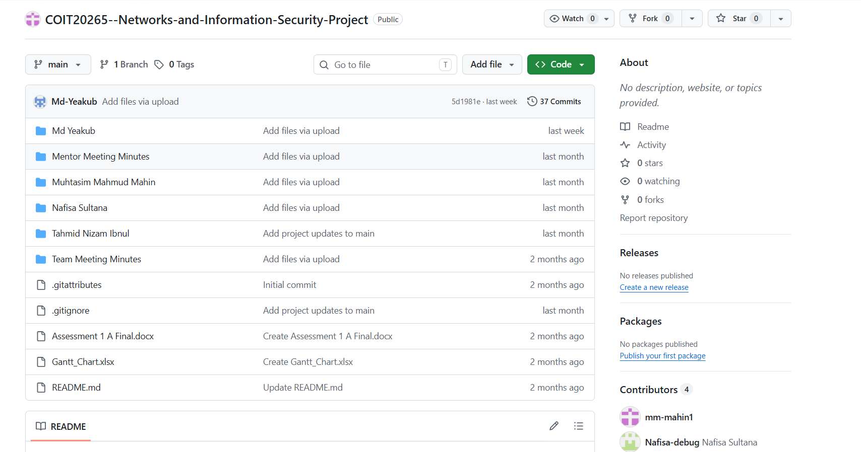

17.6 Jira
